**Databricks Manual**

**Workspace**

You can link any github repo to databricks by going to workspace and repos and add reps. You simply paste in the github rep url, and all of the notebooks will appear in databricks.

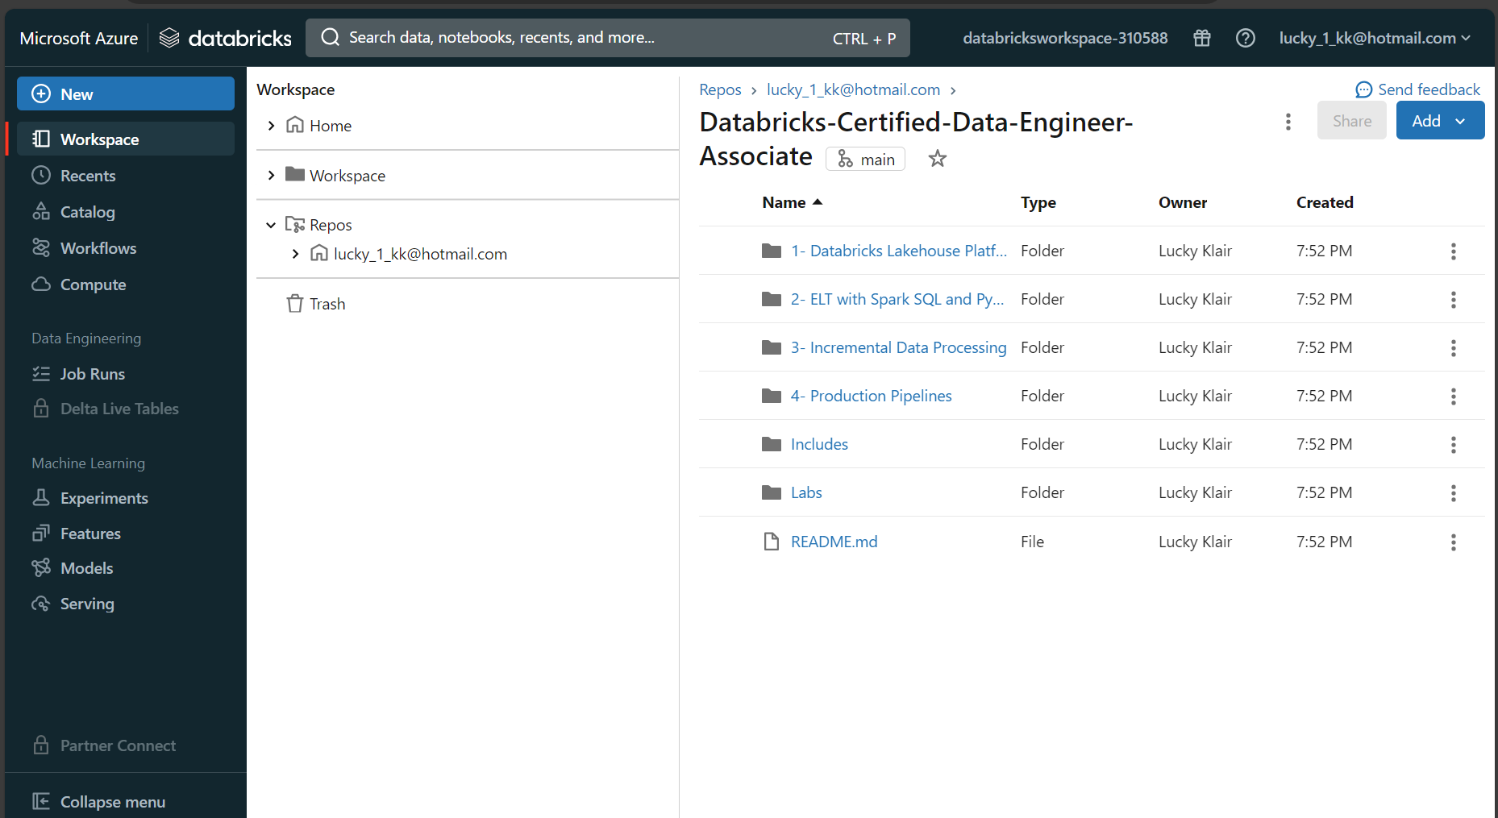

**Creating cluster.**

A cluster is a set of nodes (or computers) working together like a single entity. You can manage and create clusters in the compute section. It consists of a master node (called a driver) and worker nodes. The driver node is responsible for coordinating the worker nodes to execute tasks.

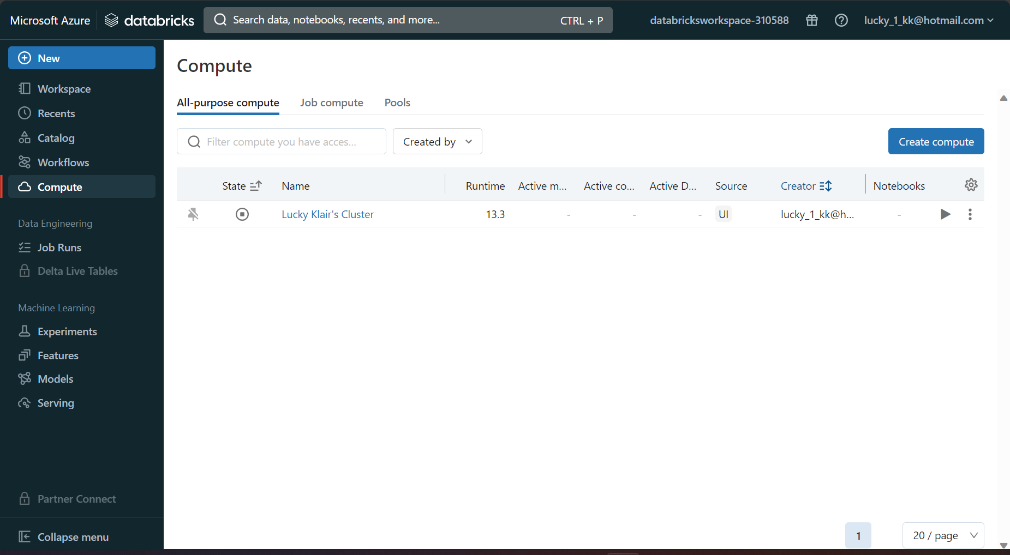

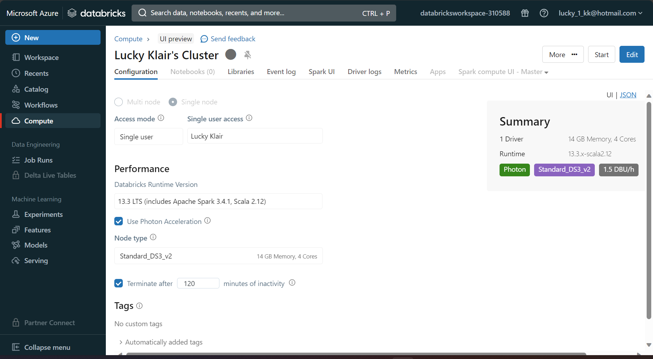

The cluster can be a single node, where you have one worker, or multi-node, where you have multiple workers. A single node option has no workers, and simple runs spark jobs on a single node. You can set the access mode to single user or multiple user. If a single user is going to use the cluster/nodes, then you assign it to a single user, otherwise multiple users can also use the cluster. The databricks runtime is the pre-installed image that comes on the virtual machine, which has a specific version of spark.

You can select the configuration of the worker nodes(machines) and the minimum number of worker nodes and maximum number of worker nodes in the event of autoscaling. You can select the configuration of the driver node as well, and the amount of time it deactivates after.

A DBU stands for databricks unit, and it is a unit of processing capability per hour. Each configuration will tell you how much DBU is consumed, and how much it will cost based on the chosen configuration of the worker and master node.

After the cluster is created, the event log helps to track all of the activity on a cluster.

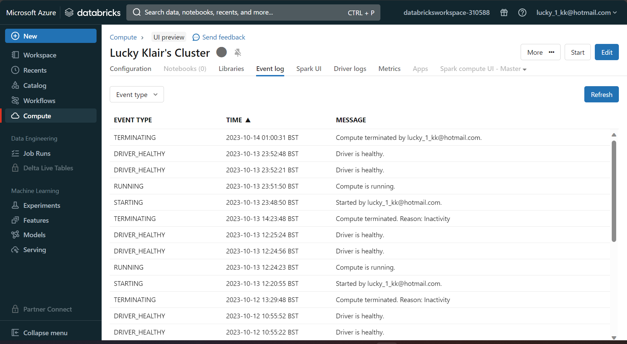

**Notebooks**

The notebooks are coding environments which allow you to write code in four different languages (python, SQL, Scala, R).

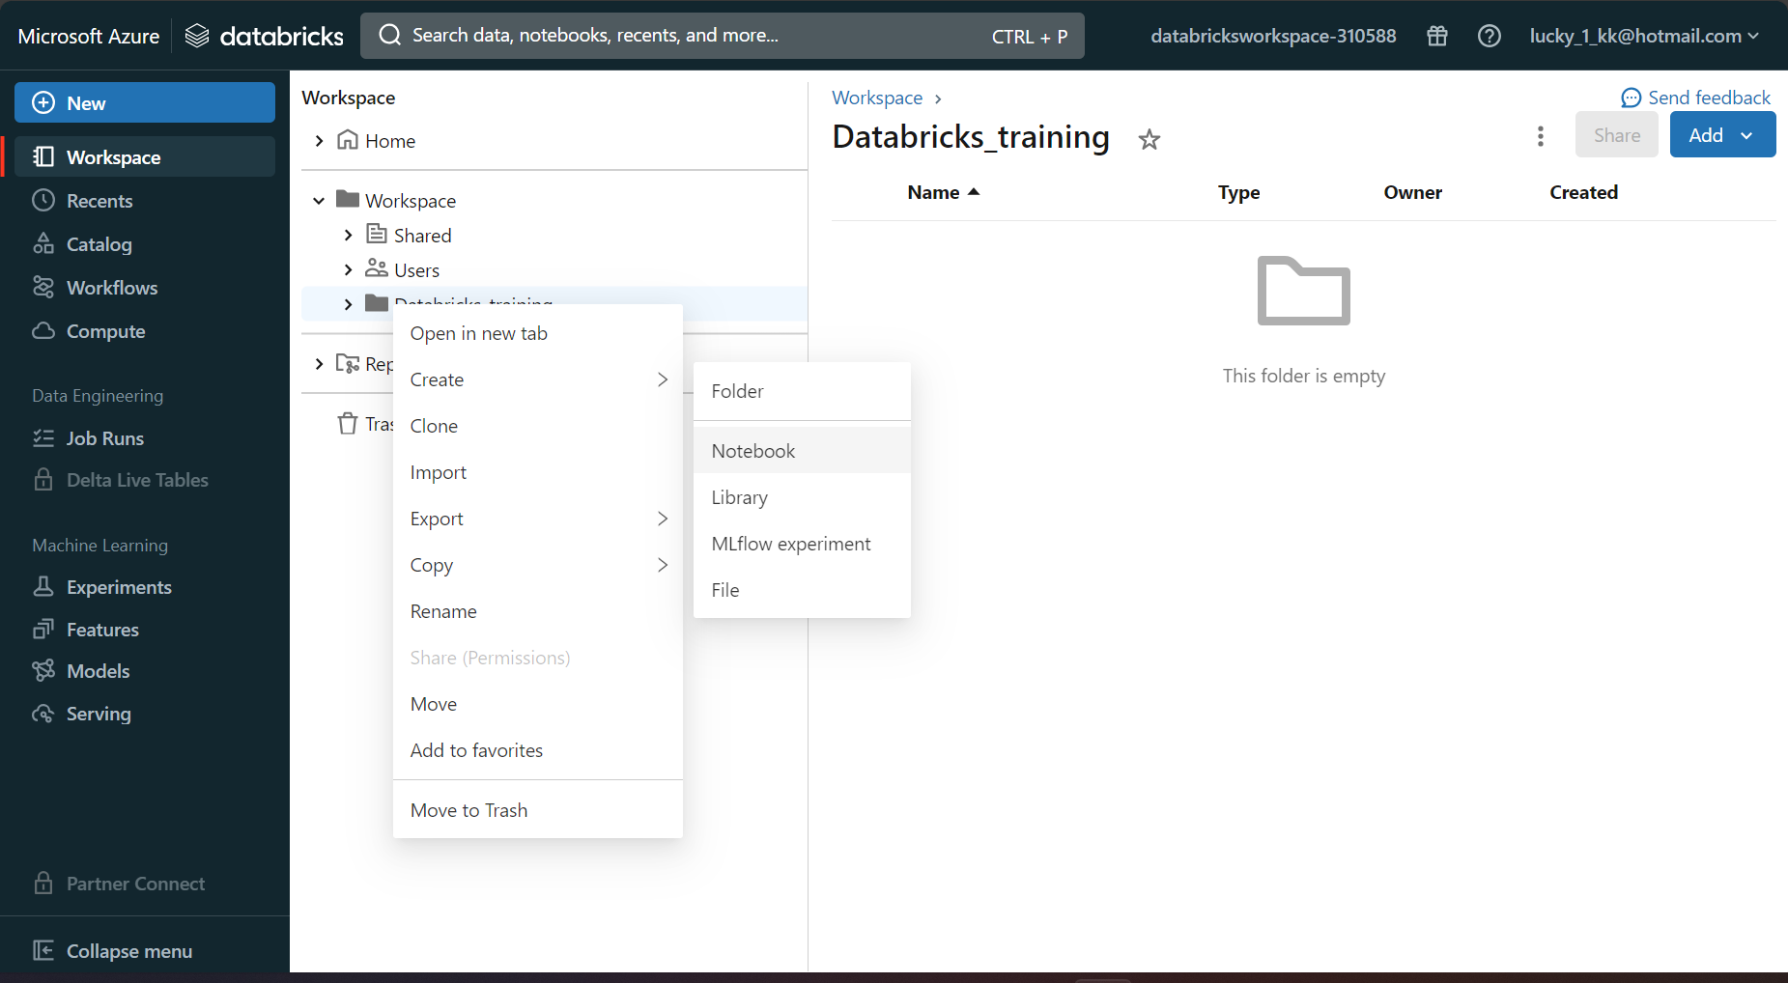

You have to connect to the cluster so that compute is available to run the notebook code. You can attach the cluster to the notebook as following:

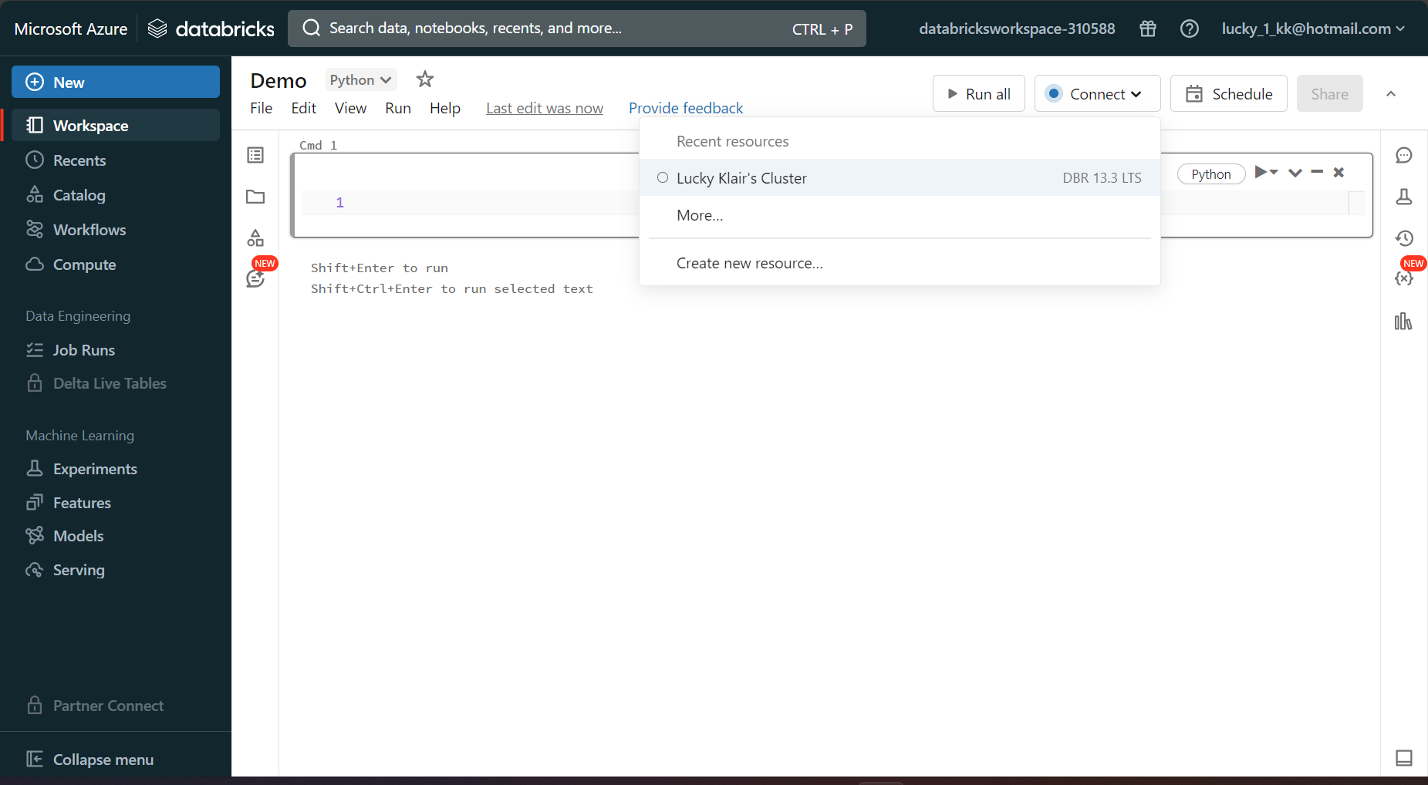

You can use a number of magic commands as shown in the image below, which break out of the default language of the notebook and you can use the magic command in the chosen cell.

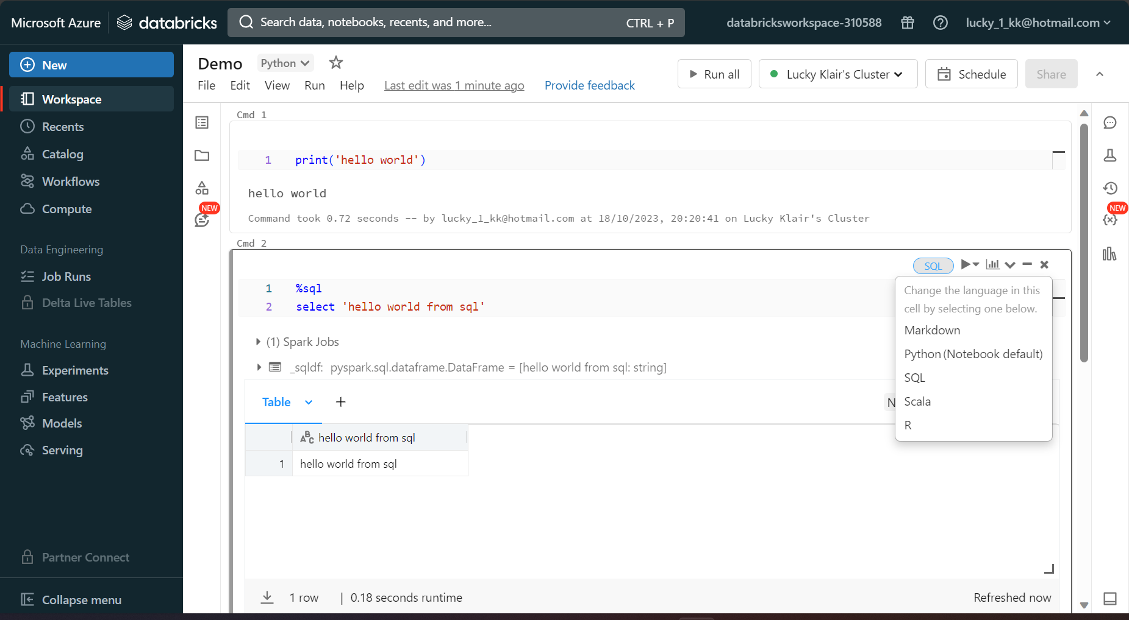

There is another handy magic command named %run. You can input another notebook within a notebook. If I create another notebook called setup, I can call it in with the run magic command. This allows the notebook to be used in a modular manner.

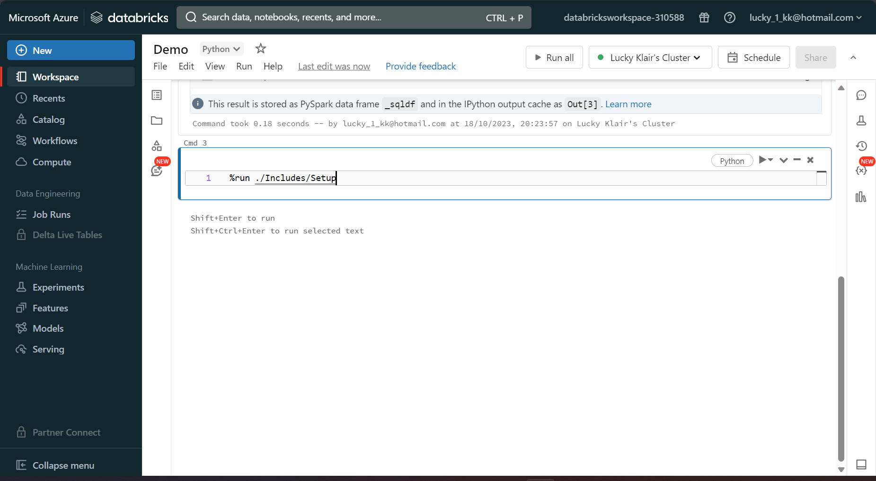

The %fs magic command allows us to use the command line operations. Here is an example of calling the files in a standard databricks folder (a folder with files that are provided to every databricks user)  
  
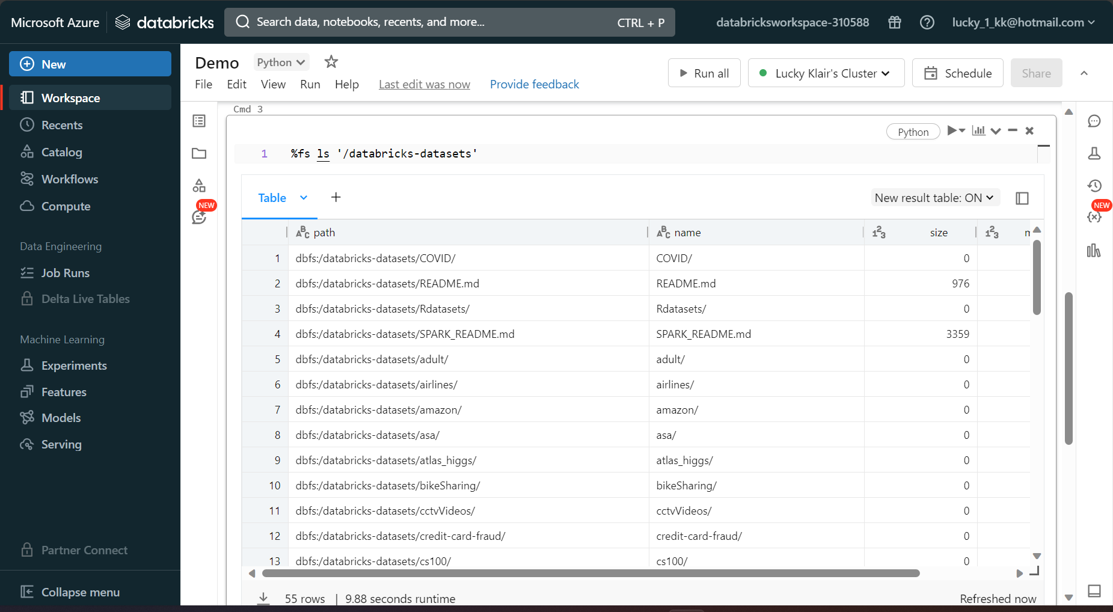

The databricks utilities (dbutils) provide a number of commands to configure the workspace/notebooks. Dbutils.help provides some guidance on what dbutils provides.

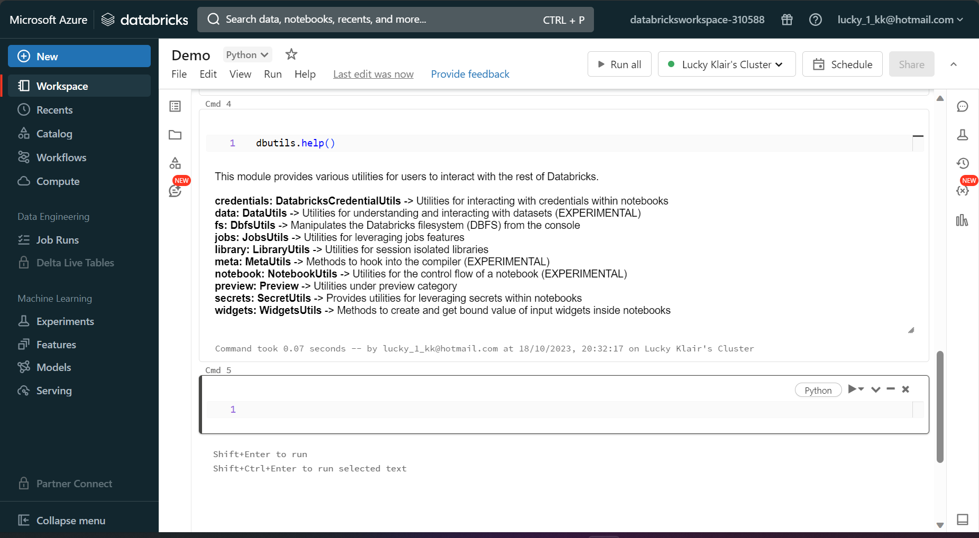

We can even get help about each of the areas themselves, such as below.

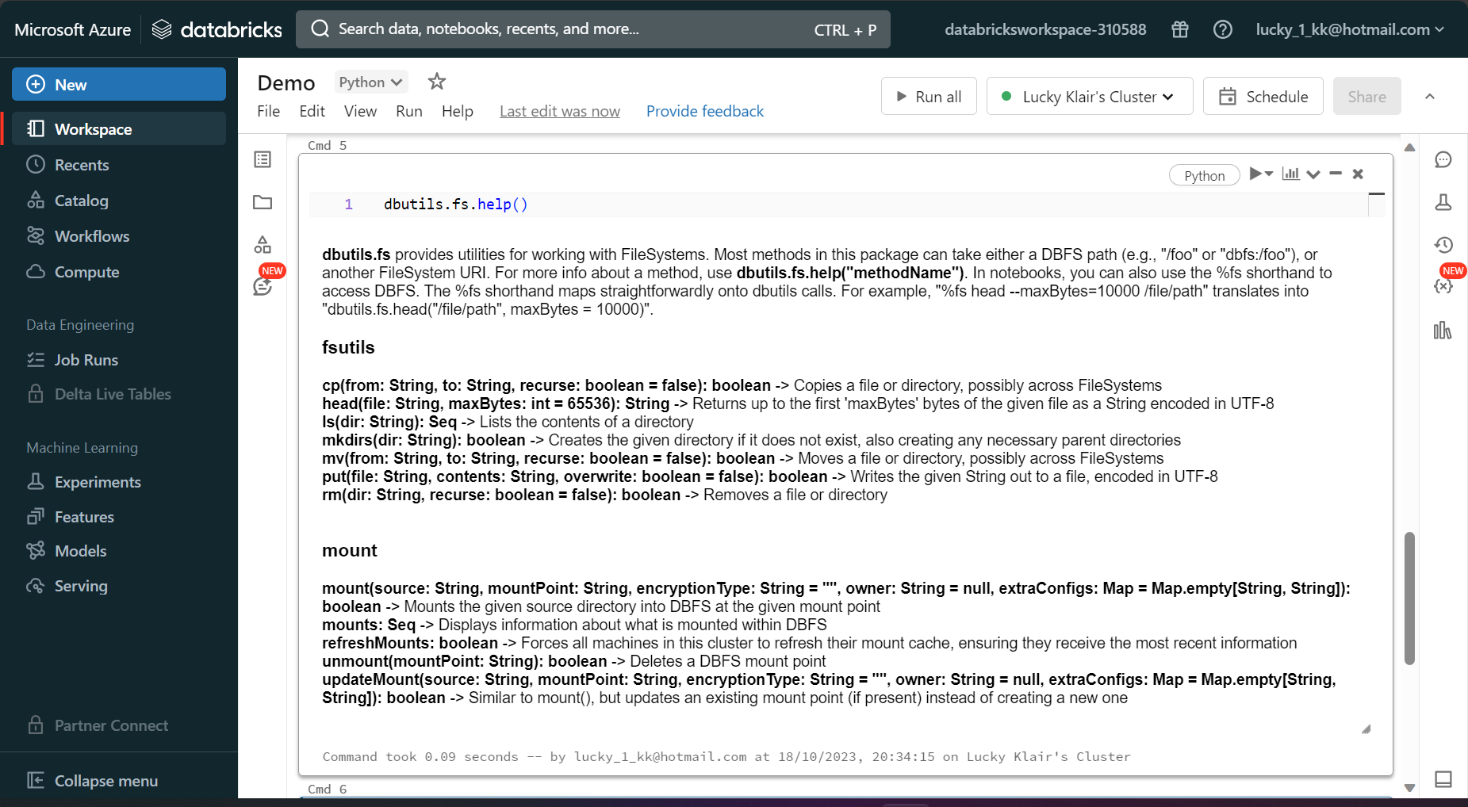

So we can also display the files in a folder using dbutils, which is a better way of doing it in comparison to the fs magic command, as it is more useful. This is shown below. You can see that it shows the name, type, size of the file, and modification time.

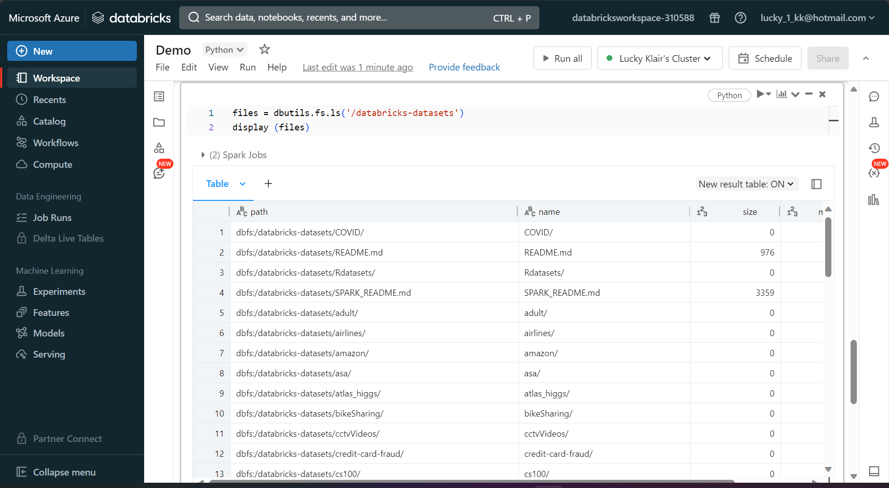

You can see the full revision history of a notebook by clicking on the area below:

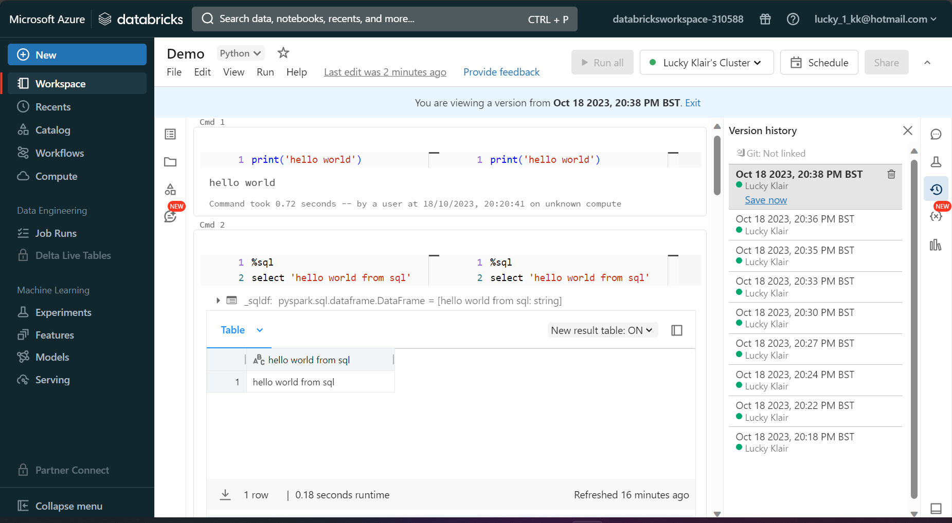

**Databricks Repos**

You can setup more advanced repository management by integrating github. This is done by following the steps below.

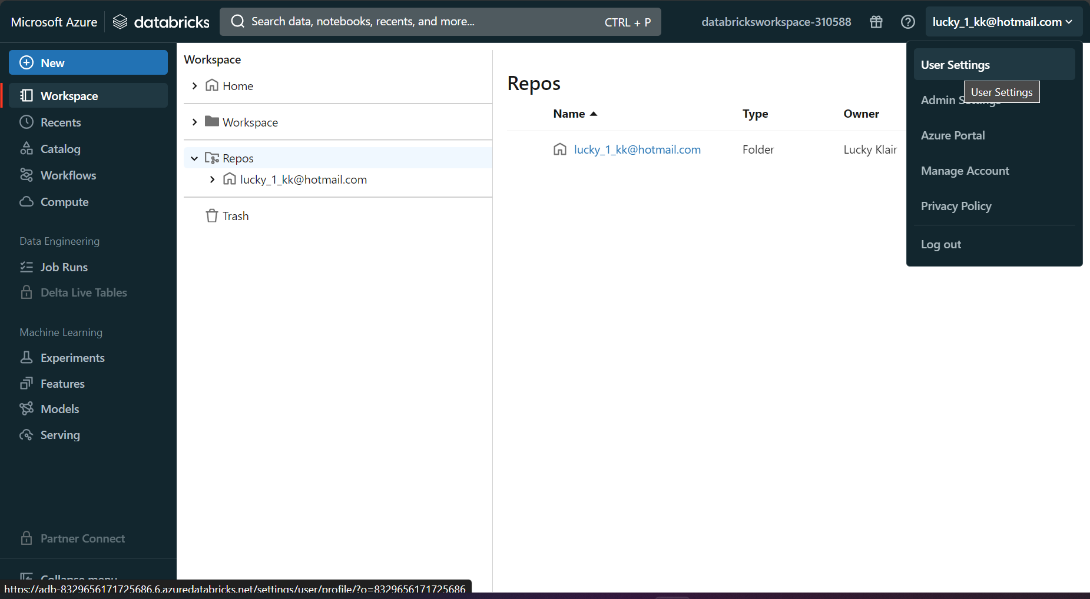

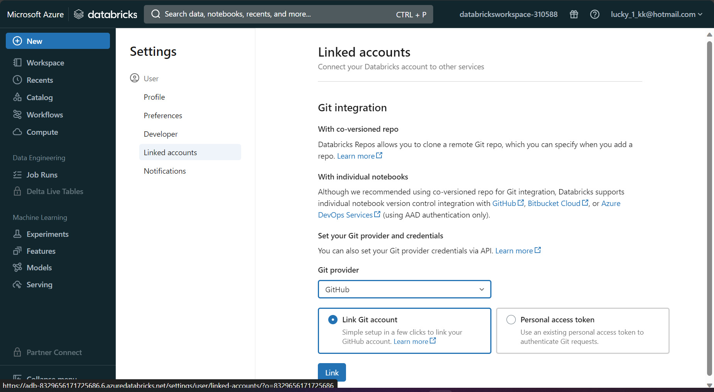

Next, you go into your Github account, and go to settings from the top right.

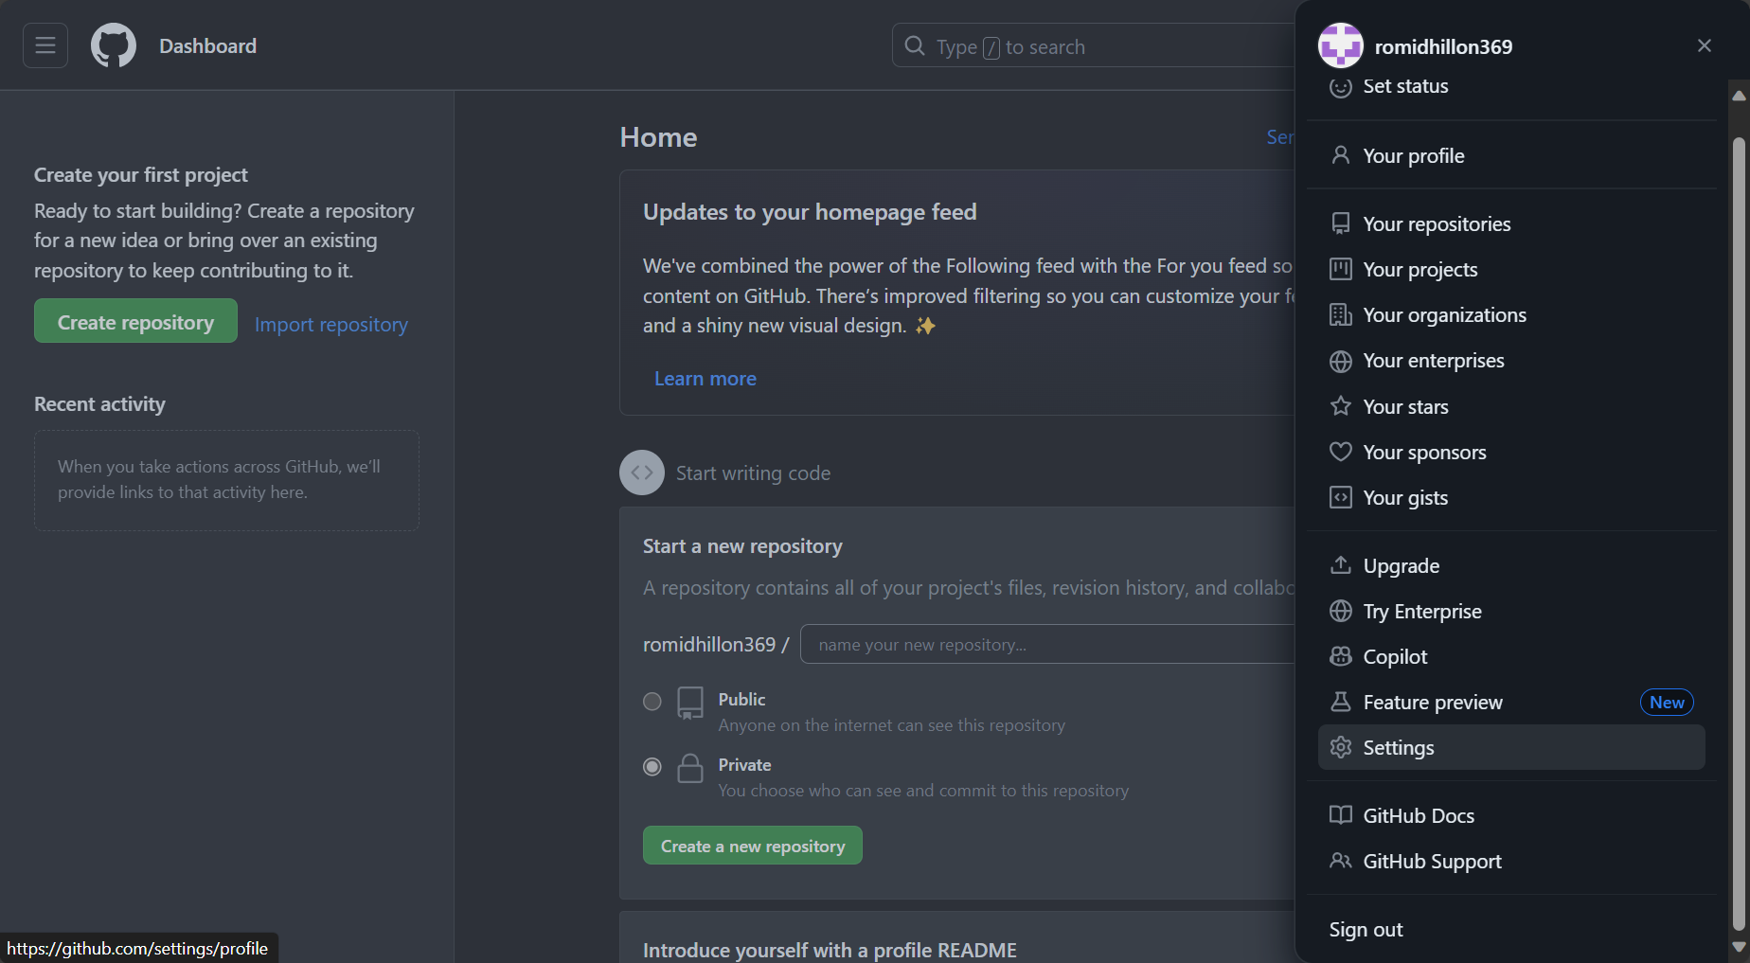

You then click on developer settings.

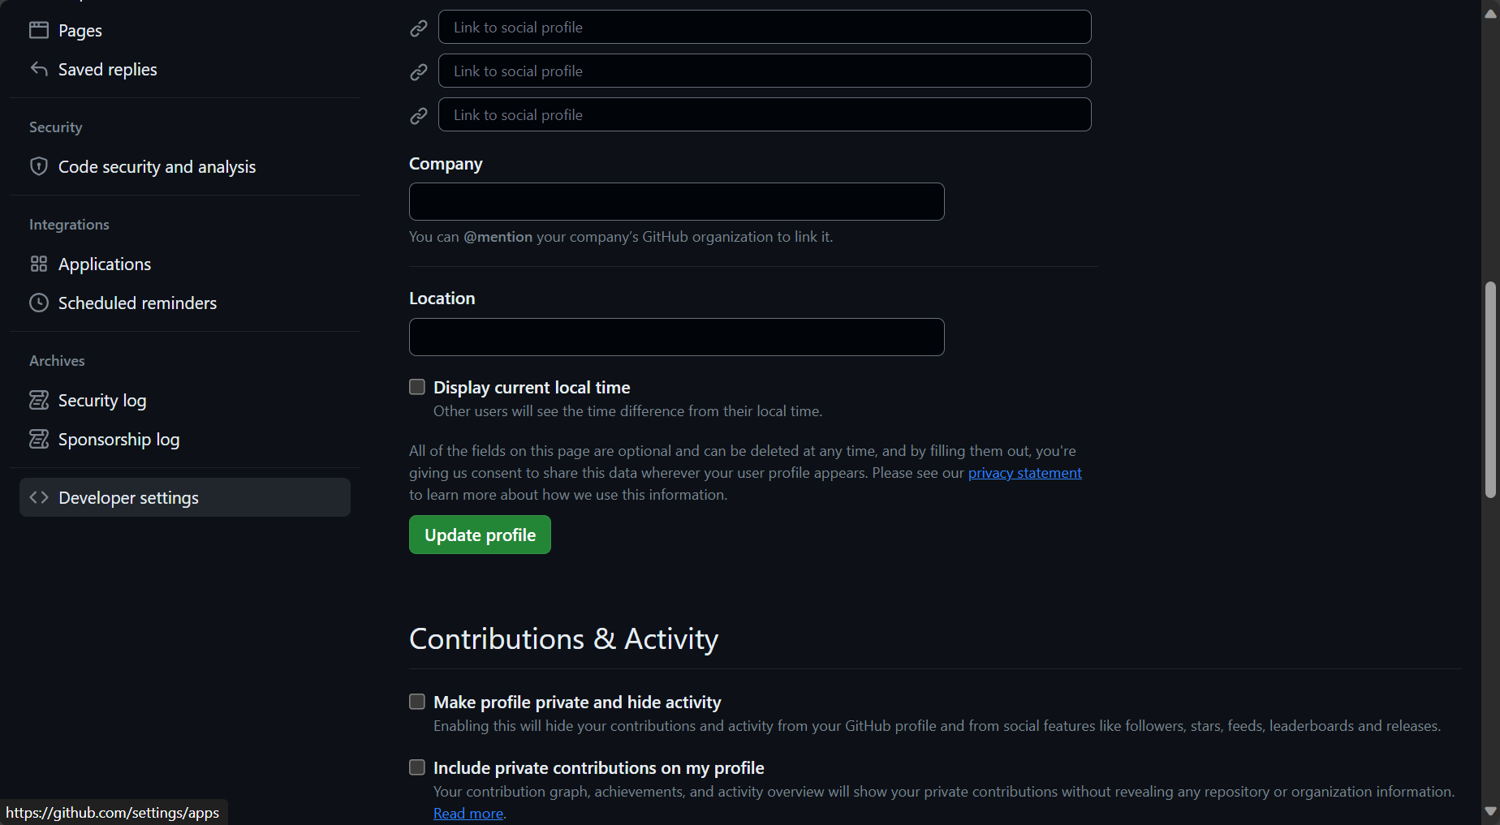

You then click on personal access token, tokens (classic) and generate new token.

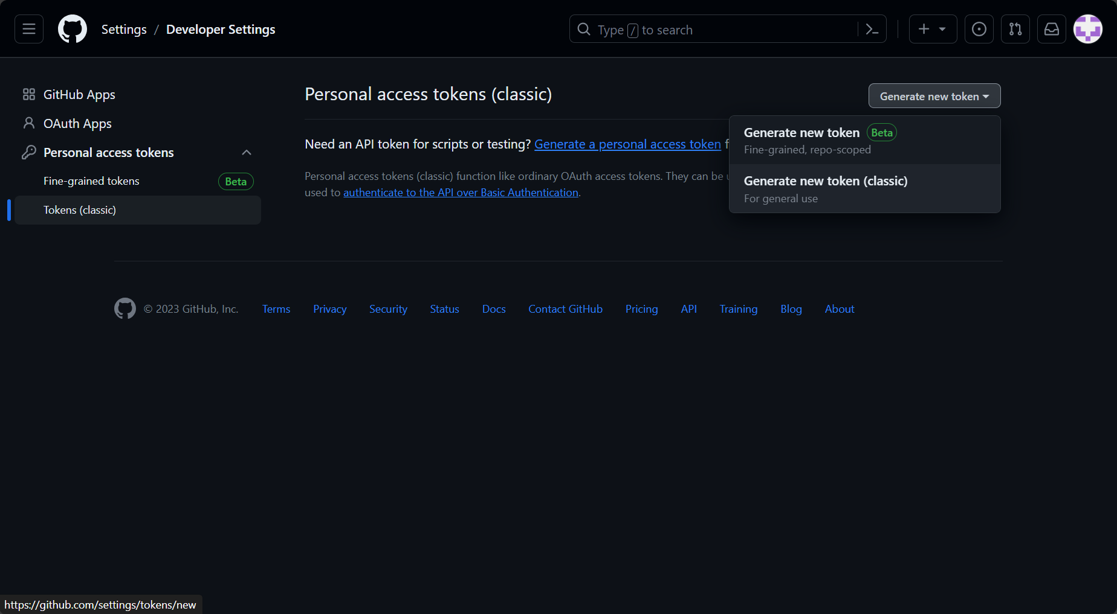

Then type in a reason for the access token, and click on the repo checkbox. Then click ok.

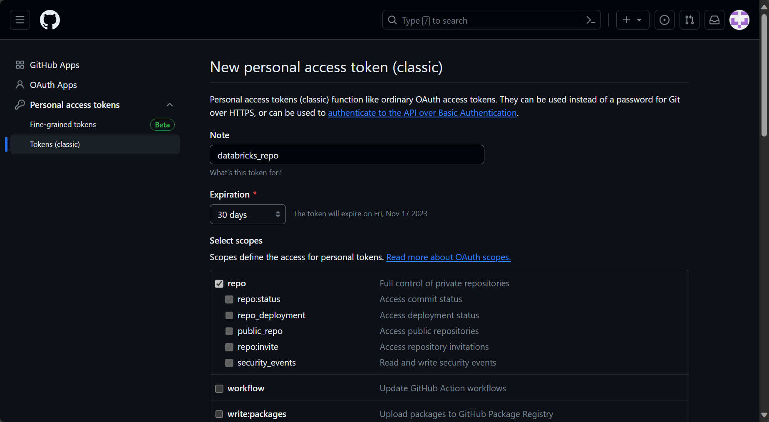

You then put in the github username and personal access token into the databricks page as seen below. Github is now linked to databricks.

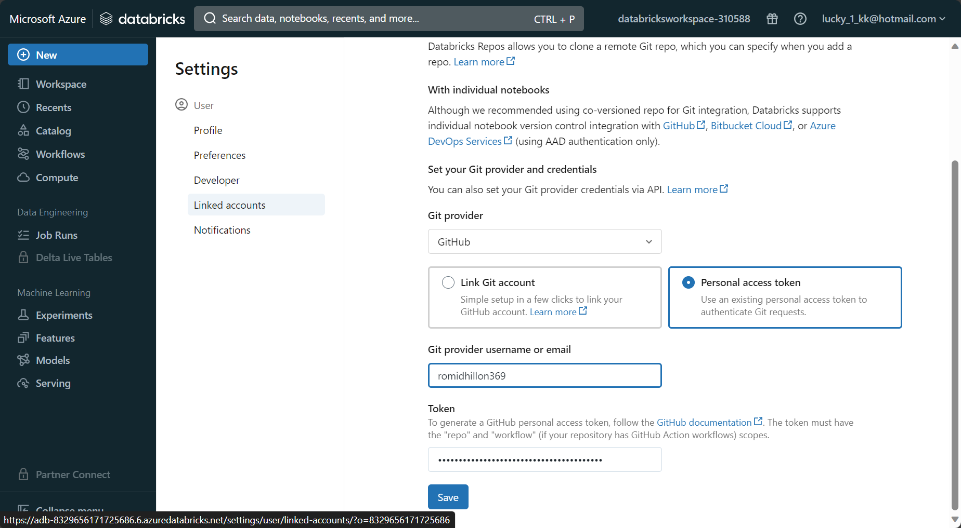

Next, lets create a repository in Github, as below:

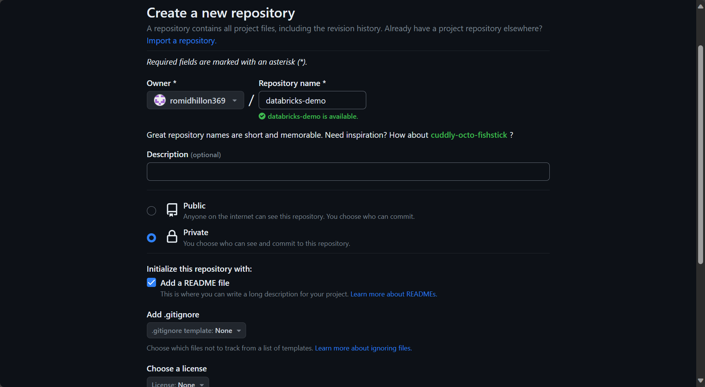

You then get the new repositories url path and go to the following in databricks

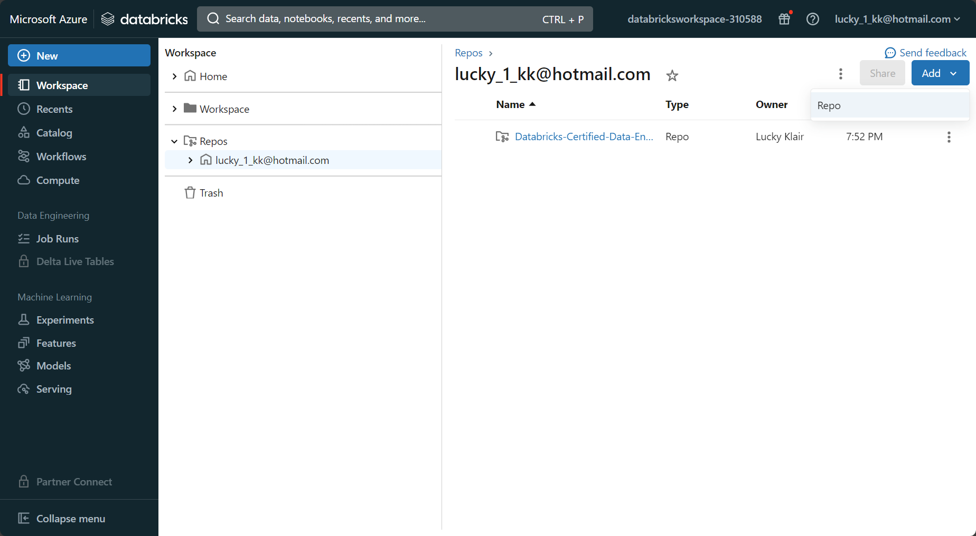

Once you click add repo, you paste the URL and the rest of the fields will automatically fill out.

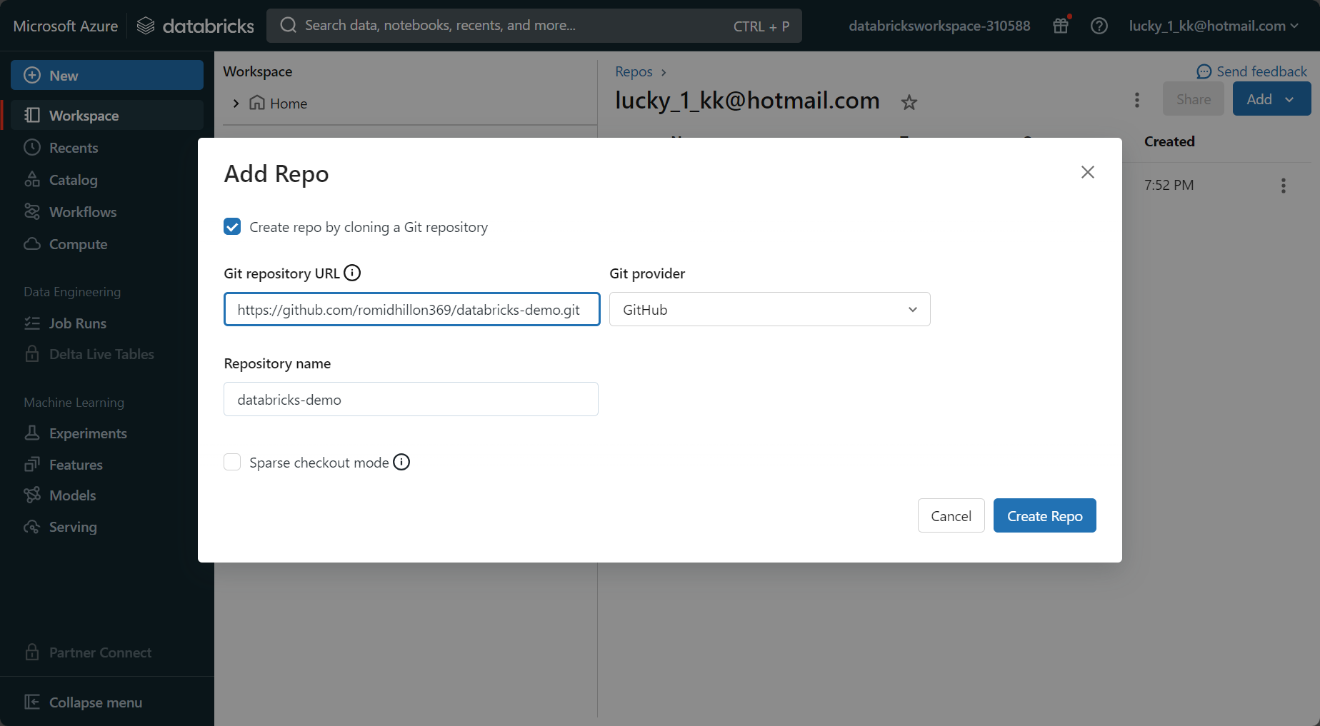

The Github repo will now appear in databricks as well.

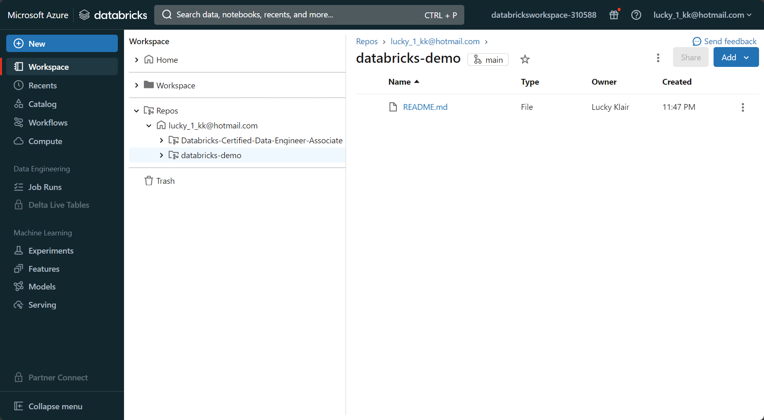

You then click on ‘main’ and then ‘create branch’. Lets create a branch named ‘dev’ and click ok.

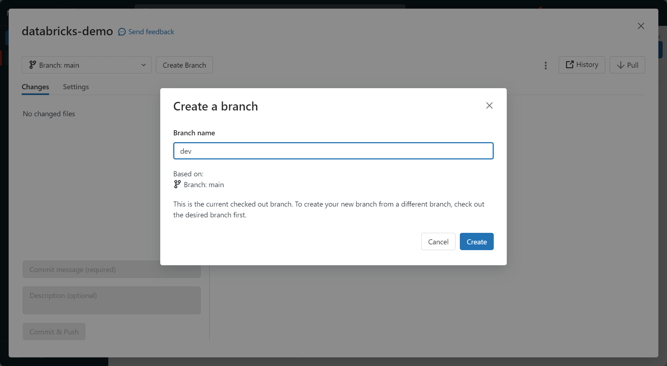

The branch will switch to dev, however, we can always switch back to main when we want.

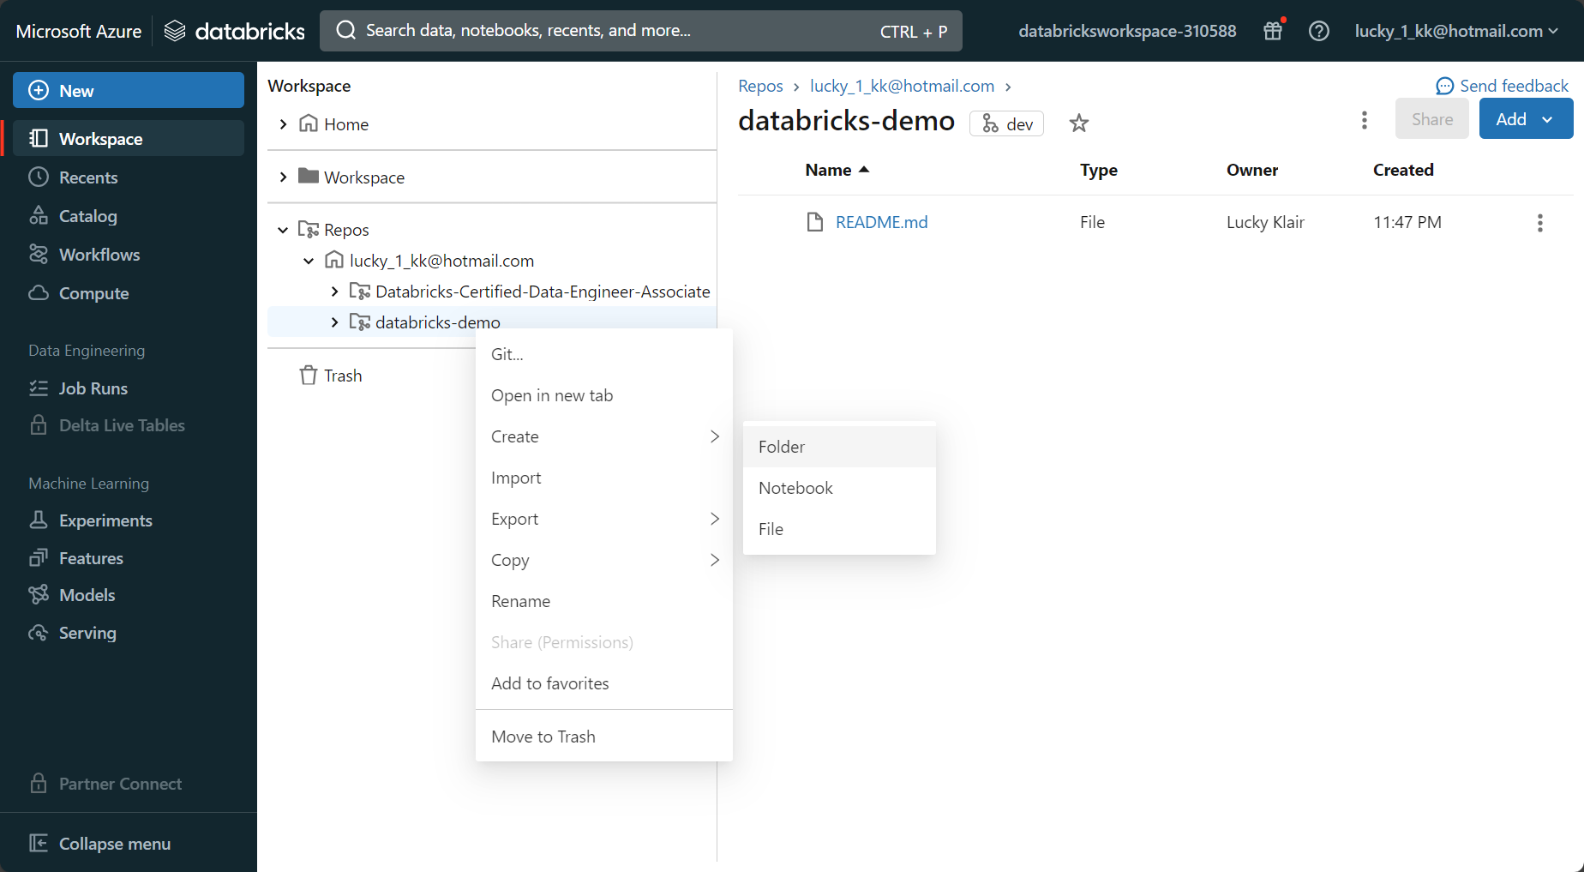

Inside the github repo (situated inside databricks), I will create a new folder and a notebook within that folder.

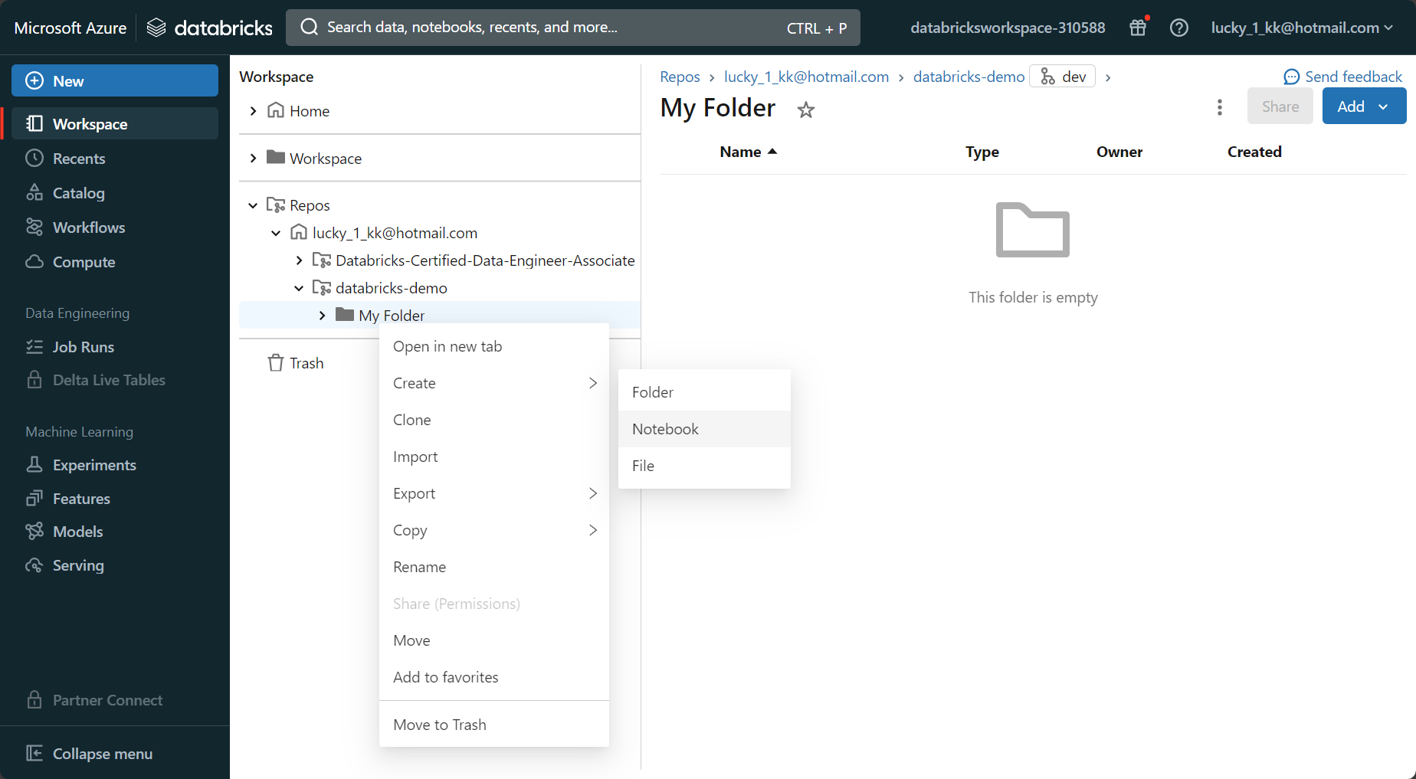

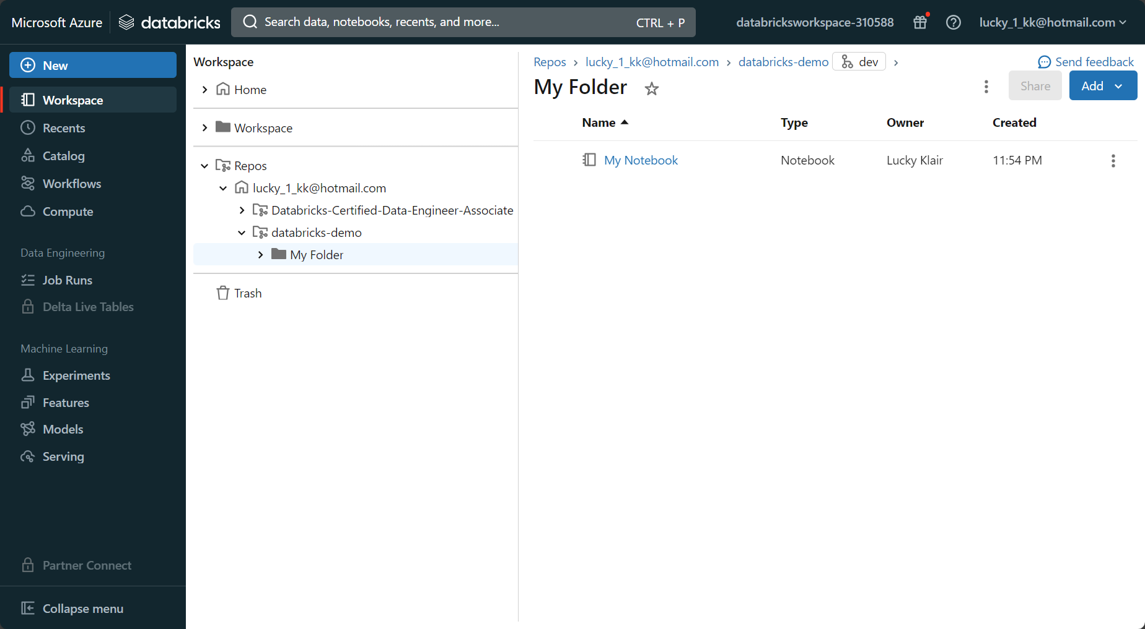

You can import a notebook into the repo, or alternatively, I can clone existing notebooks from my workspace into the repo like this:

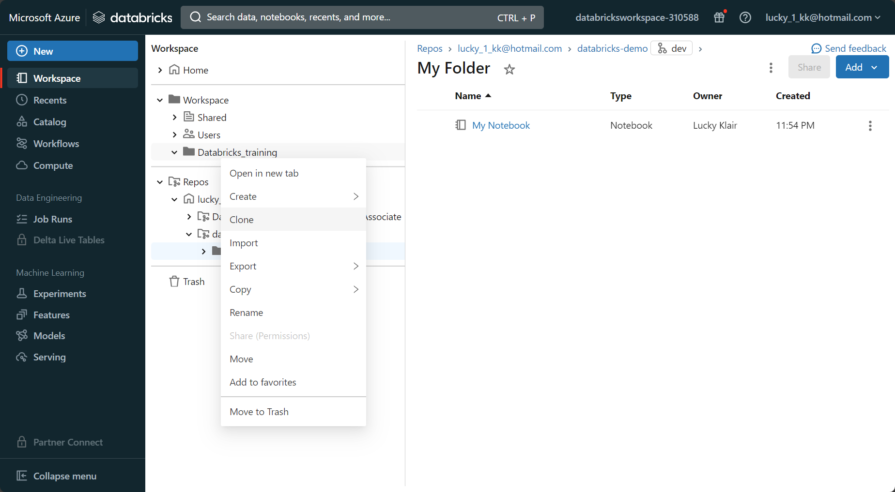

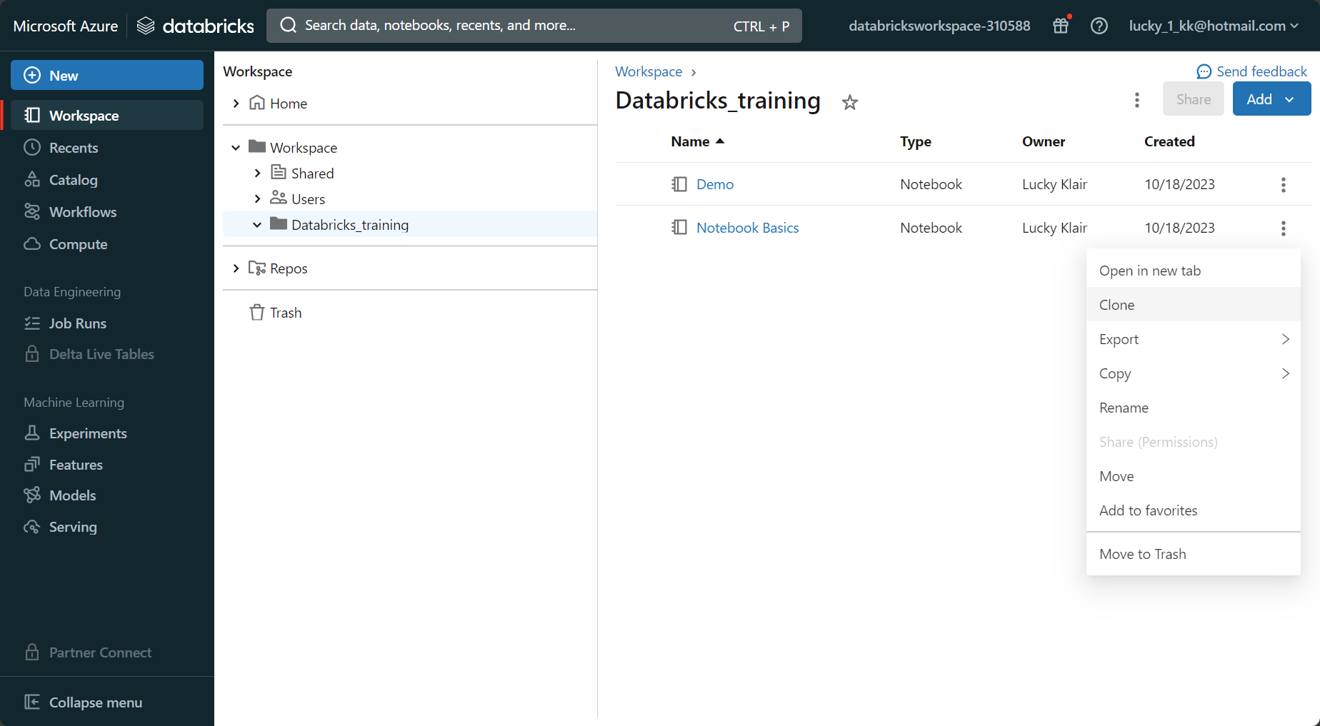

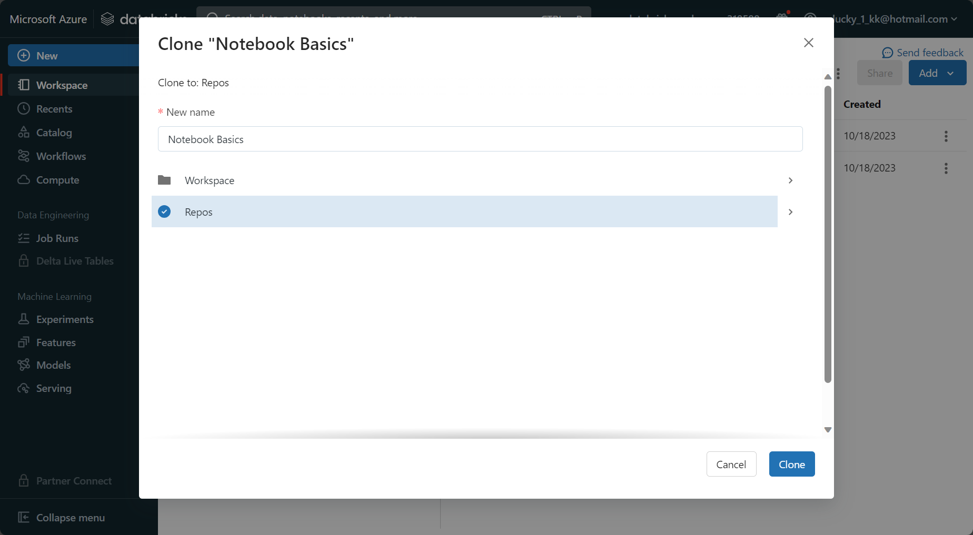

I want to clone the notebook to ‘repos’ and then into my folder within the repository that I want.

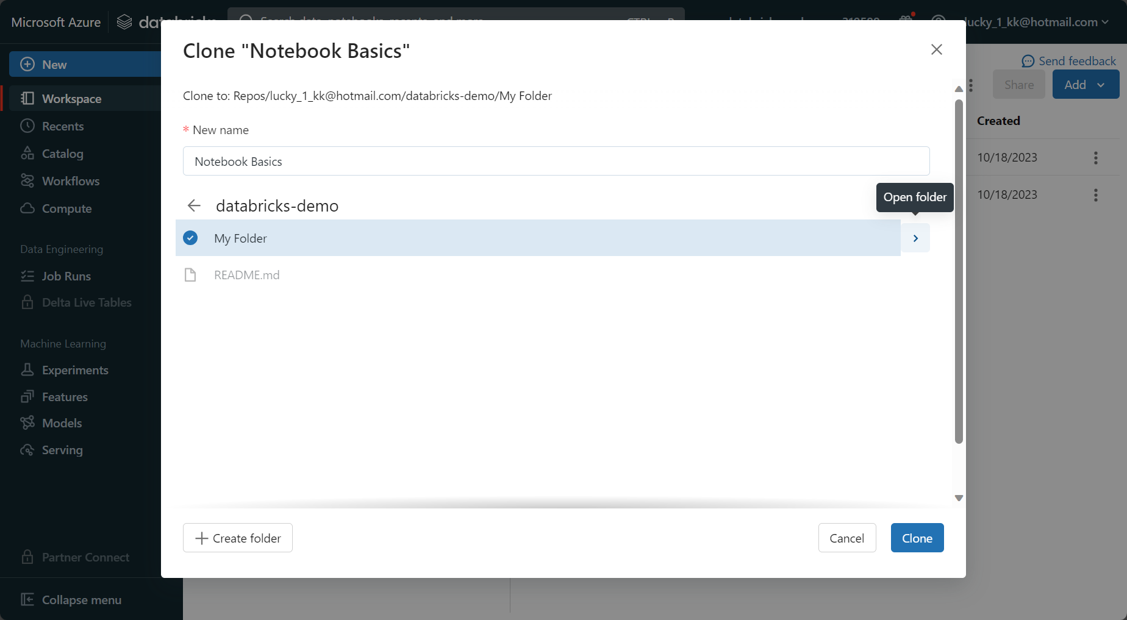

We can now see that the notebook basics file is inside the repo.

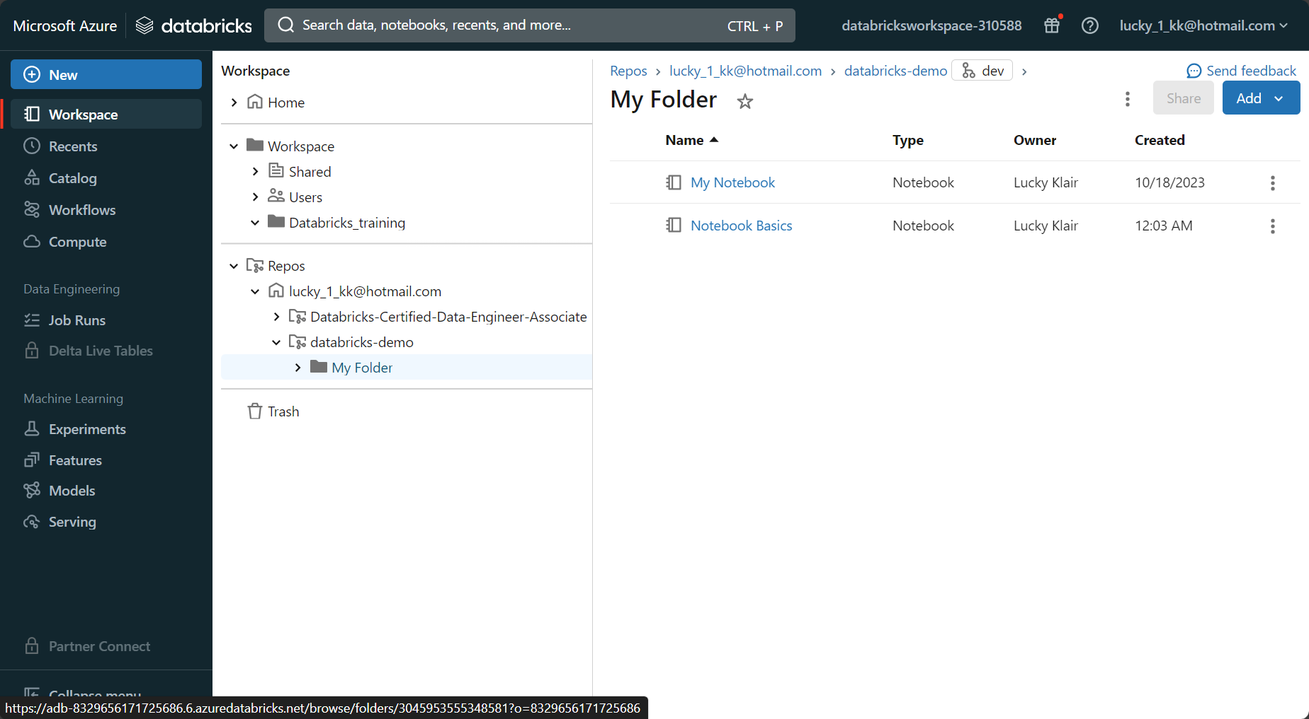

Now that these changes have been made, we want to commit and push these changes to GitHub. We click on the repository name in databricks and then click on dev.

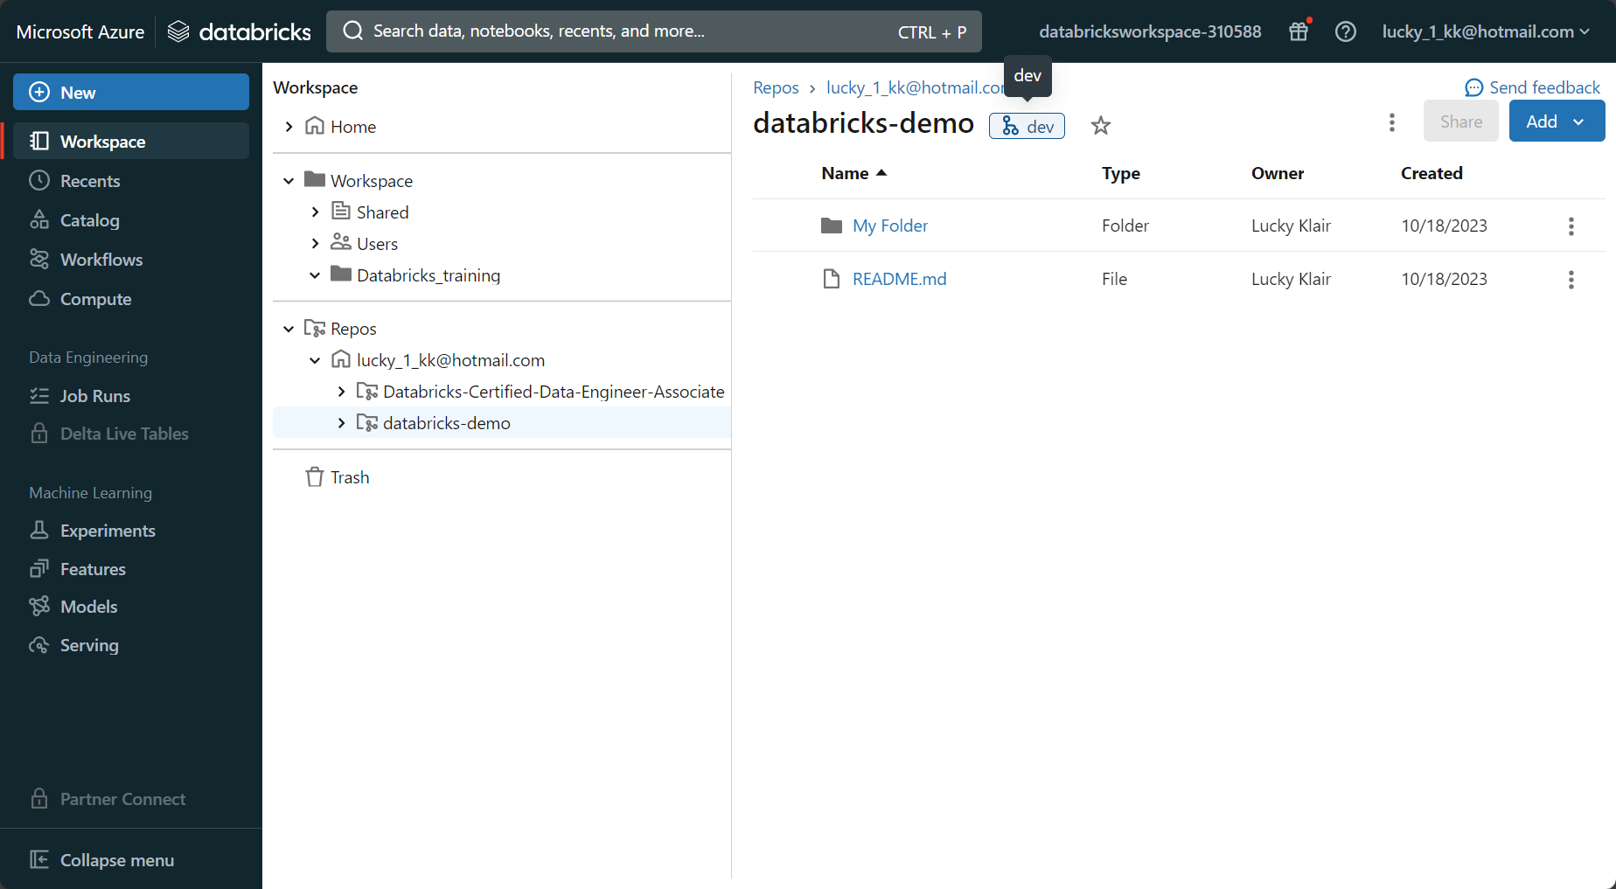

You write a commit message and then push the changes.

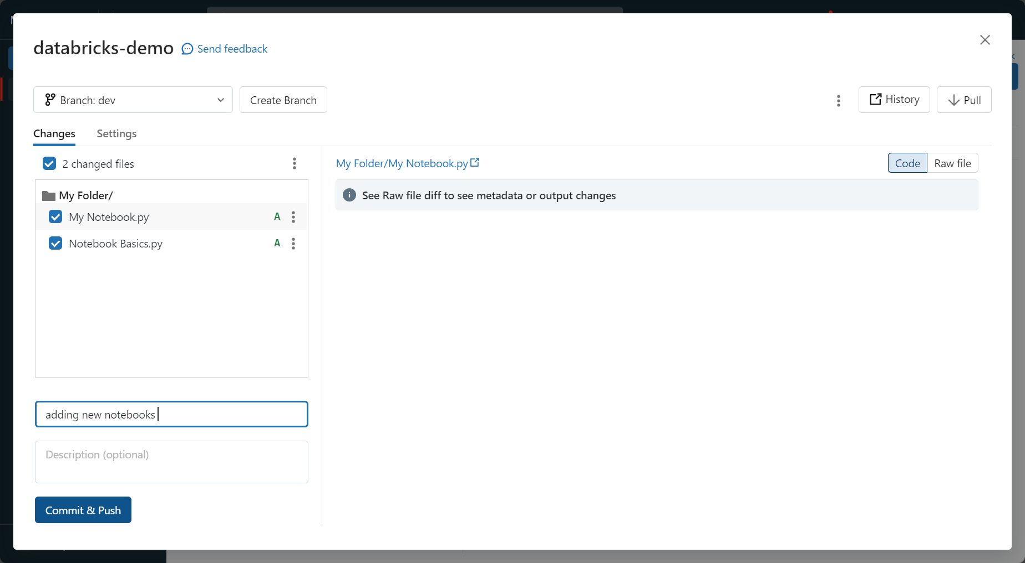

Now that notebooks/code has been pushed to the dev branch, you still wont be able to see it in the main branch. In order to see it in the main branch, you have to go to GitHub and switch to the dev branch within the repo.

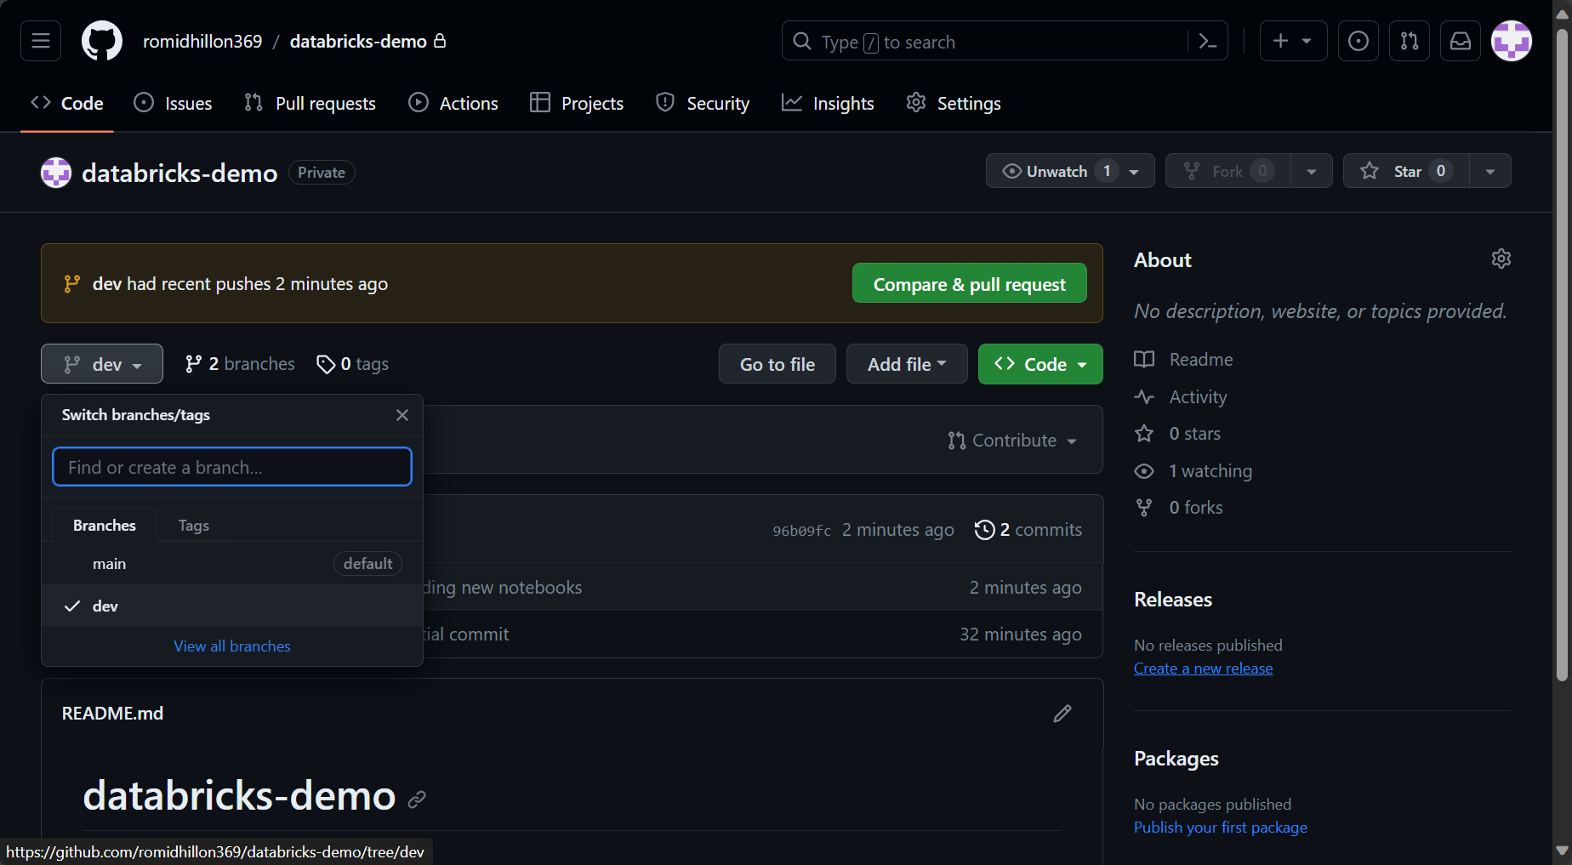

You then click on contribute and open pull request.

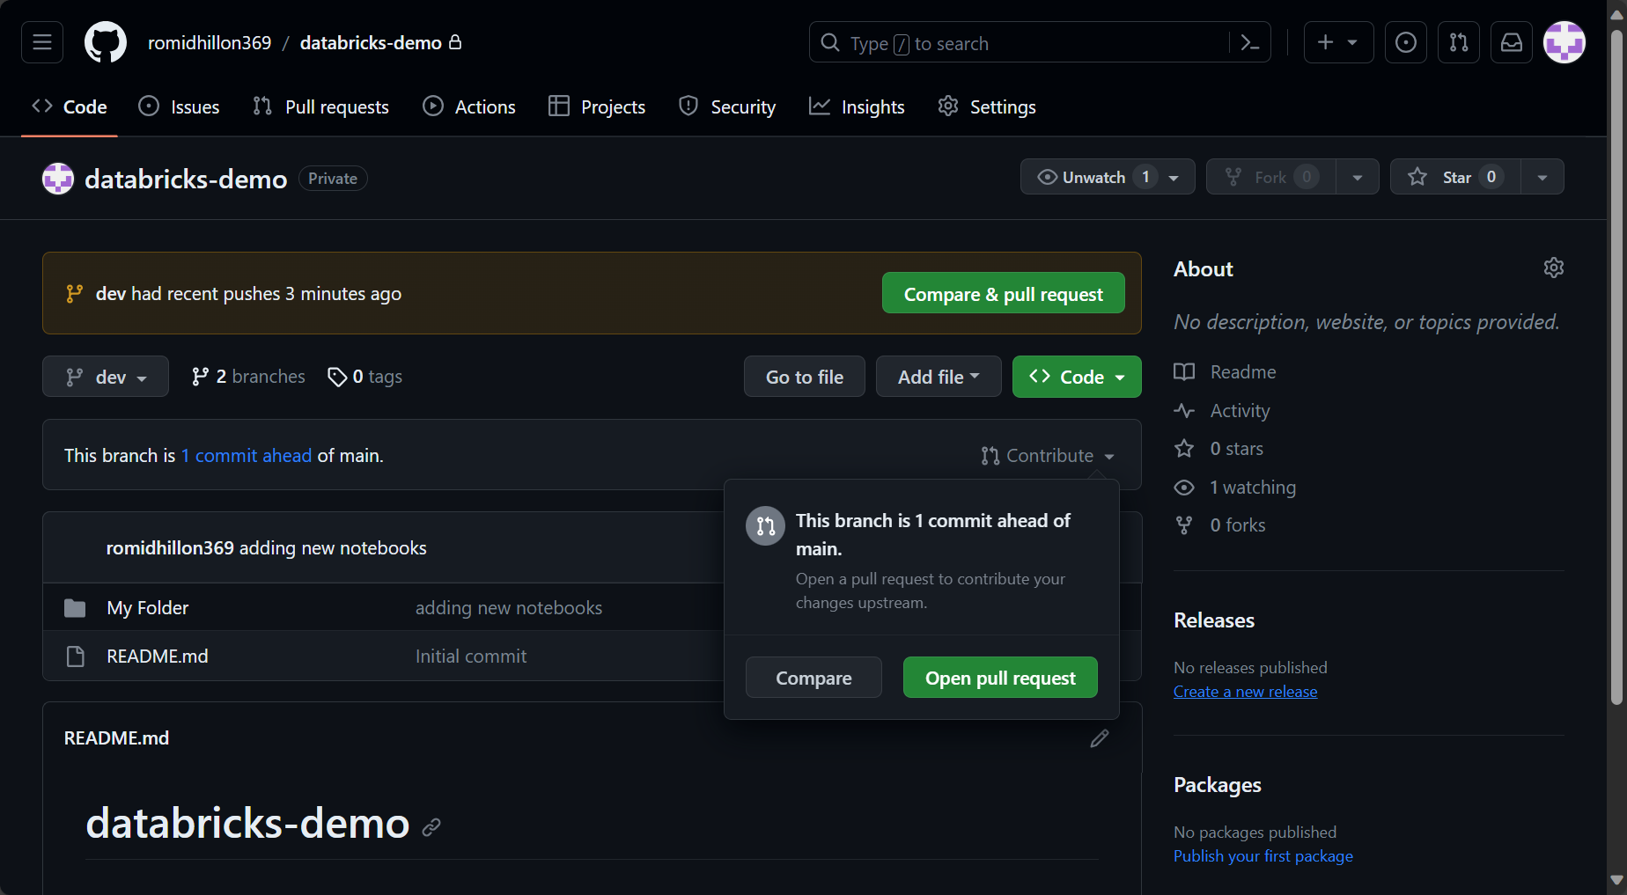

Then click create pull request.

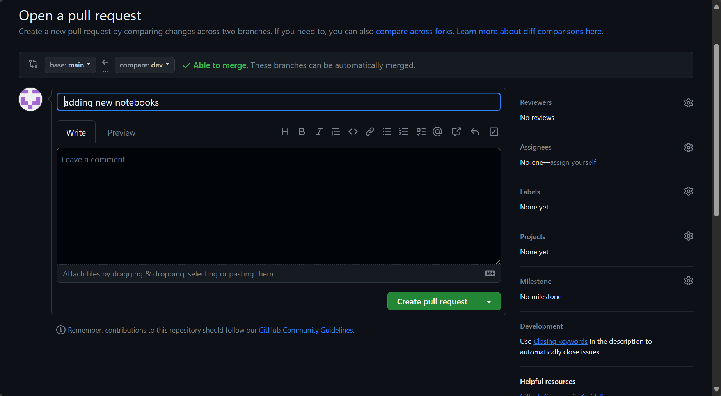

Then merge pull request and confirm merge.

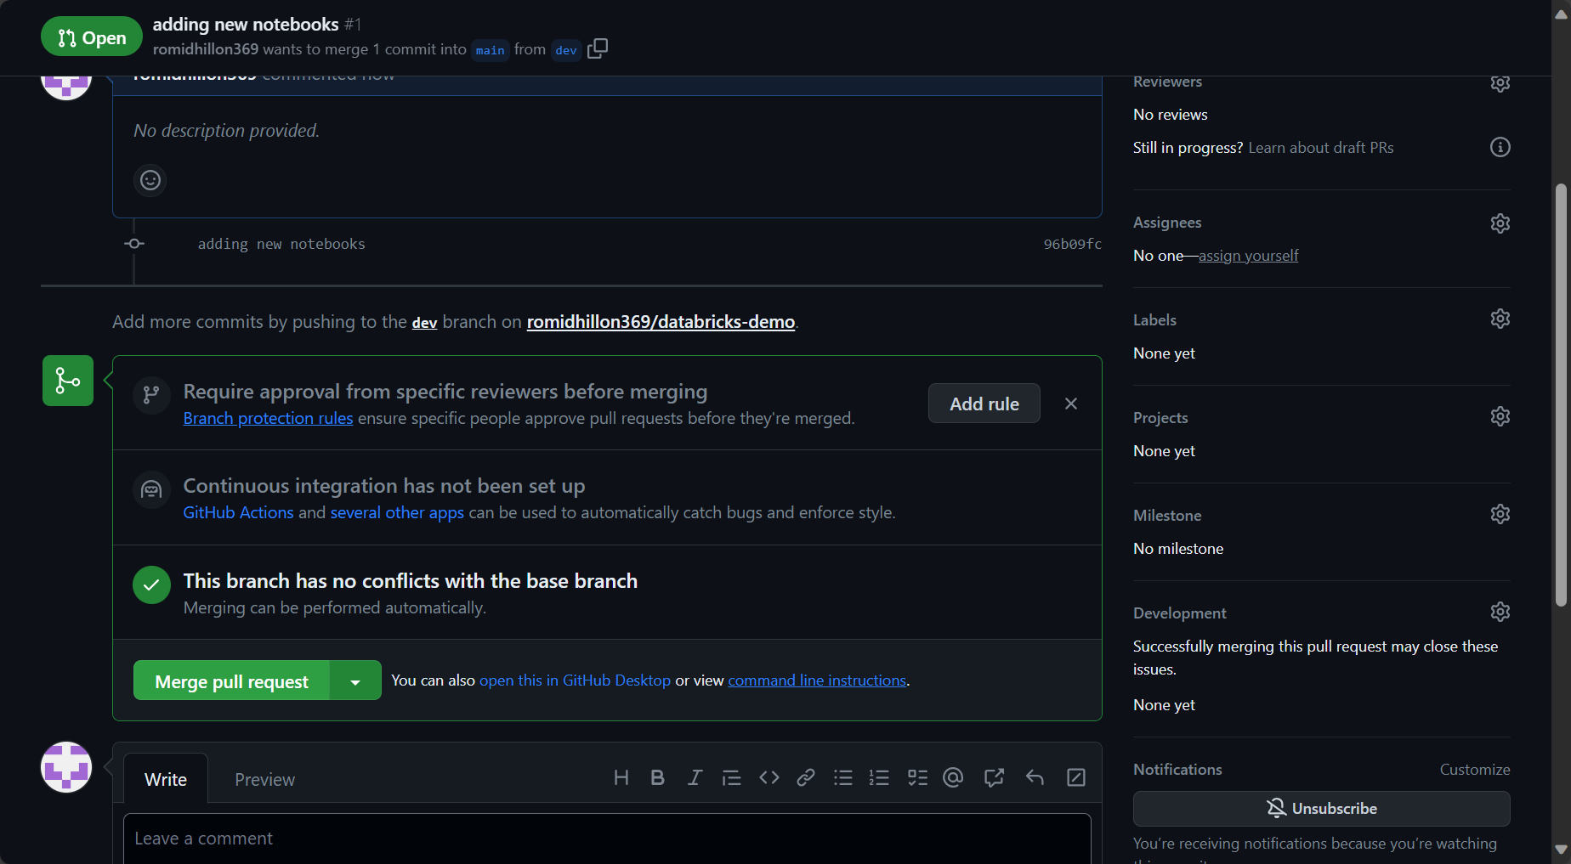

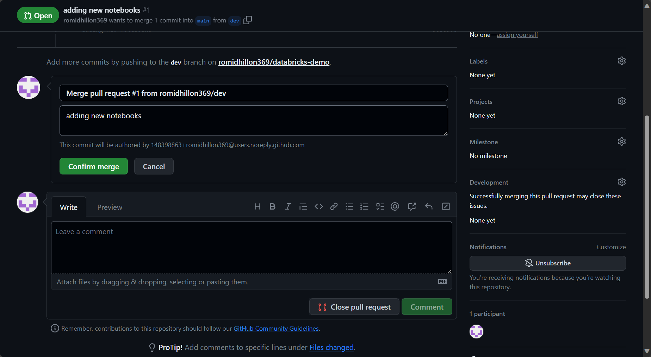

Now in databricks, go to the main branch in the repo and then click pull in the top right. Then click confirm when prompted.

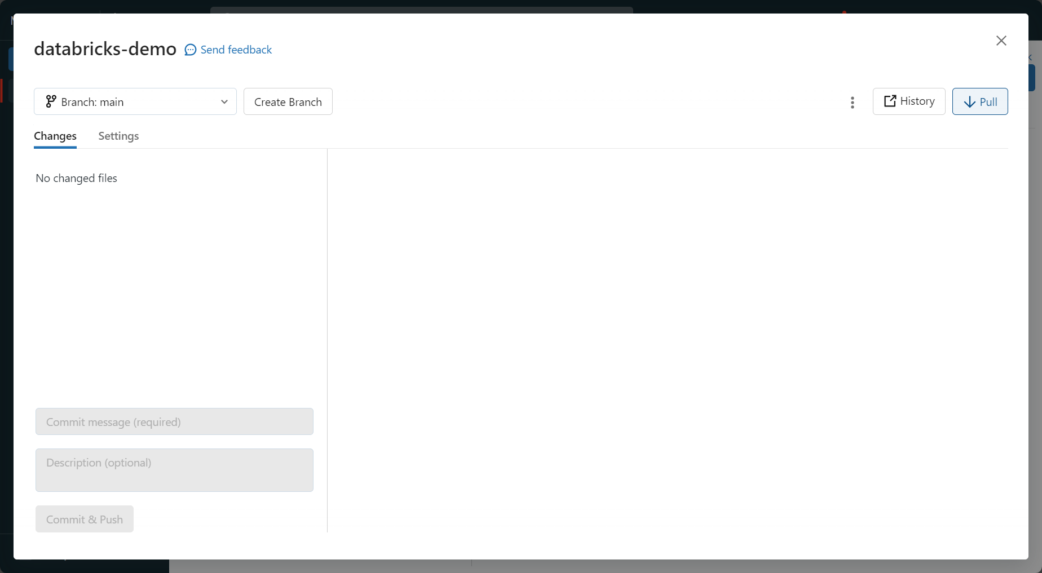

The notebook that was pulled from the dev branch to main branch can now be found in the main branch. This confirmed that the above worked.

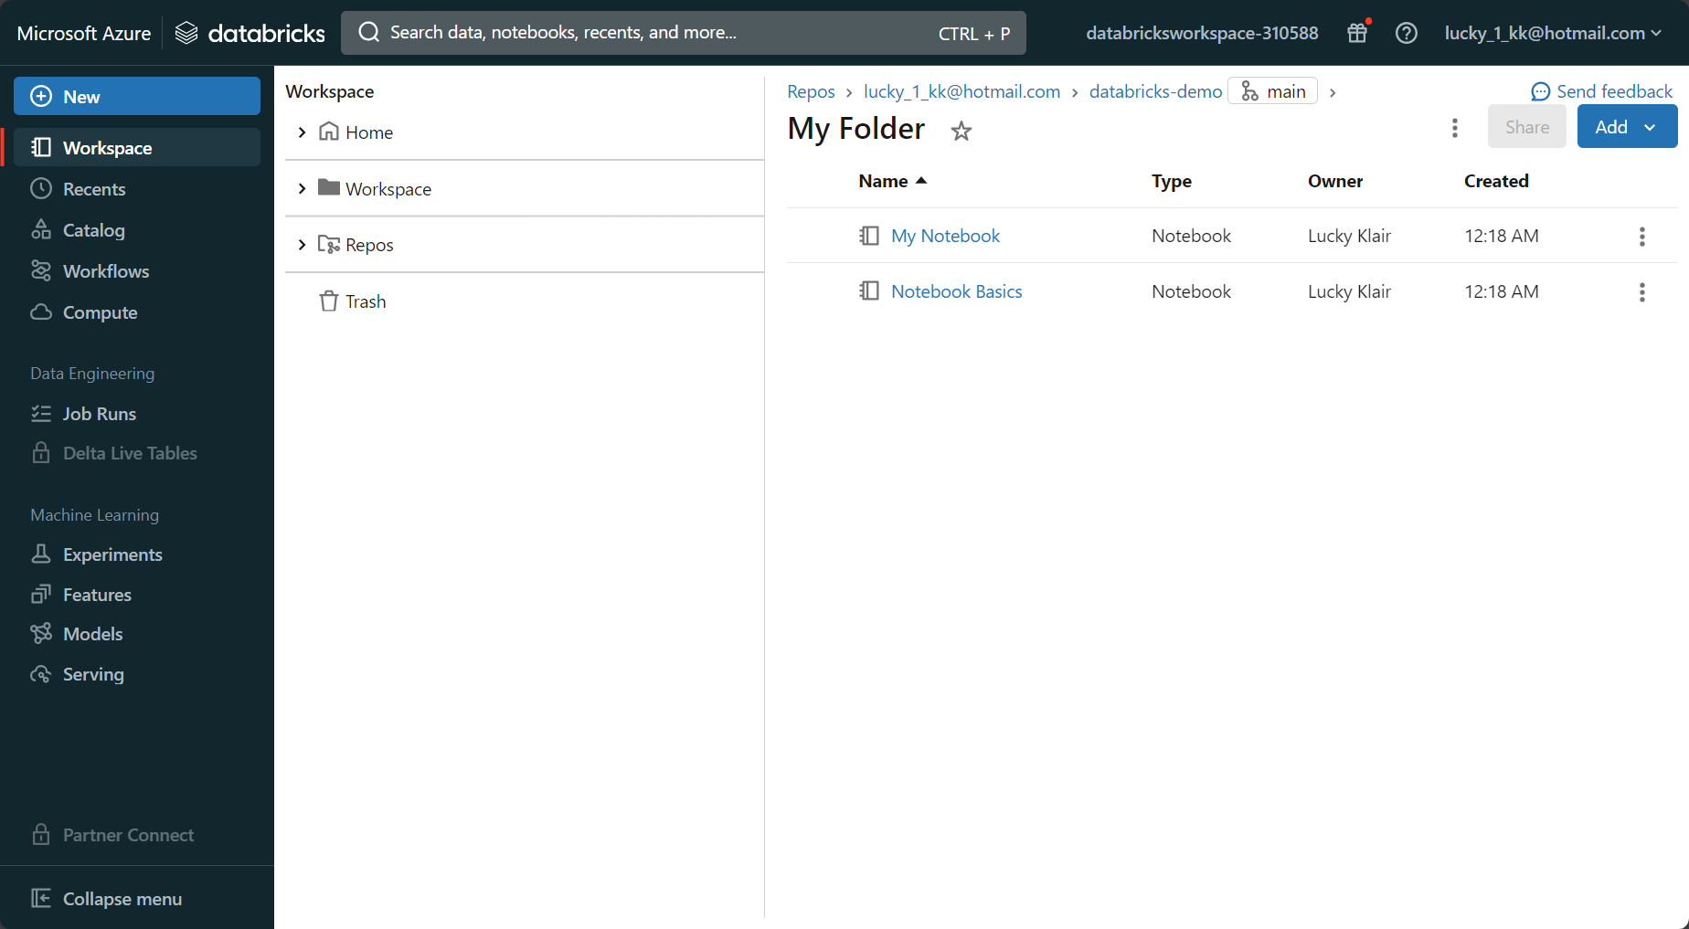

Delta lakes

An open source storage framework that brings reliability to data lakes. Delta lake is not a data warehouse and is not a database service, and it is open source, storage framework (layer), which enables the building of a lakehouse. It is deployed on the cluster as part of the databricks runtime.

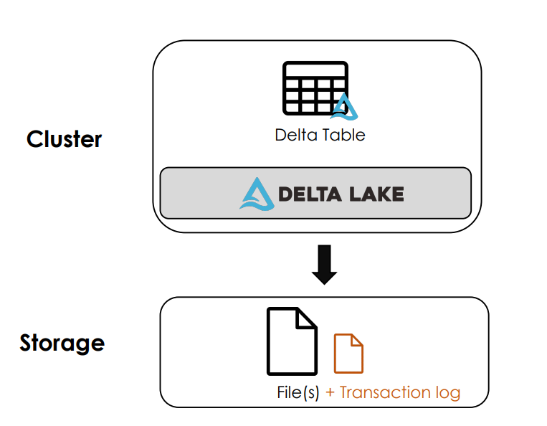

Delta lake has a transaction log built in which…..

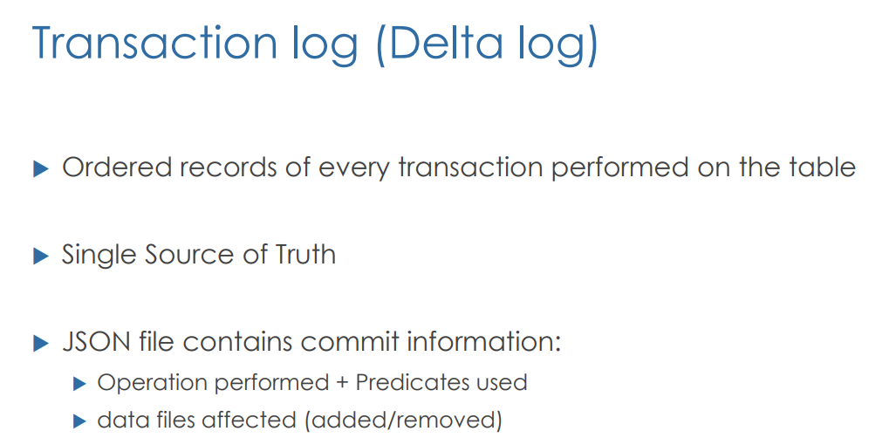

Each time you query a table, spark checks the most recent records to query the data. Each committed transaction is recorded in a JSON file such as update or insert.

The way delta lake works is that there is a writer process and reader process. Once the writer process starts, databricks stores the delta lake table into delta files in a parquet format. As soon as the writer process finishes writing, it adds a transaction log and the corresponding JSON file into the delta log directory. A reader process always starts by reading the transaction log, and it reads the JSON file, which contains information about files 1 and 2. So to reiterate, when the data is written, a parquet file gets created as a delta file, and a corresponding JSON file is stores in the delta log directory. The transaction log is linked to the parquet file and the JSON file, so the reader will read the JSON and knows the relevant parquet file that is also linked. In this way, the delta lake architecture always has the latest data.

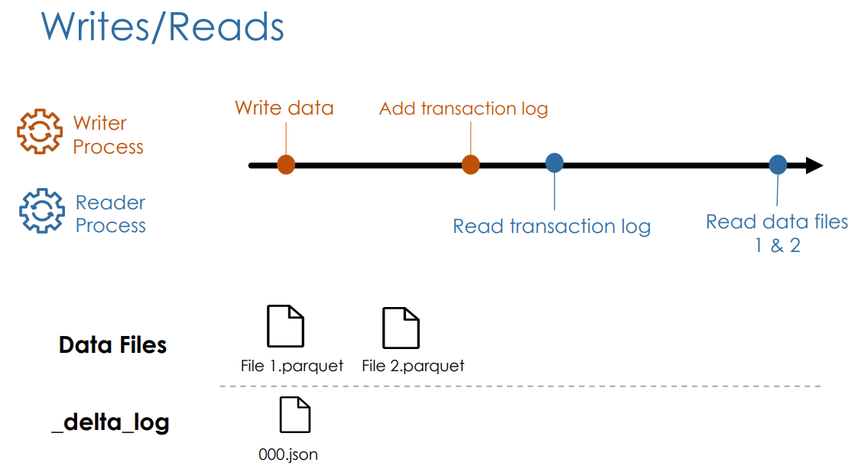

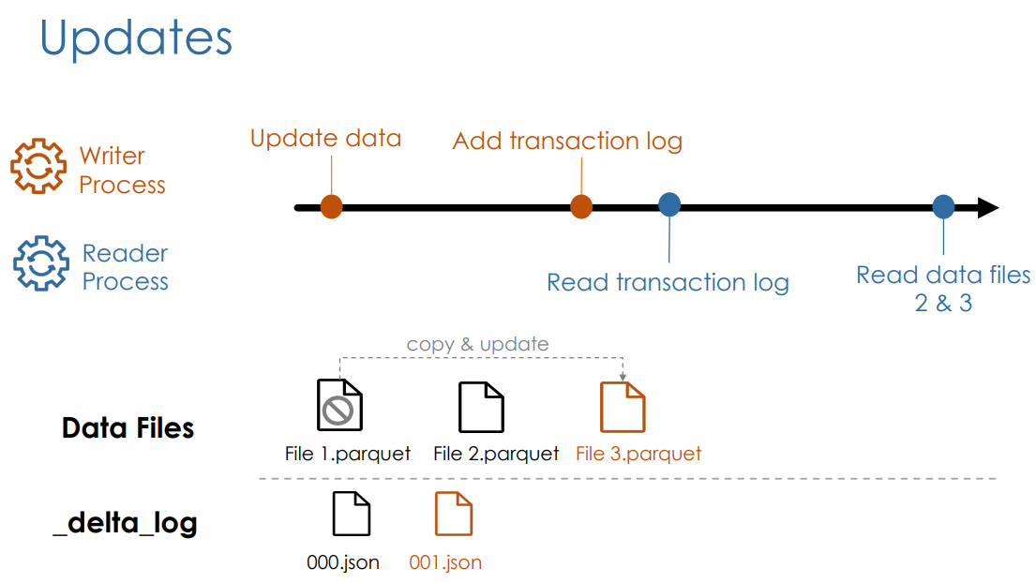

In the second scenario, the writer process wants to update a record that is in file number 1. It makes a copy of file 1, make the updates in file 3 and get rid of file 1. It then updates the log by writing a new JSON file. This new log file knows that file number 1 is no longer needed. The reader process now reads the transaction log, that tells that only files 2 and 3 are part of the current table version. It can start reading the latest data. This leads to the following advantages:

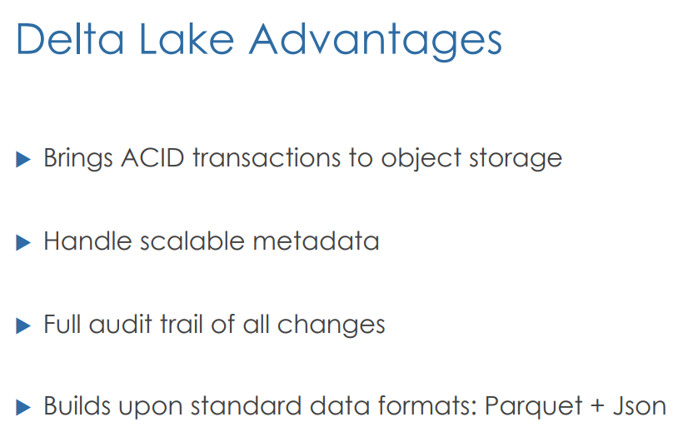

**Understanding Delta tables**

You can create tables in the same way that you create tables in SSMS. You have a statement (create table), the table name, and the schema, which is the id, name, salary, along with data types. Delta lake is the default format, and you don’t need to specify anything regarding delta.

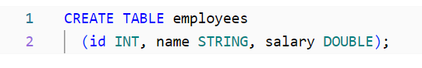

You can then insert values into the table

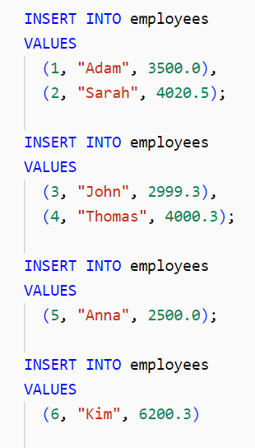

Now that the table has been created and the values have been inserted, go to the catalog tab and look inside the default folder within hive_metastore. You will be able to see the table named employees.

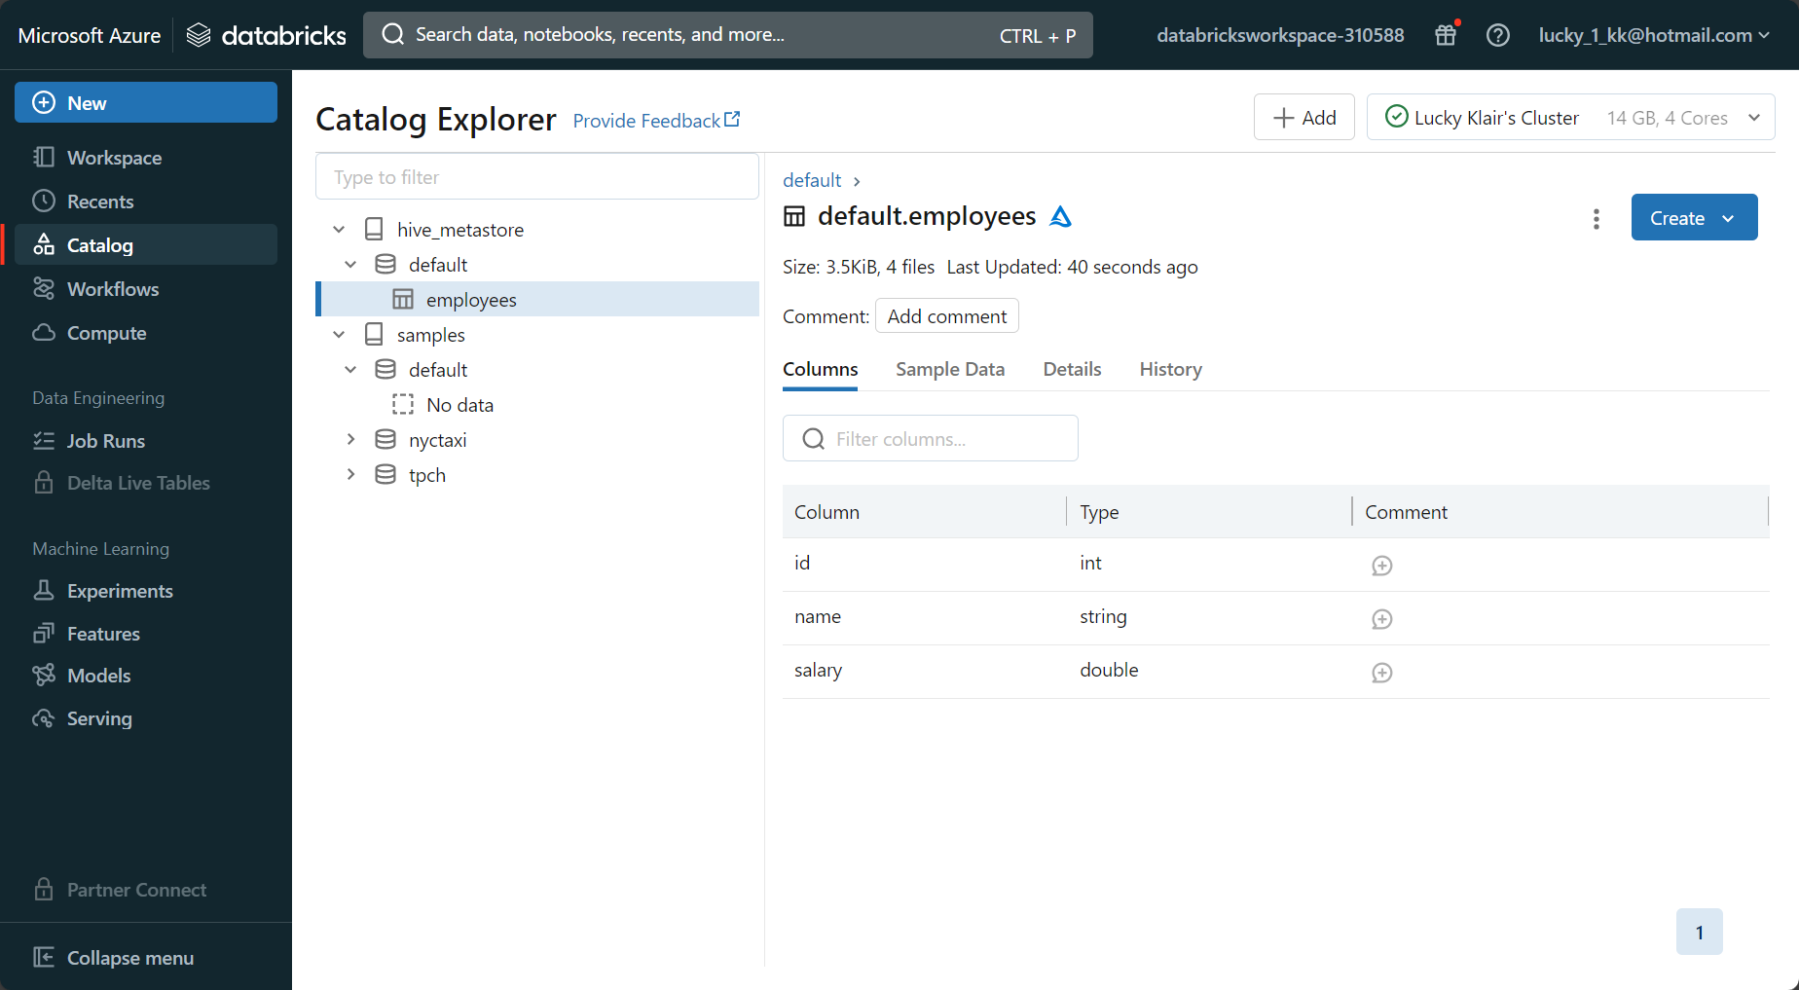

The describe detail command is an important command to explore the metadata associated with the table:

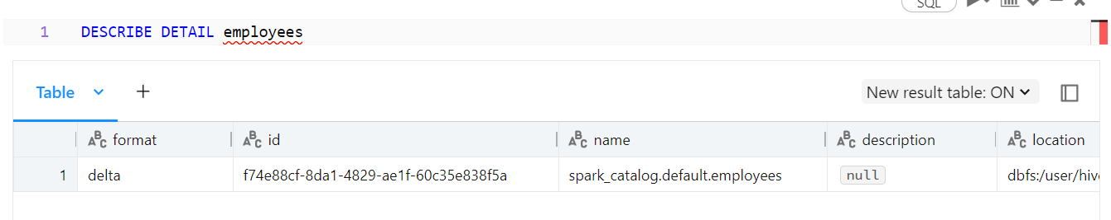

Lets take the location URL and put it into the fs ls command. You can see the files in that location

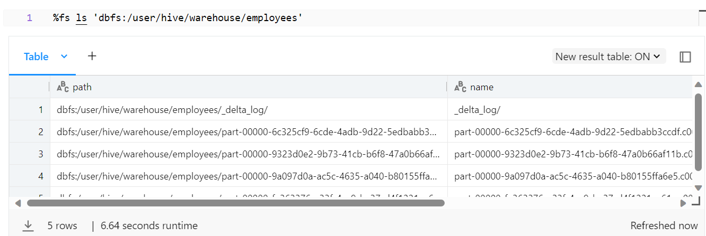

The directory contains four parquet files. Spark works in parallel, so you can see that the cluster has 4 cores, so there were four executers working at the same time, to insert the six new records into the table. This is why there are four parquet files in the path, as four cores were working on it, each taking on a chunk of the workload.

Updating tables

Let us now update the table to add the salary of 100 where the name is like A. The number of rows affected are two rows.

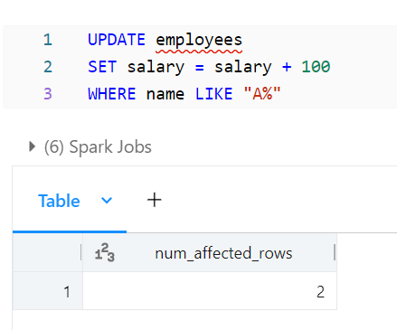

Lets now look at the file path again. There are now 8 files rather than 6 (like before). Databricks has simply copied the original files that needed changing and created a new parquet file for it with the updated information. The log contains the parquet information, however, only databricks knows which files are the latest version.

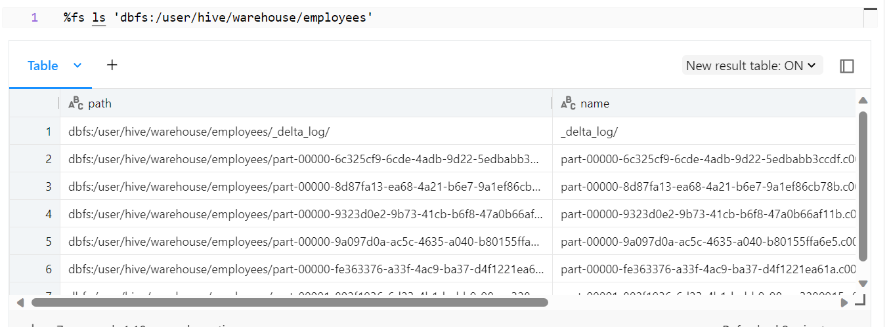

If we look at the number of files through describe, we can see that it is still 4 and not more than that.

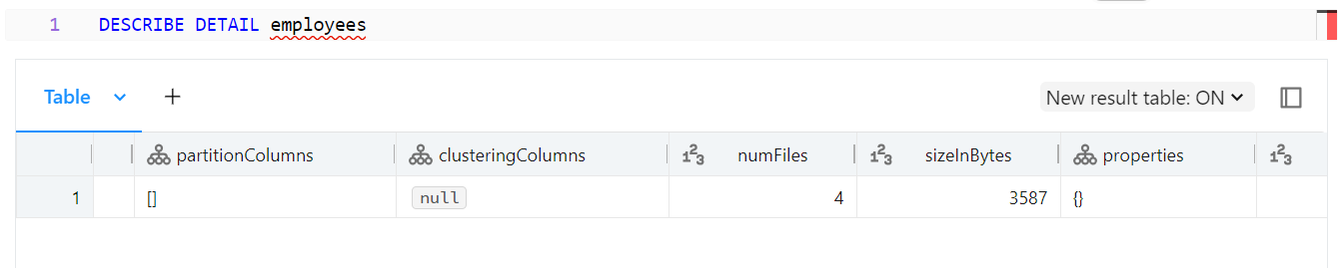

If we select the rows again in the table, we can see that databricks has used the transaction log to update the table for the two relevant rows.

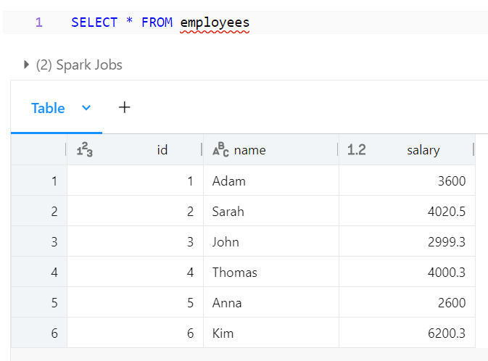

Thanks to the transaction log, we have a history of operations that have taken place on the table. This can be accessed with:  
  
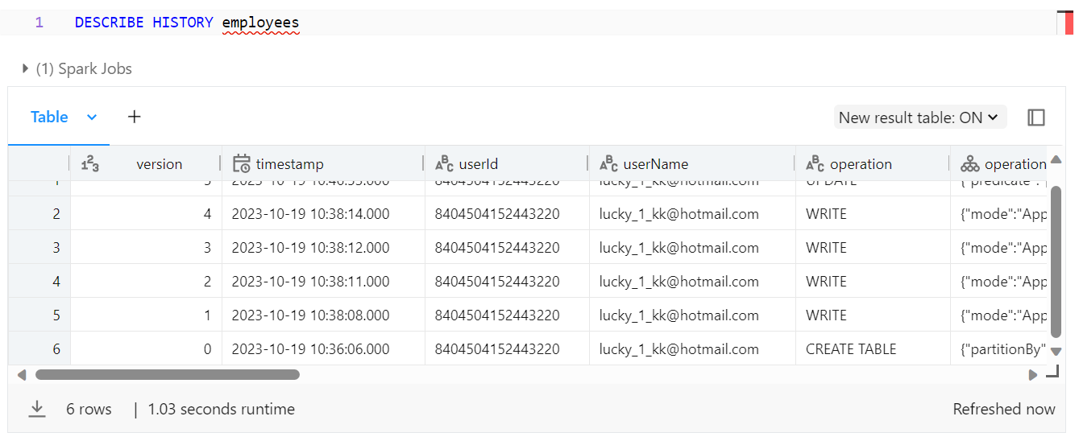

The transaction log is located in the delta_log table within the directory. Each new transaction is a JSON file being written to the transaction log as seen below.

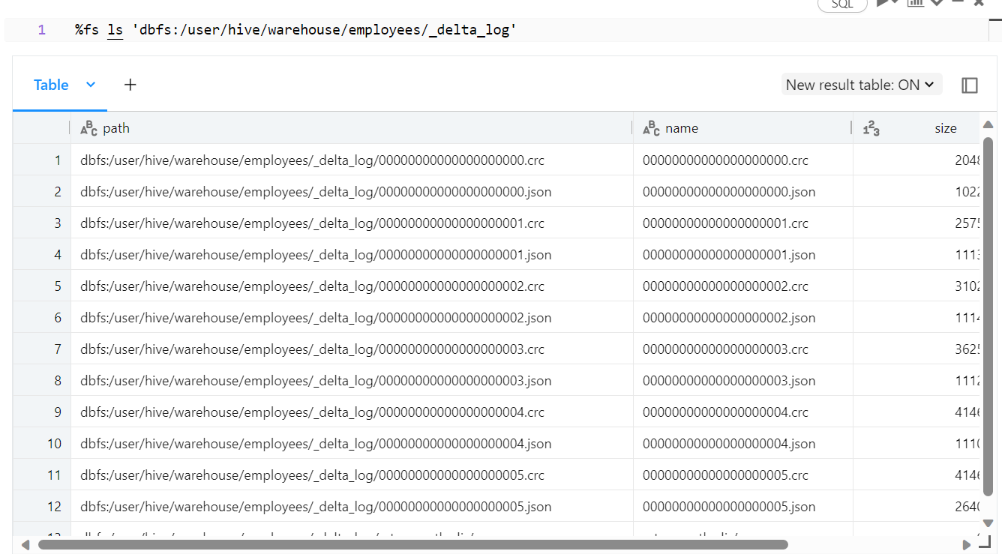

So, to make it clear, the path where the parquet files are stored is the following



The path where the transaction log is located is the following.



We can put in a command to check the file itself, the one where the update has been made. We can see that there has been the removal (soft delete) of rows, and there has been the additional of other information.

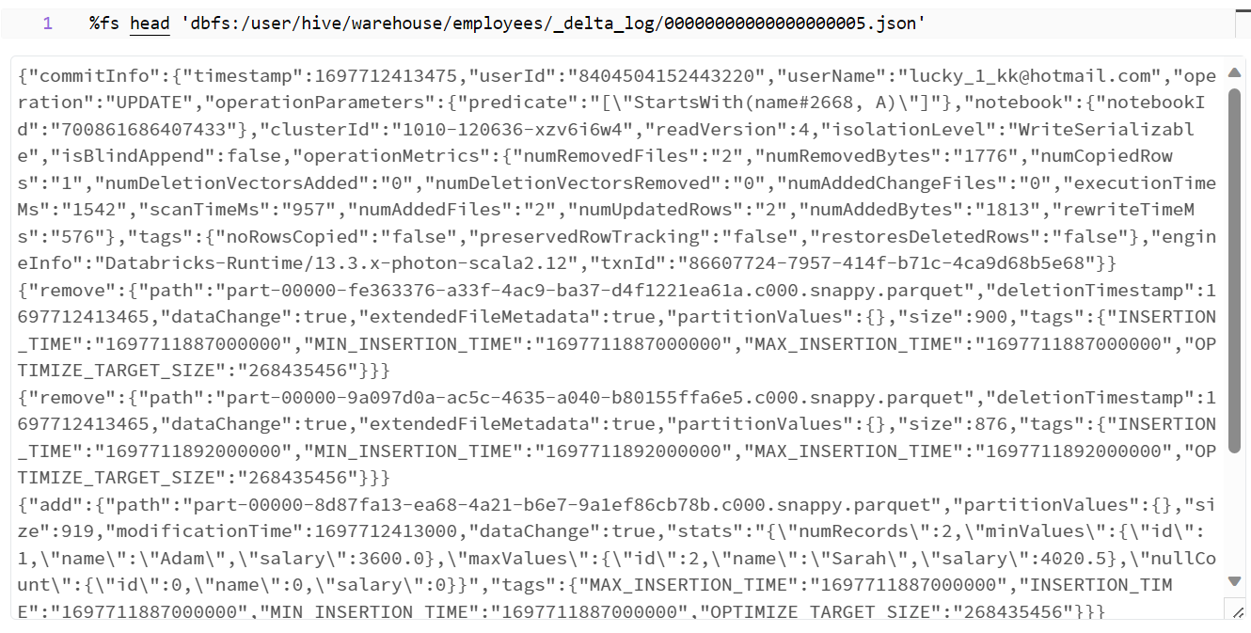

**Advanced delta lake features**

You can do time travel on tables. Every table is versioned automatically. By using the command below, you can see each version of the employees table and relevant information.

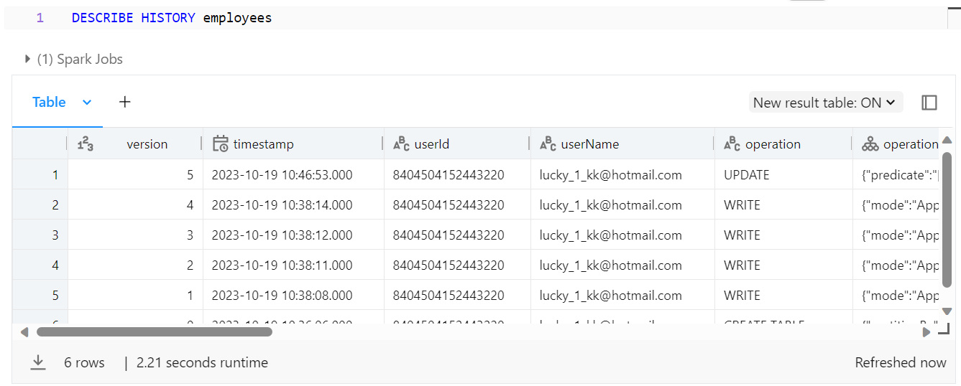

You can query different versions by using two different methods below, one is ‘timestamp as of’ and the other is ‘version as of’. So you can query a table based on a date or a version.

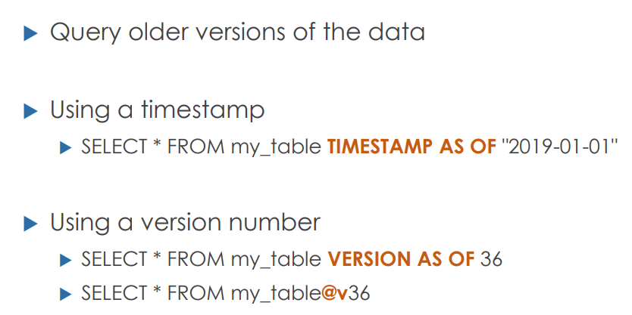

A practical example of this is shown below:

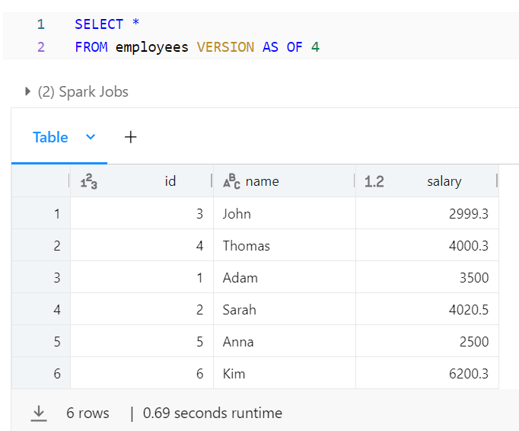

Another way of doing this is:

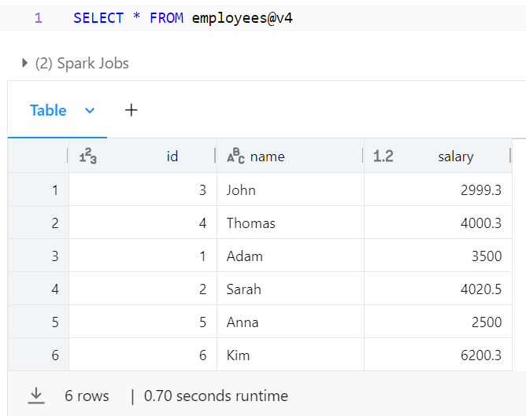

You can also roll back versions so that you can reinstate tables to previous versions:

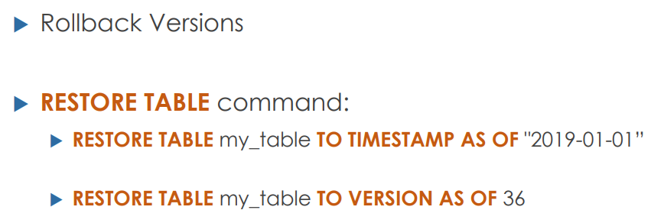

So, if we delete the employees table as below:

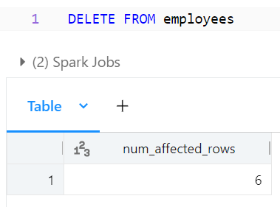

We can then restore the table as below back to version 5:

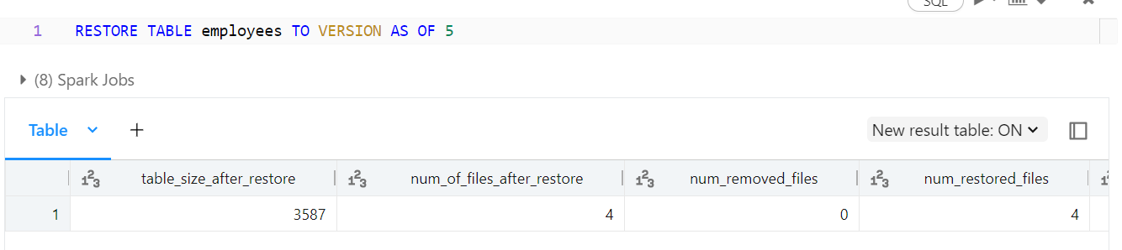

After restoring it, in the describe history of the table, you can now see that the table was restored as the last operation.

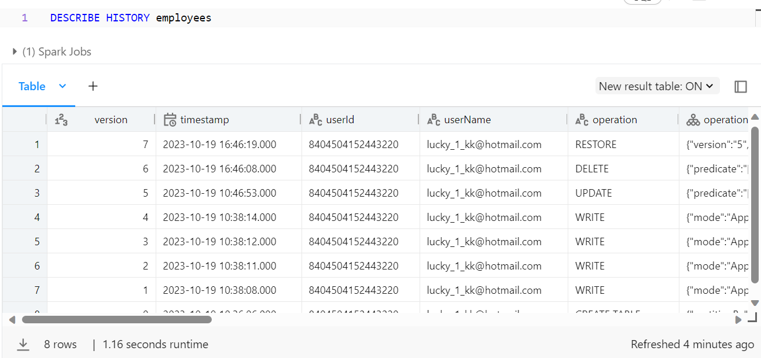

Compaction

This is about compacting small files. Delta lakes can improve the speed of reading queries for a table by compacting many small files into fewer larger files as shown below. This is done with the optimise command.

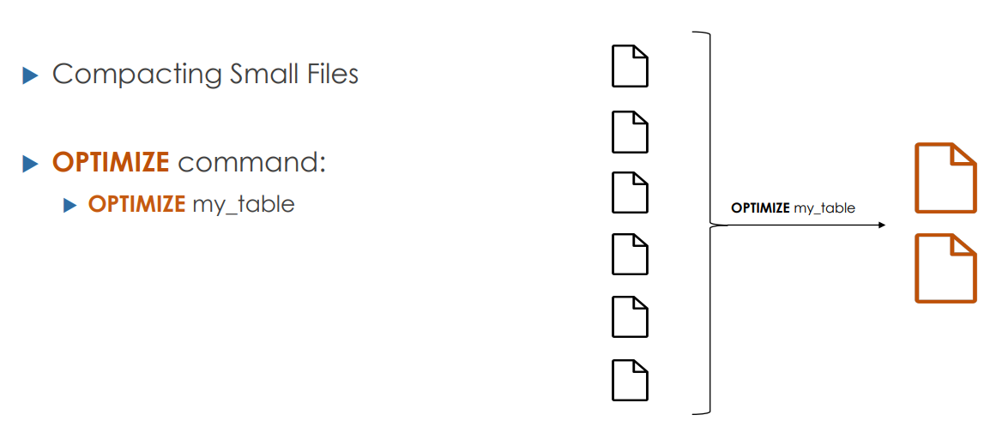

With the optimise command, you can also perform z-order indexing to improve performance.

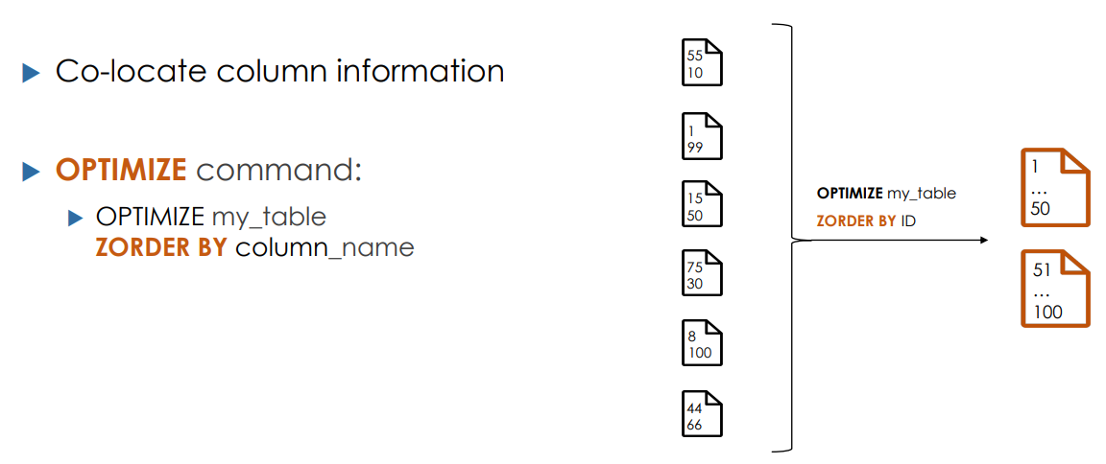

Lets say that there are 6 files, which contain column data for product id from 0-100. Lets say that this data is stored in 6 files by databricks, by optimising using z order, we are putting the column data into two files rather than 6, and the id’s 0-50 are in file 1, and 50-100 are in file 2. If a user queries product id 30, then databricks knows to look in file 1, and will even need to look in file 2. This makes it a lot quicker, as databricks only needs to look in file 1, bypassing the need to search through 50-100.

Vacuum

As databricks has a transaction log which copies files to update tables and then stores the new files, a big backlog is created of previous parquet and JSON files. Databricks has an option to clean up the historical files which are no longer needed. This can be done with the vacuum command. However, vacuuming all previous files means no time travel to previous versions, so a right balance is needed.

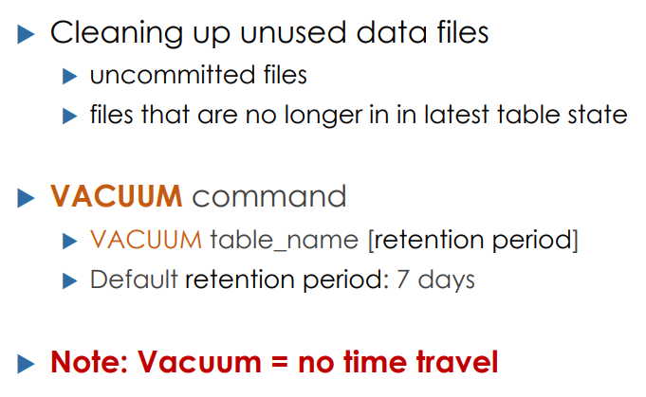

Lets now see the number of parquet files located in the directory:

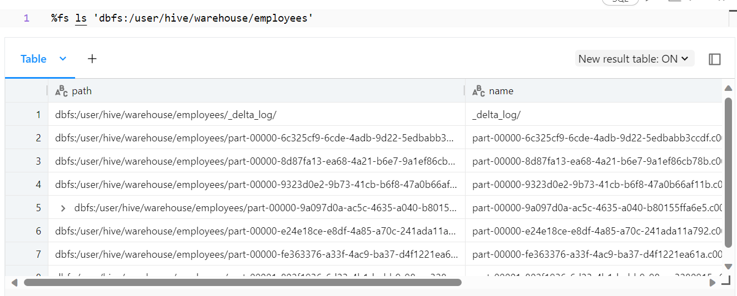

After compaction, some of the files in the directory are old files, and can be removed. We can now simply use the vacuum command.

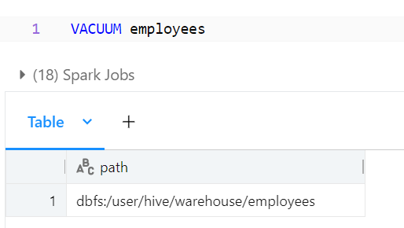

After vacuuming, notice that the files do not disappear straight away. This is due to Databricks having a minimum retention period of 7 days. If you check the directory again, the folder again in 7 days, it will be cleaned up.

Drop tables

Just like in SSMS, just can completely delete tables by using the drop tables command:  
  
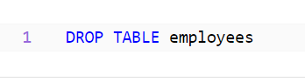

Relational Entities

In Databricks, a database is a schema in Hive metastore. You can use either commands to create a database:

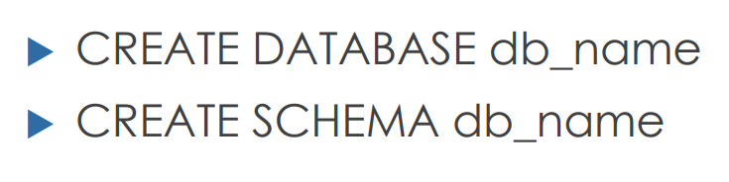

**Hive metastore**

It is a repository of metadata, which stores metadata about tables such as table definition, format of the data, and when the data is stored in storage.

The workspace consists of a central hive metastore, and within that metastore, there is a default database. You can use the create table command to create tables within the default database. The storage is linked to the workspace, and the location is specified in the image below. The storage also contains two tables within the storage file structure.

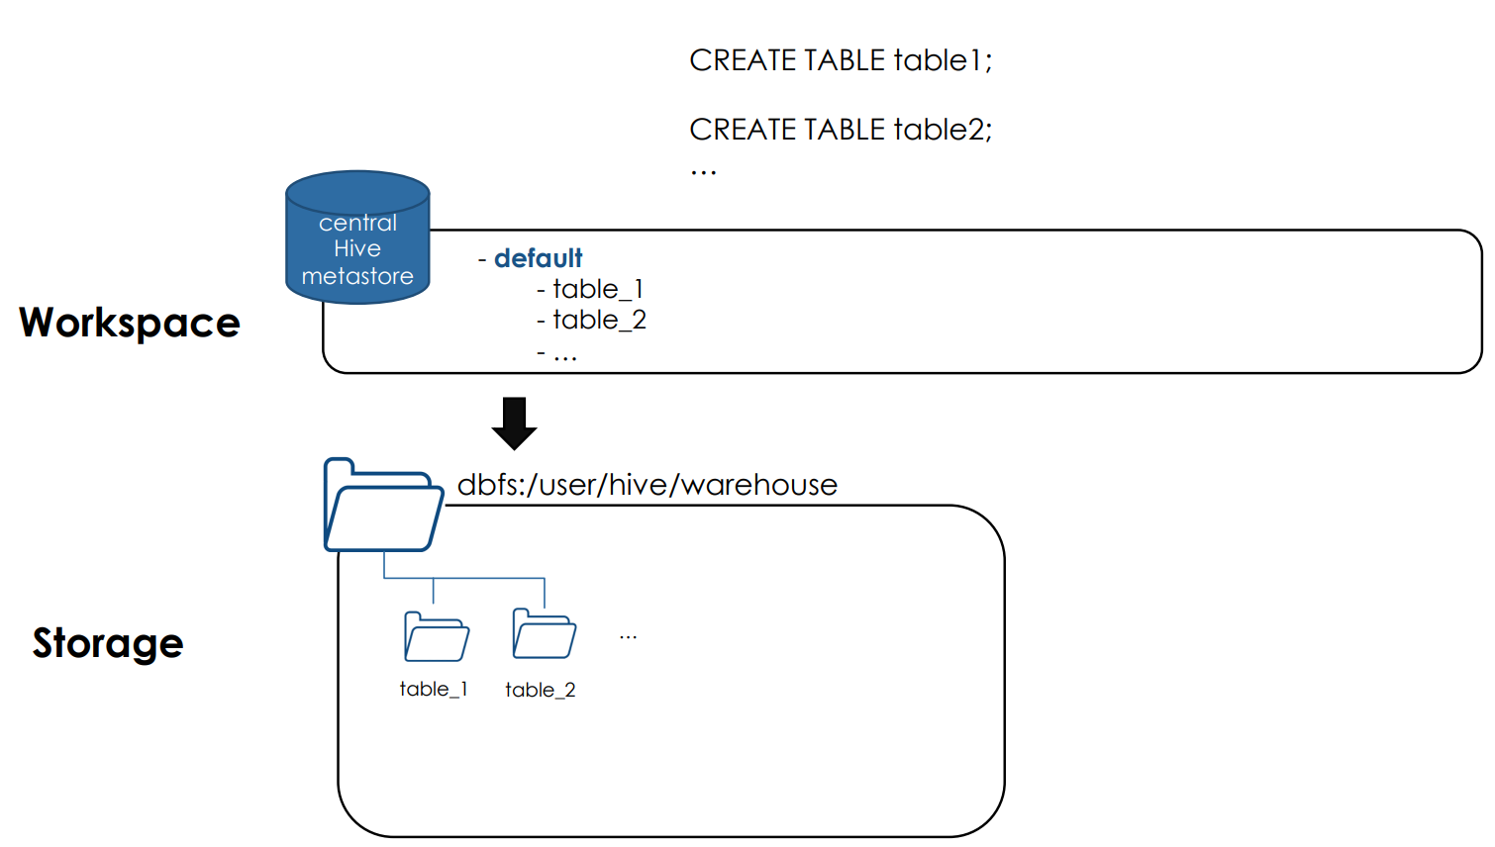

We can do not have to use the default database. We can choose to create another database by using the command in the image below, and to storage tables in that database/schema. The storage file will have an extension .db to signify that it is not the default database.

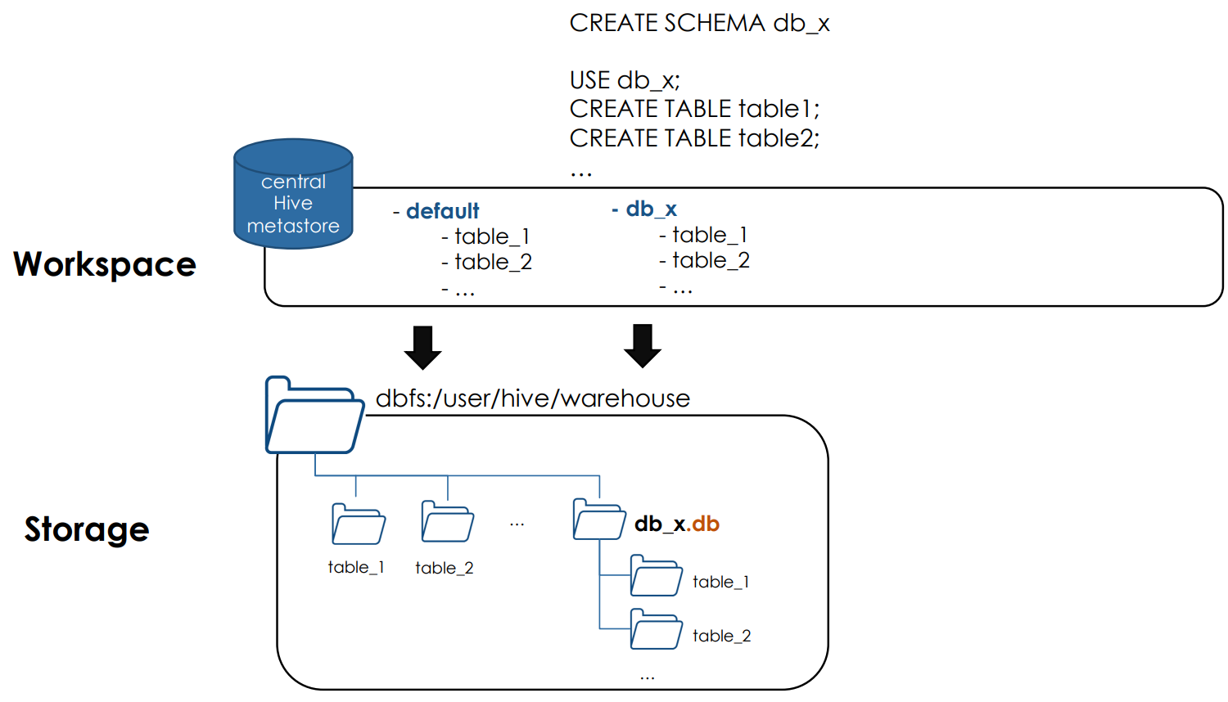

We do not even have to use the databricks storage. We can choose to store the database files in a custom schema linking it to another system by using the location command as below.

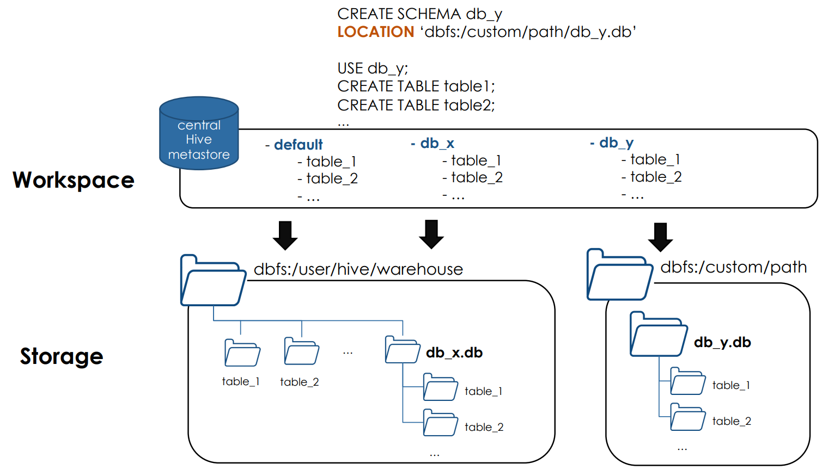

Managed tables vs external tables

Managed tables are considered those tables which are created in the central hive metastore AND the hive storage. However, external tables are considered those tables which have metadata in the central hive metastore AND have a custom storage outside of the hive storage. When managed tables are dropped, the table storage files also automatically get dropped. However, if the external tables get deleted (dropped), then the external table files will not get deleted in the external storage.

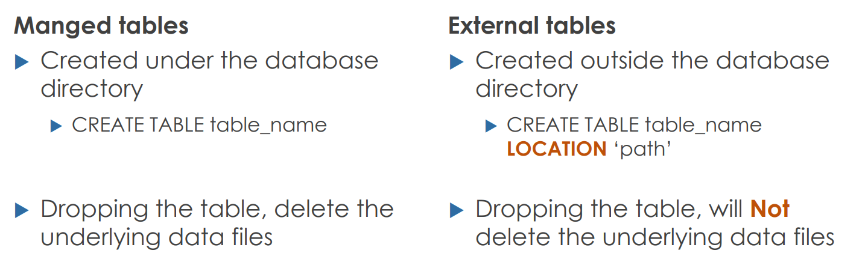

Databases and tables in Databricks

Lets create a table named managed_default, and insert some data into it.

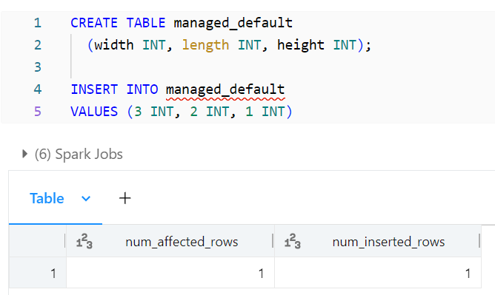

It is a managed table as we are not specifying the location keyword. We can see that the managed default table has been created in the default database.

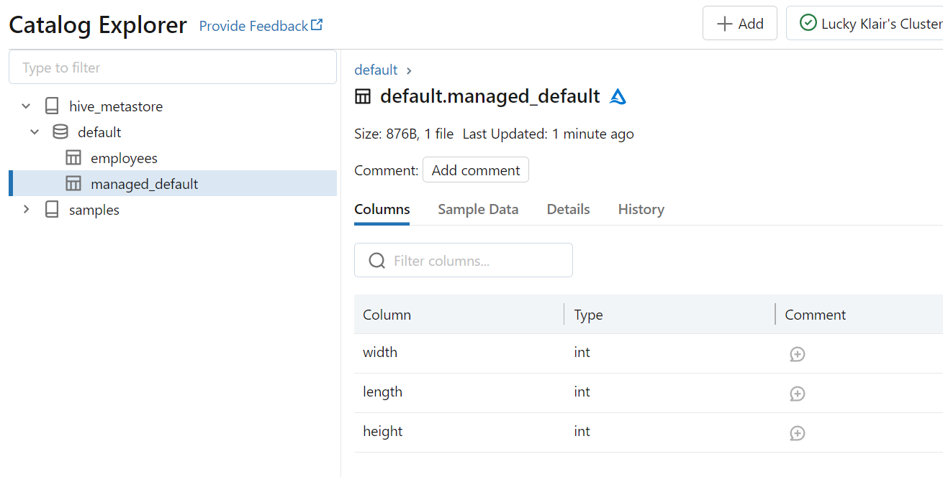

Let us now use the describe extended command to see the metadata information about the created table.

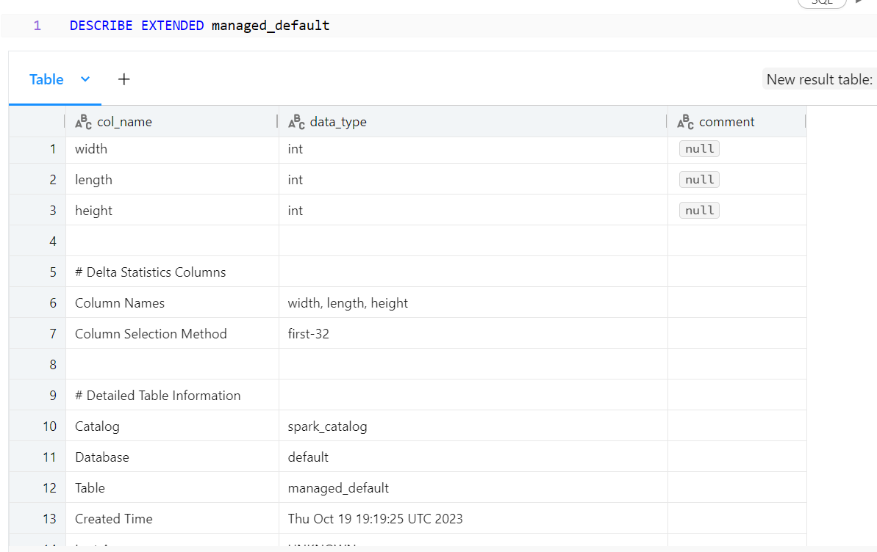

We can see where the location of the table is, and various other information. Lets now do the same commands, but this time lets create an external table.

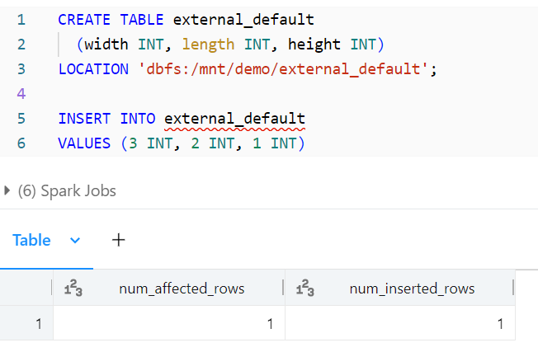

When describing the external table, you can see that the type is external and you can also see the location of it.

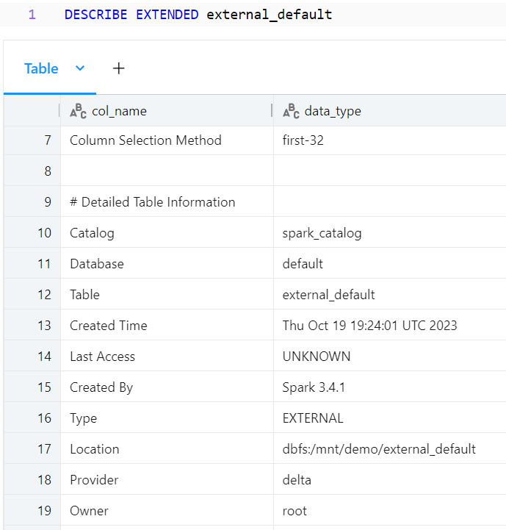

The external_default table and the managed_default table are found In the central hive metastore as seen below:

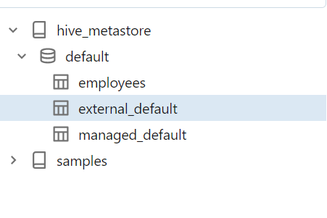

However, if we tried to drop the table for the external default table, the table files will not get deleted in the location path, as it is an external table. If we tried to drop the managed_default table, both the table files and the tables will get dropped.

We can create new databases by using the schema command or database command such as:

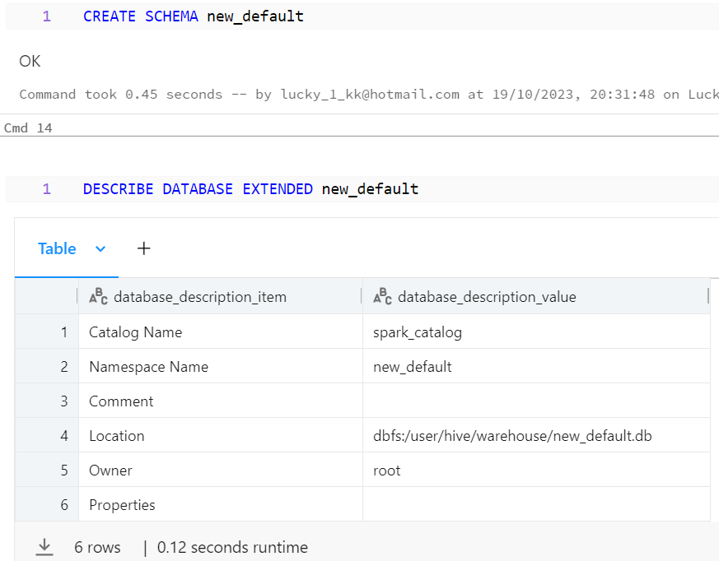

Notice that the location path shows an extension of .db. As shown before, any databases other than the default database will have an extension of .db.

Let us now create an external and managed table inside the new database that we created above. We have to use the USE command to use this database as below:

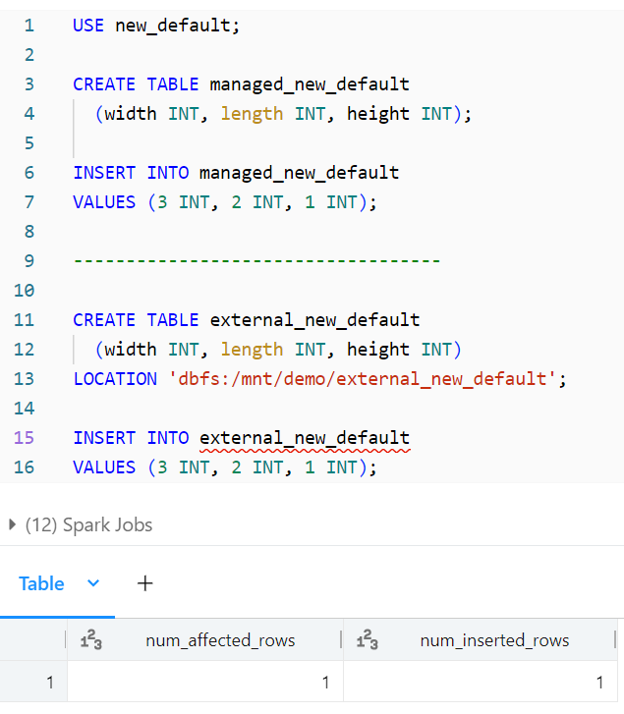

The new tables in the database have been created, as shown below:

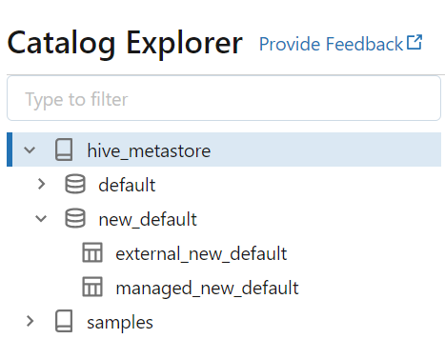

We can create a schema named custom, and provide a custom location for the storage of the files. We can see that the location is a custom location.

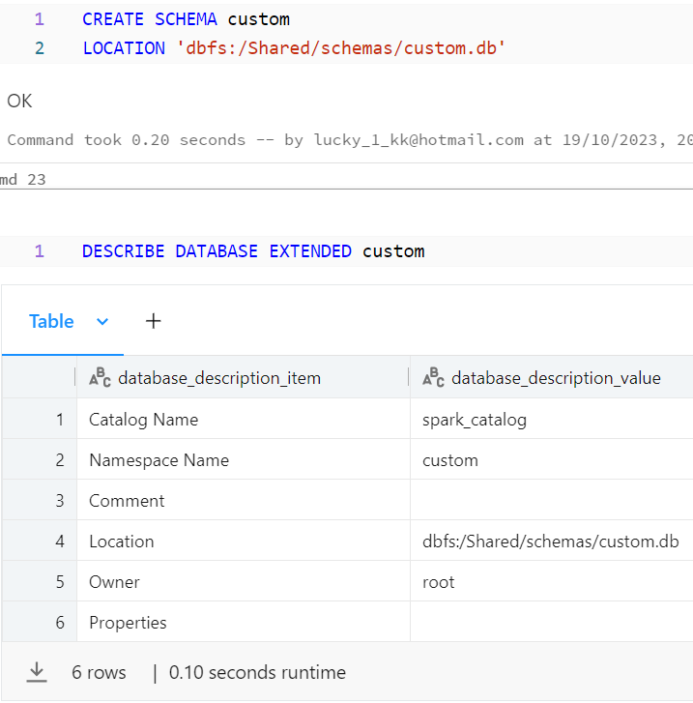

**Setup Delta Lake tables.**

We can create delta tables by using CTAS (create table as select) commands.

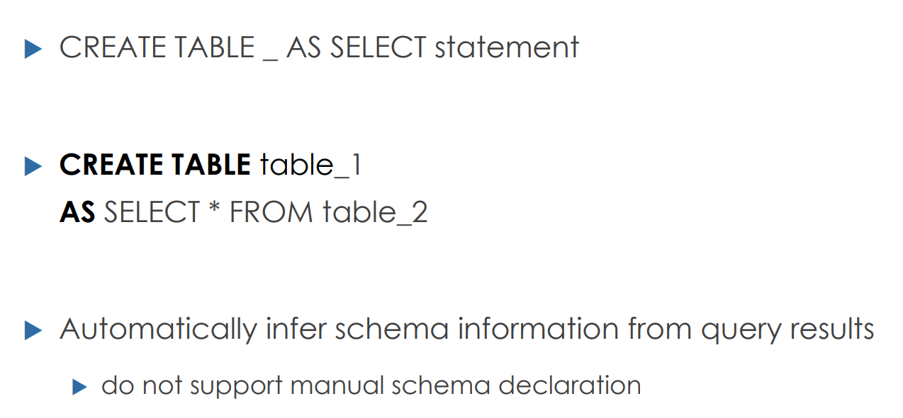

We can also do simple things like omit table columns or change column names upon the creation of delta tables. For example:

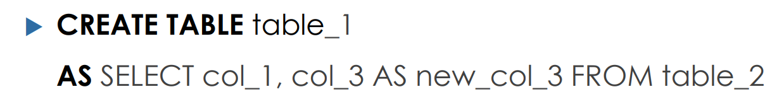

There are some additional options when creating delta tables using CTAS. You can add some additional table preferences like comments, and patitioning. If a file is very large, then it may make sense to partition the file by putting certain columns in different files. However, this is not beneficial for small to medium files. By default, it is best not to partition delta lake tables. You can specify a location path to some other external place if you wish.

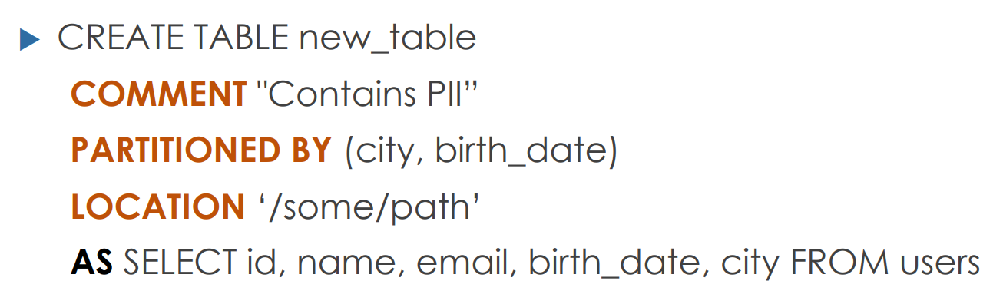

What are the differences between normal table creation and delta lake table creation?

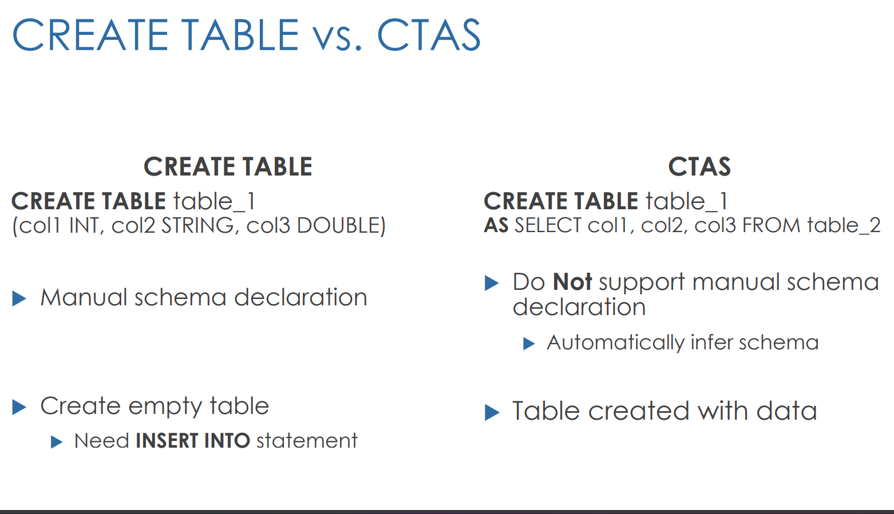

Constraints

Delta tables support two types of constraints which are shown below. Please note that the original table cannot have constraints on it before it is made into a delta table. The check command is similar to the where command in normal SQL.

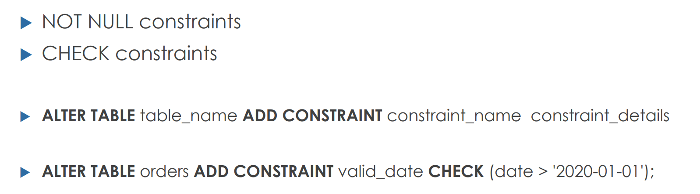

Cloning delta lake tables

Deep clone commits both data and metadata of the table to the target. A shallow clone only copies the transaction logs, and it is a quick option to copy.

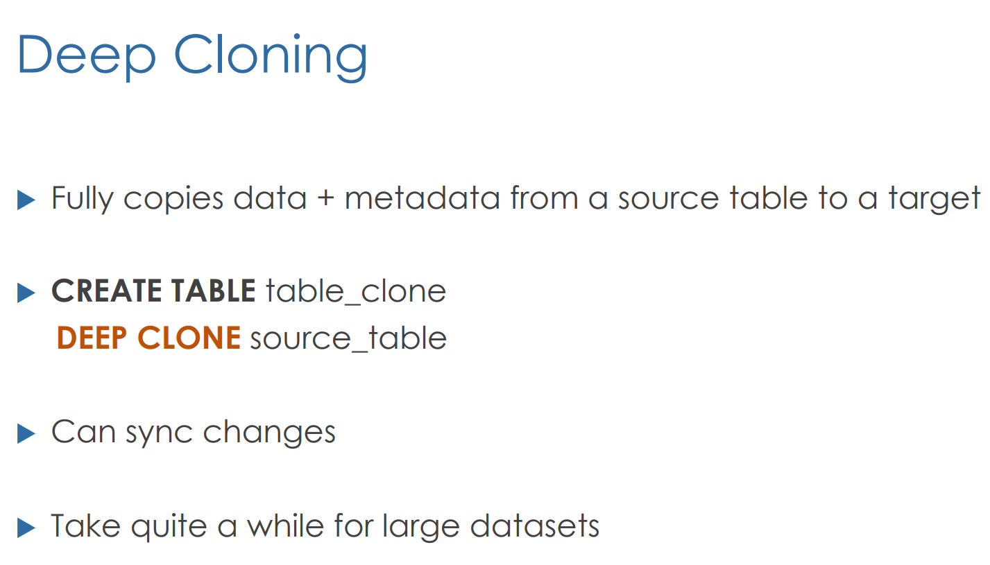

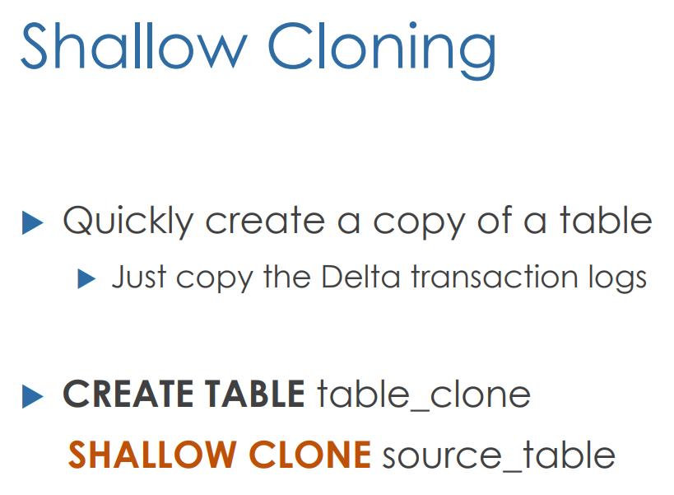

Views

A view in databricks is a virtual table which has no physical data. It is a query against SQL tables. This is better depicted below. A view is just an SQL statement which performs the query once the view is executed.

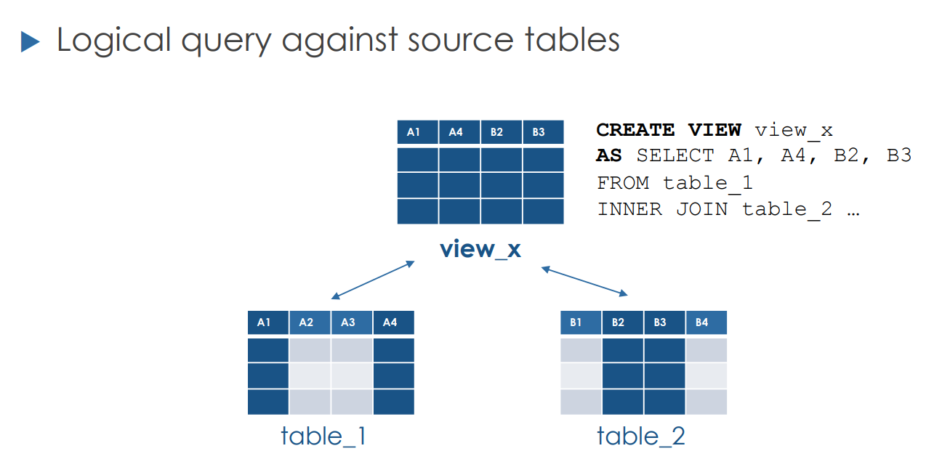

There are three types of views in databricks:

* Stored views – a view that is stored and will remain even once the spark session finished.

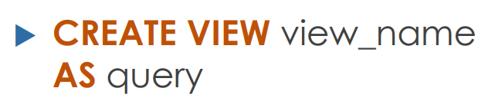

* Temporary views – which only exist for the spark session. A spark session activates when you open a new notebook, start a cluster, etc.

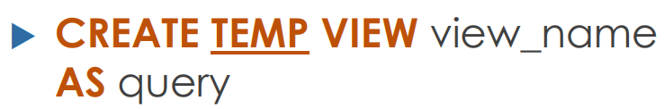

* Global temporary views – these work if the cluster is running

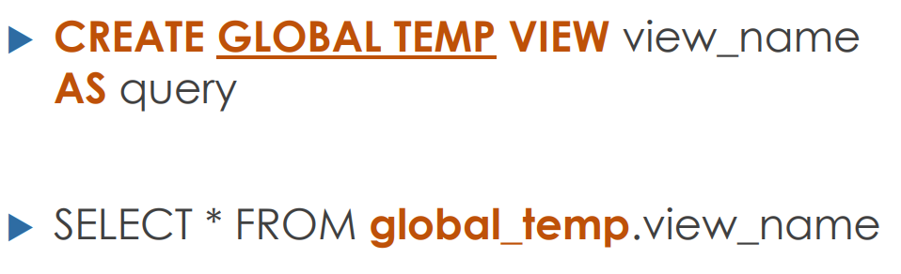

Lets now compare the three different views.

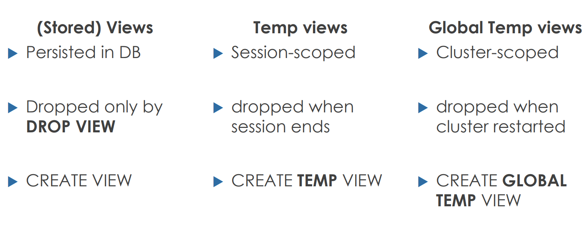

Working with Views

In order to work with views, lets prepare a sample table. We will start by creating the table named smartphones and insert data into it.

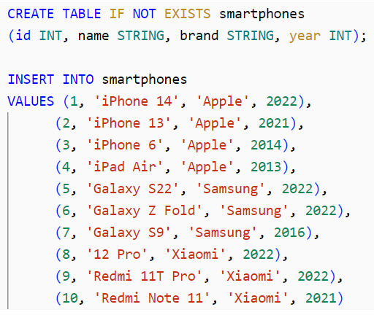

We can show the tables across all different databases.

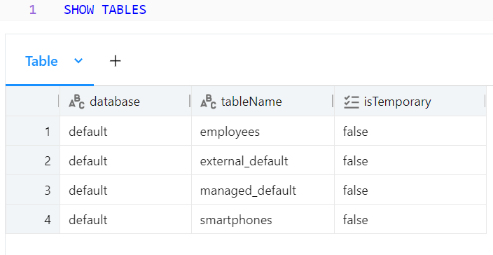

We want to now create a stored view that only shows apple phones:

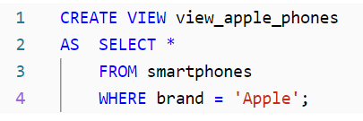

We can now use the select statement on the view.

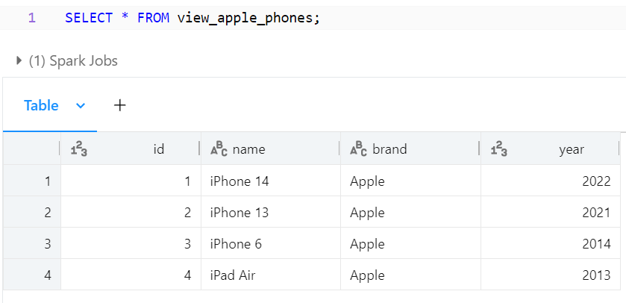

You can now see that the view is stored in the database and is not a temporary object.

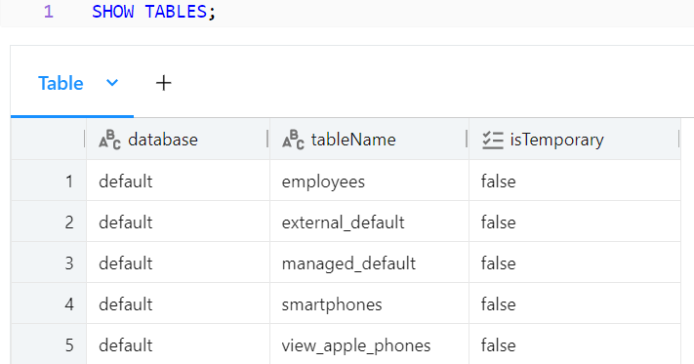

We can create a temporary view like this:

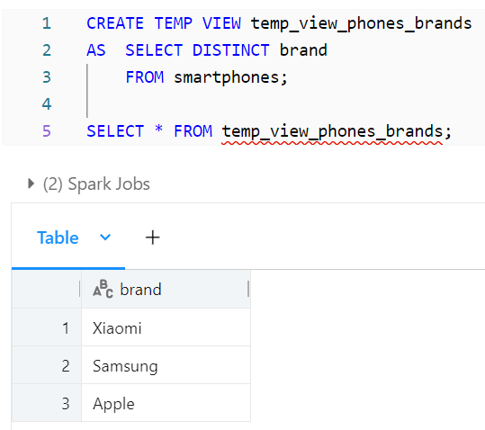

When you show tables, it can be seen that this view is temporary. As it is temporary, it is not assigned to any database.

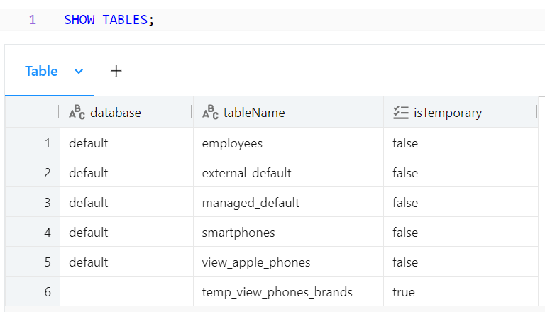

We can also define global temporary views as:

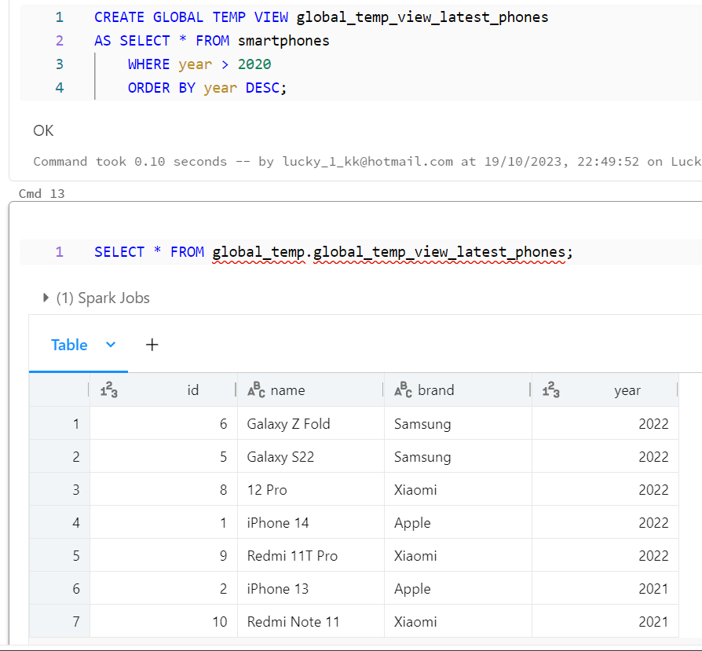

The global temporary view needs to be queried using the global temp database, as that is where it resides. You can see that the global temp view is not in the normal databases. Rather it is in the global temp database.

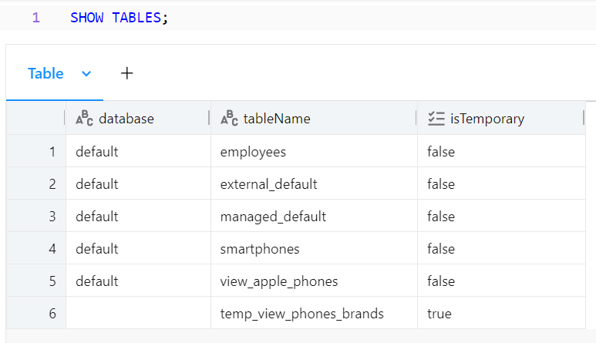

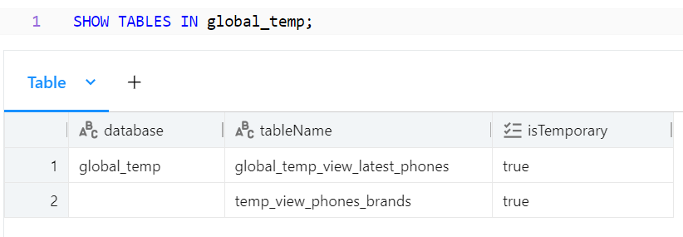

You can drop tables and views like follows:

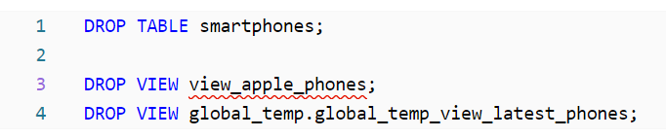

Querying files

You can directly query files from external sources and store them as delta tables.

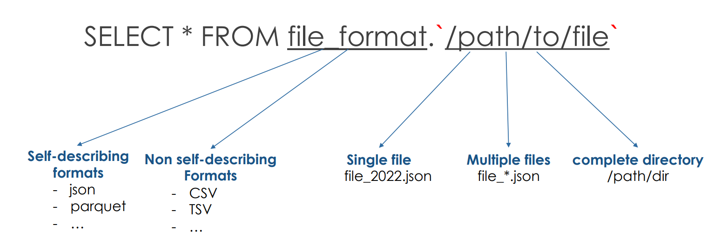

Here is the schema for a stored dataset.

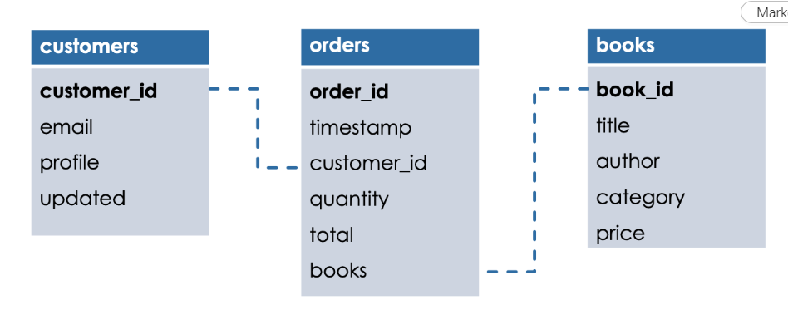

Lets say that I want to run a notebook inside my current notebook. I can do this with the run magic command. First, lets choose the notebook script that I want to execute inside the current notebook.

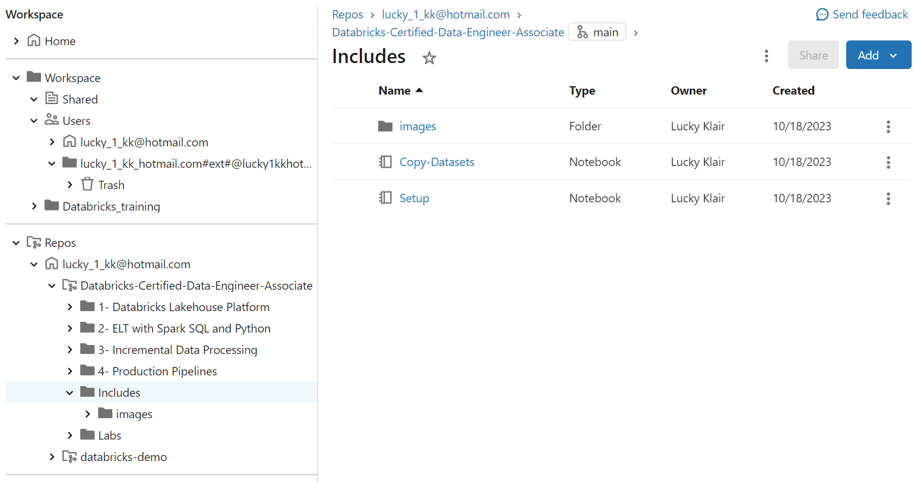

In the includes folder, there is a file named copy datasets. We want to run this in the current notebook, so I do this with

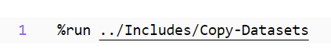

The Databricks utility function used to list the contents of a directory in a Databricks file system is used named dbutils.fs.ls. It returns a list of file and directory metadata for the specified path. We want to find the list of files at the path specified below. At this path, there are a range of customer json files. We display these files.

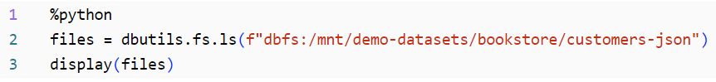

In order to query this file, we use the select * from command as below:

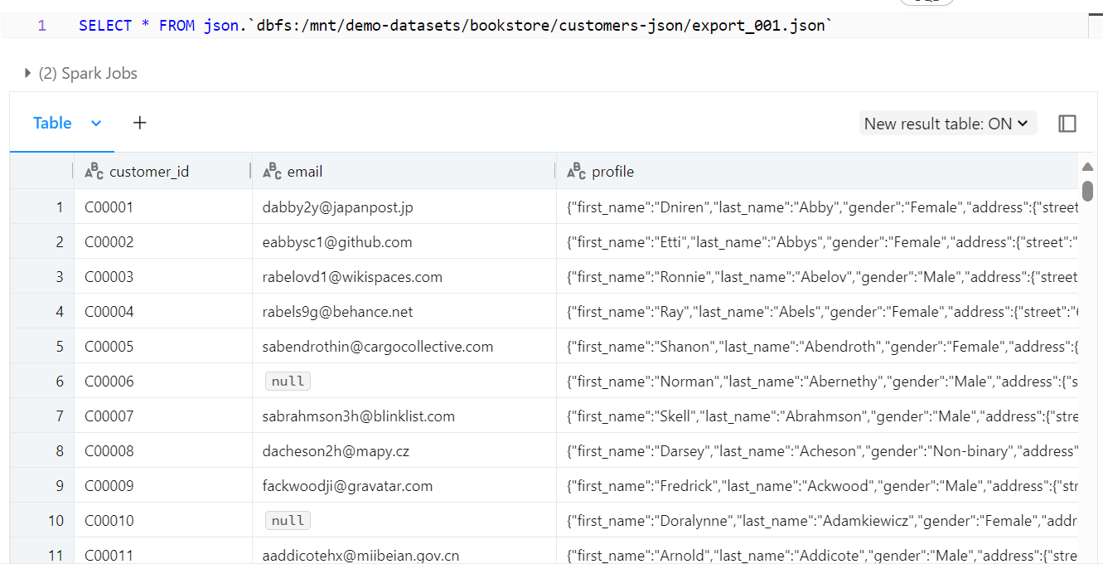

As shown before, the format for this command is to first state the file format, and then the path to that file. We are using backticks as well, and not single quotes.

We can query data in multiple json files in a directory by using the asterisk.

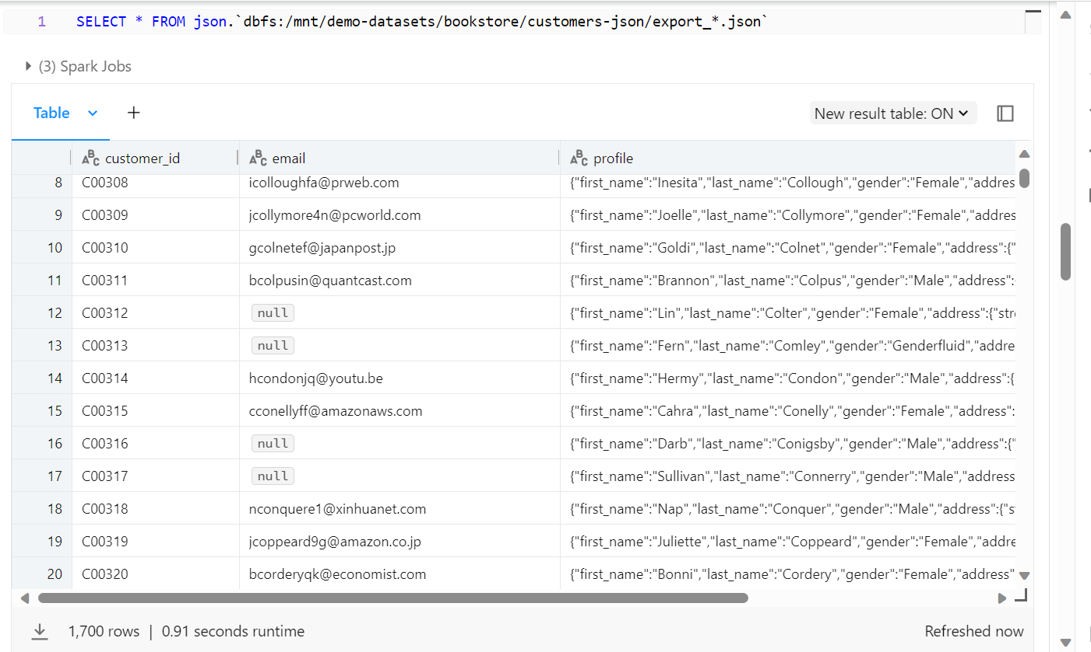

We can count how many rows we have with the following:

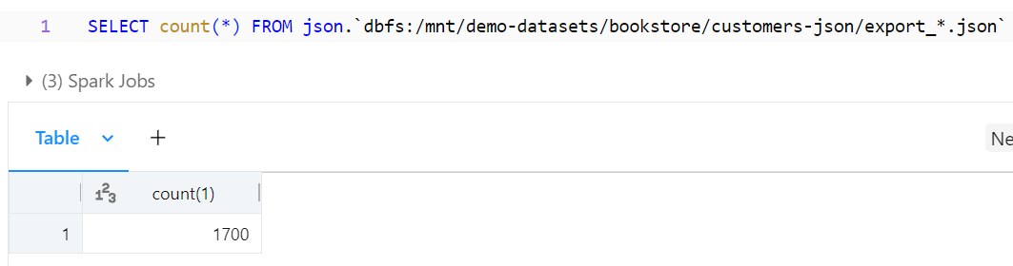

You can use a particular select command which show you the source location of each of the files when querying.

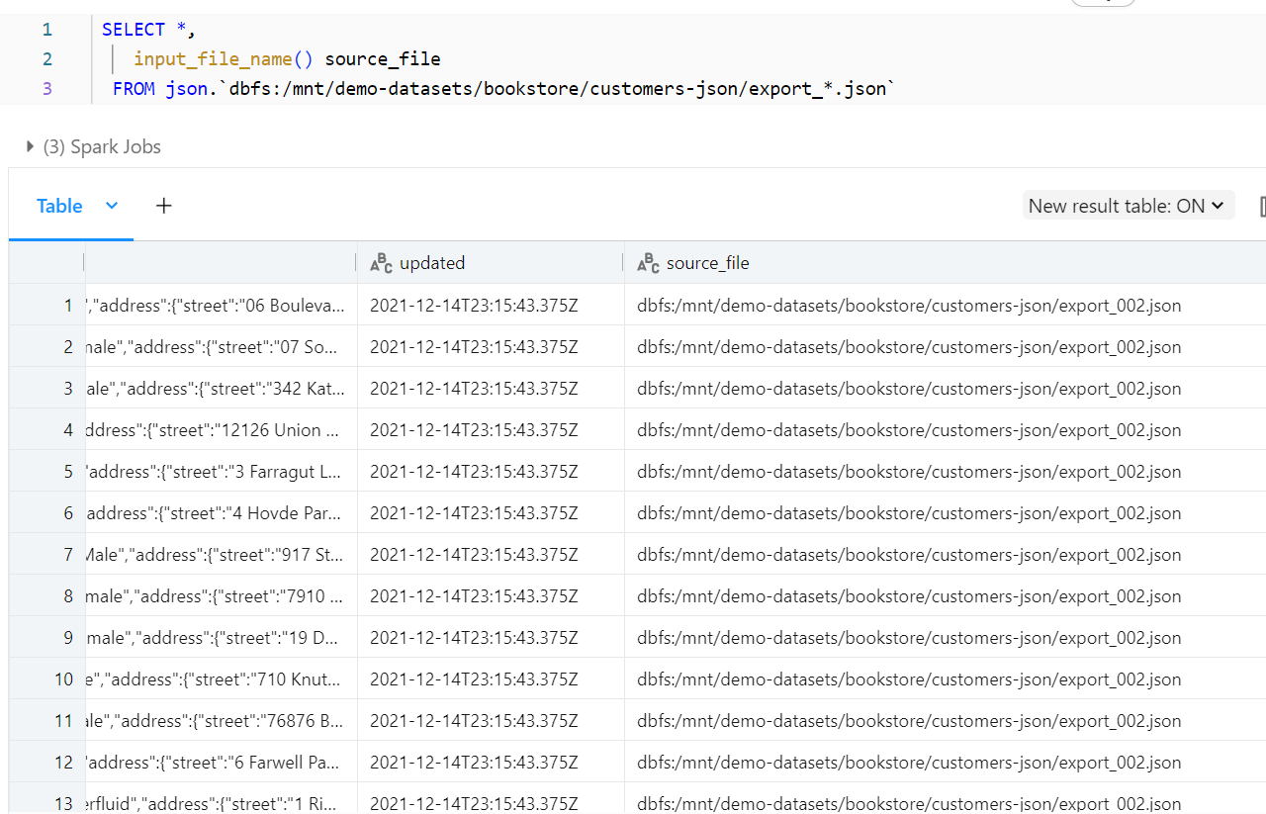

We can also query text format as well. This allows us to query any file and get the text result for it. We can see in the table below that the JSON file contents are provided in text format.

We can also query and get the results in binary format if we wish. This is done as:

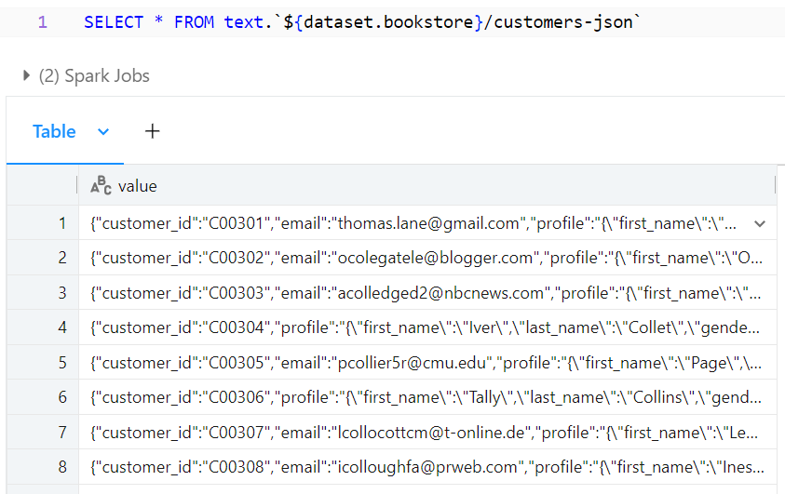

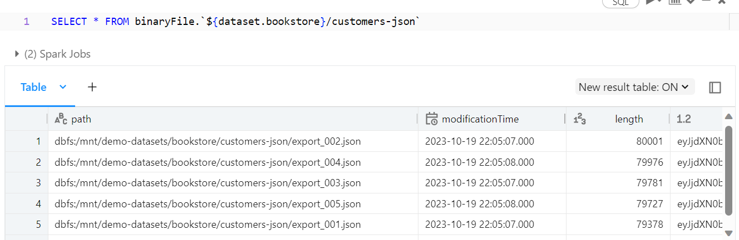

This gives us the path, modification time, and length which is the binary representation of the file.

We can also get the results in csv format, however, you can see that the delimiter is not quite right which chunks the words together in a row. This works well if you have a well structured file.

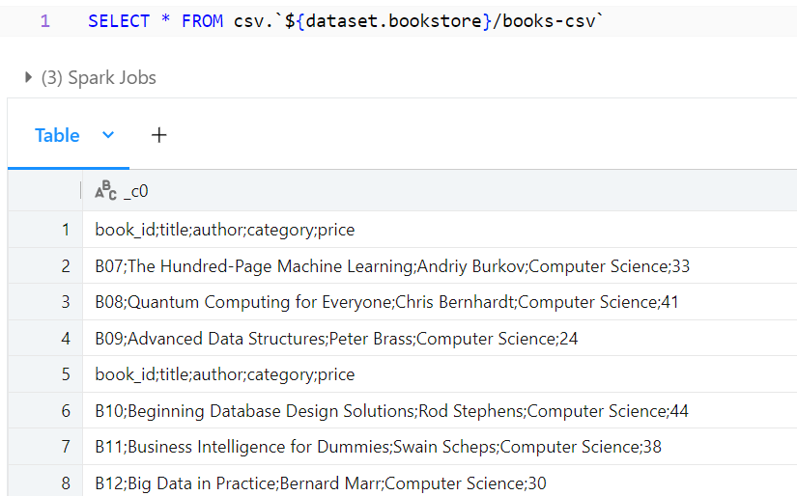

**Writing to tables**

We start by using a parquet file and creating a new delta table for orders. This can be seen below. Parquet files have a well defined schema, so we are able to extract the data correctly.

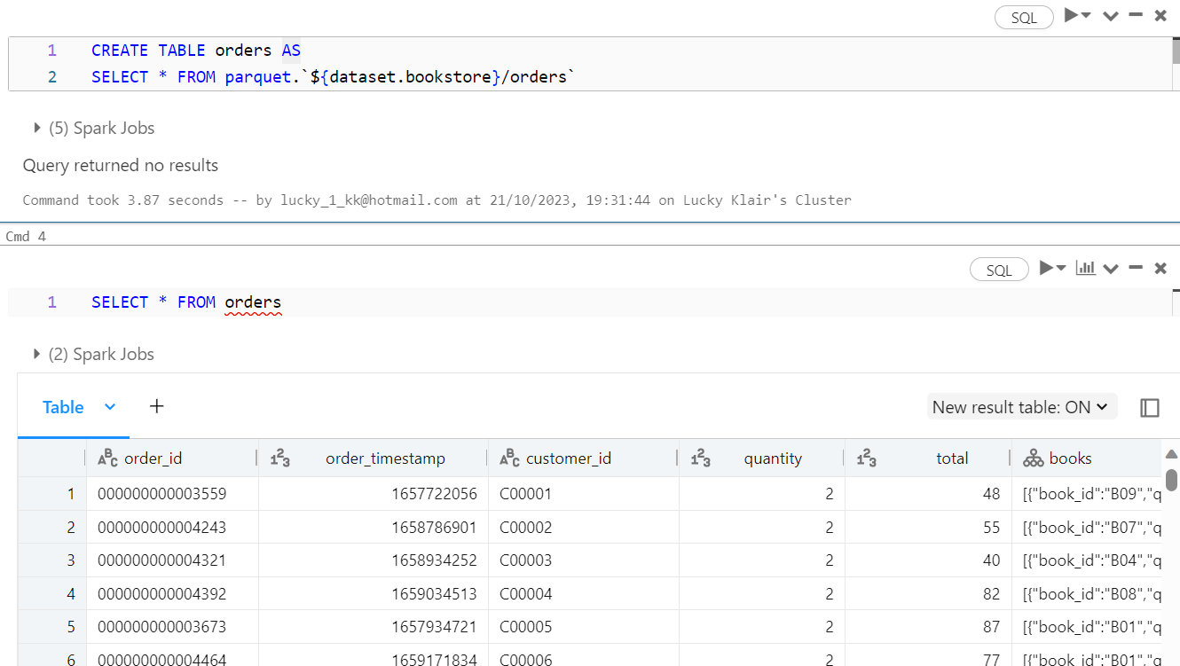

We can overwrite the table by using a CRAS statement. This is useful as it simply copies the previous file and then creates a new file. This is useful as it allows time travel, and concurrent work, as users can still use the current version of the table as the new one is being created.

The Create or replace statement is CRAS statement as fully replace the contents of the table when executed.

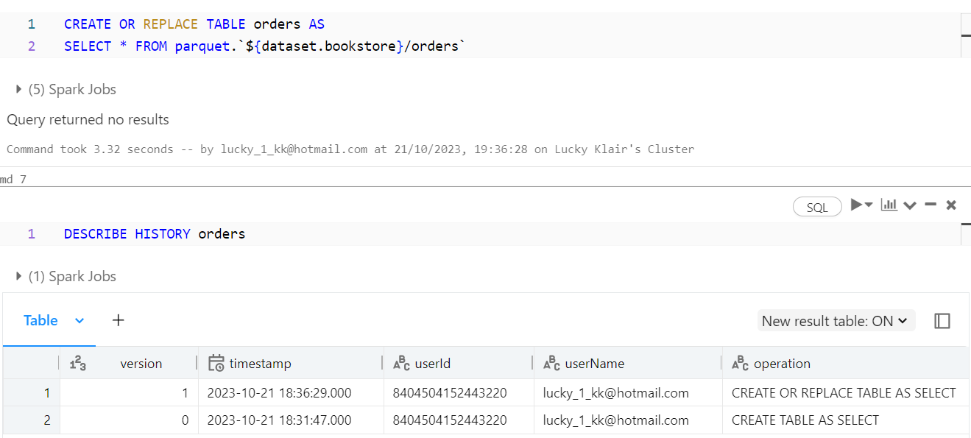

The version 1 has generated a new table version. The second method is an insert override statement. The data in the target table will be overwritten by the data from the query.

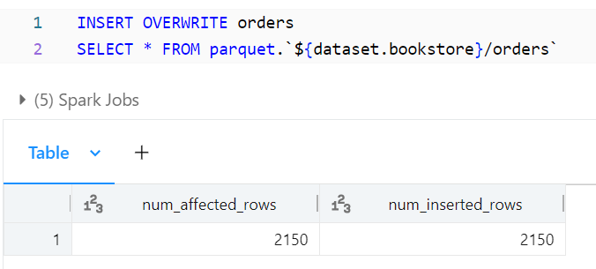

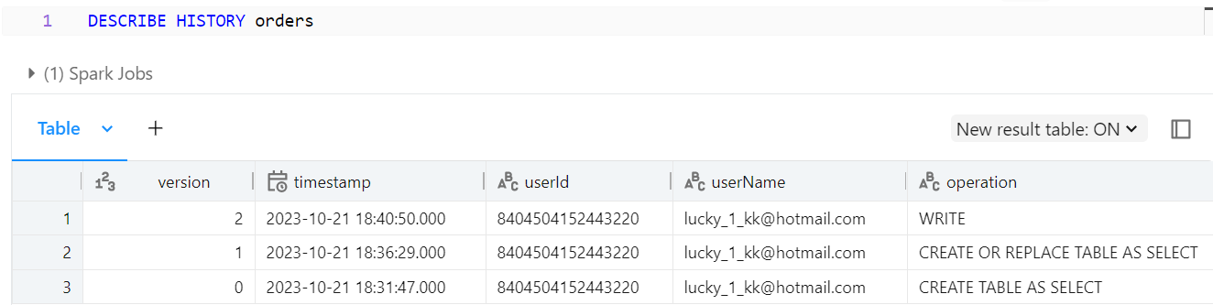

2150 records have been overwritten

One important point is that you cannot add a column when attempting to overwrite the current table in this manner. This will come up with an error as shown below:

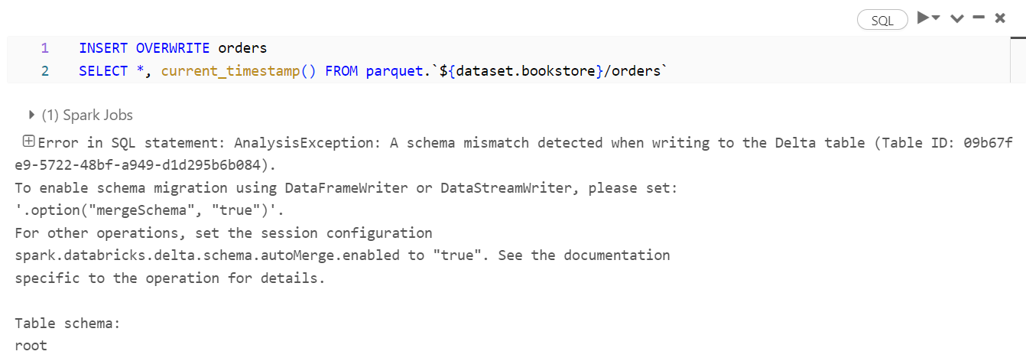

The error states that there is a mismatch in the schema, as you are attempting to write an additional column which was not there in the original table.

You can append records into the tables you have created by using the insert into statement. This is shown below.

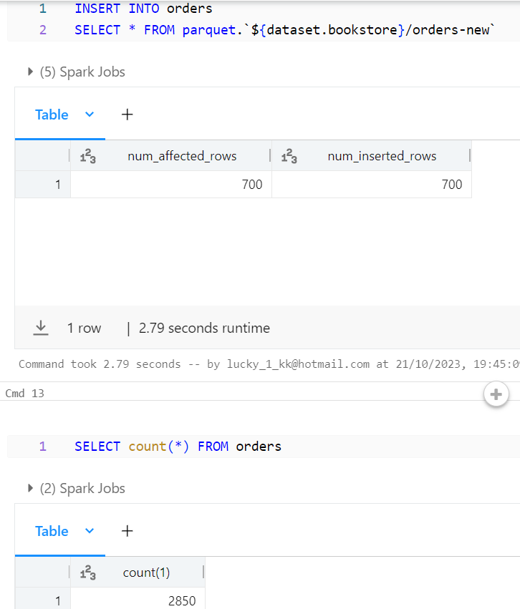

We can see above that 700 records were added into the table successfully. So if we have another file, we can read that path and push those records into the table. However, it must be noted that re-executing the query multiple times will add the same records over and over, duplicating the records. To resolve this issue, we can use the merge into statement. By using this method, you can upsert data into the target table, which means you can merge, update, and delete using the merge into statement.

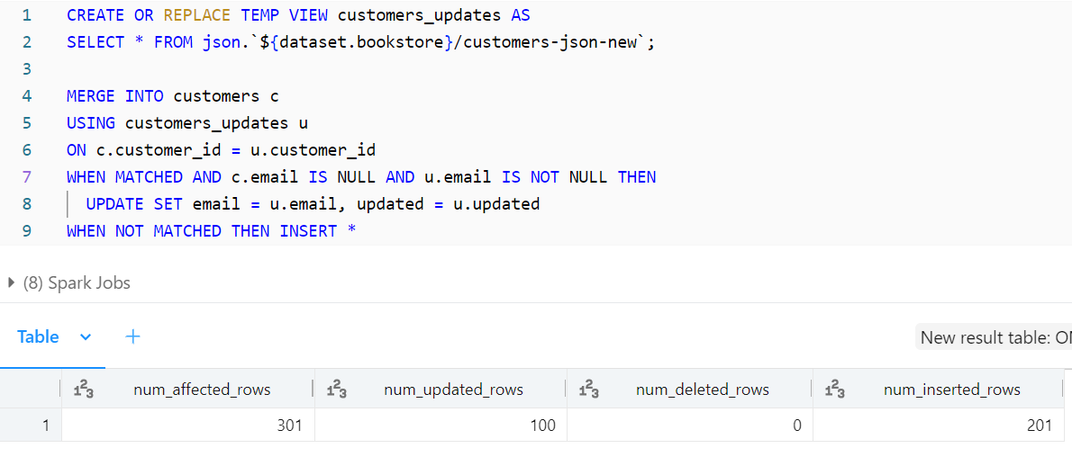

The code above uses SQL's MERGE statement to update or insert records in a table named customers based on the data in a temporary view that has been created named customers_updates.

CREATE OR REPLACE TEMP VIEW customers_updates AS ...: This line creates a temporary view named customers_updates that contains the data from a JSON file located at the path ${dataset.bookstore}/customers-json-new.

MERGE INTO customers c USING customers_updates u ON ...: This is the main part of the SQL statement where the MERGE operation is performed.

customers is the target table you want to update or insert data into.

customers_updates is the source data from the temporary view.

c and u are aliases for the target and source tables, respectively.

ON c.customer_id = u.customer_id: This part specifies the join condition between the target and source tables. It tells the database how to match records.

WHEN MATCHED AND c.email IS NULL AND u.email IS NOT NULL THEN ...: This part of the MERGE statement defines what should happen when a match is found. Specifically, it checks if the email in the target table is NULL and the email in the source table is not NULL. If both conditions are met, it updates the email and updated columns in the target table with the values from the source table.

WHEN NOT MATCHED THEN INSERT *: This part specifies what should happen when there is no match between the target and source tables. In this case, it inserts the entire row from the source table into the target table.

The code essentially updates the customers table with data from the customers_updates temporary view when a match is found based on the customer_id column. If there is no match, it inserts the row from the source into the target table.

In the next example, we create a temporary view using CSV format and state some options.

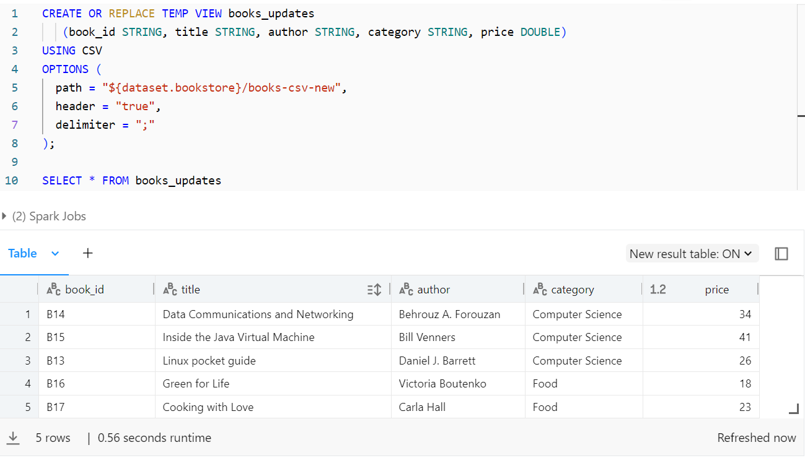

Once again, we use the merge into statement which can be seen below.

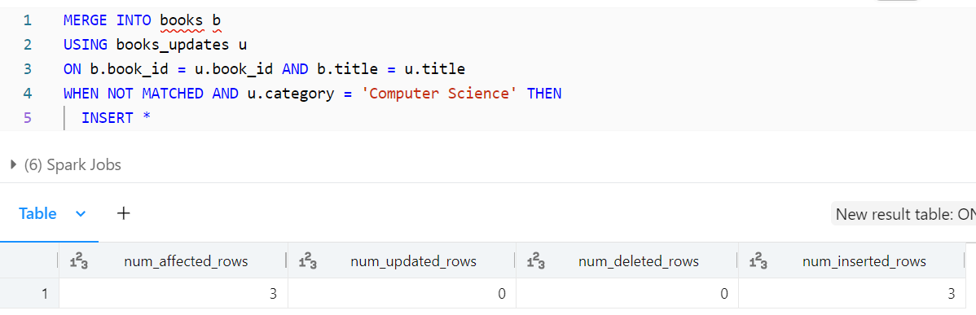

The code above is a MERGE statement that operates on a table named books and a source dataset or view called books_updates. It specifies how to update or insert data into the books table based on the conditions provided. Here's a breakdown of the code:

MERGE INTO books b USING books_updates u ON ...: This is the main part of the MERGE statement.

books is the target table you want to update or insert data into.

books_updates is the source data from another table or view, represented with the alias u.

b and u are aliases for the target and source tables, respectively.

ON b.book_id = u.book_id AND b.title = u.title: This part specifies the join condition between the target and source tables. It tells the database how to match records for updates or inserts. In this case, it matches records where both the book_id and title are the same in both tables.

WHEN NOT MATCHED AND u.category = 'Computer Science' THEN INSERT *: This part of the MERGE statement defines what should happen when there is no match between the target and source tables, and the category in the source table is 'Computer Science'. In this case, it inserts the entire row from the source table (books_updates) into the target table (books).

The code essentially inserts rows from the source table books_updates into the target table books if there is no match based on the book_id and title, and if the category in the source table is 'Computer Science'. We are only inserting new data if the computer science category is not already existing.

One of the benefits of the merge statement is that there are no duplicates. If we re-run the statement, it will not add the same records, as they are already in the table.

**Advanced Transformations**

We start by querying the customers table, and the profile column has a complex data structure as it has nested JSON.

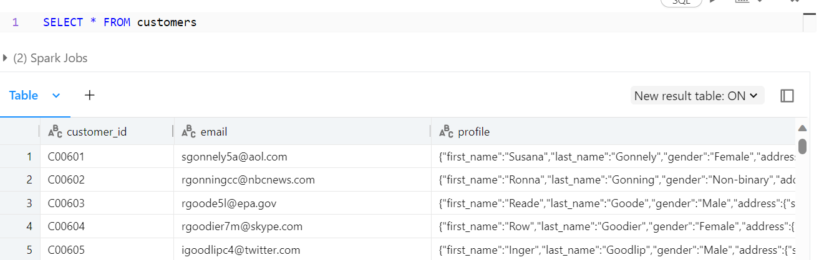

As we can see, the address is a JSON string that contains the street, city, and country of the customer.

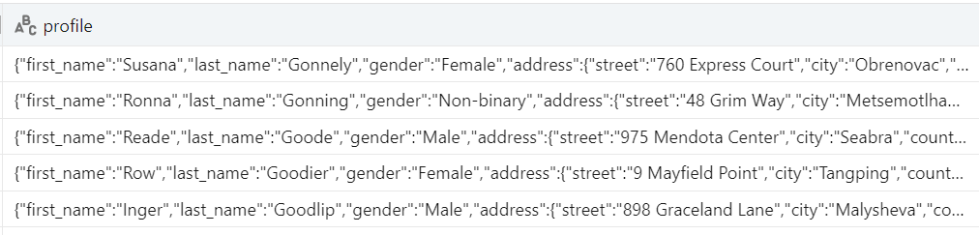

SparkSQL has direct functionality to interact with JSON strings. We can use the colon syntax to traverse nested data structures.

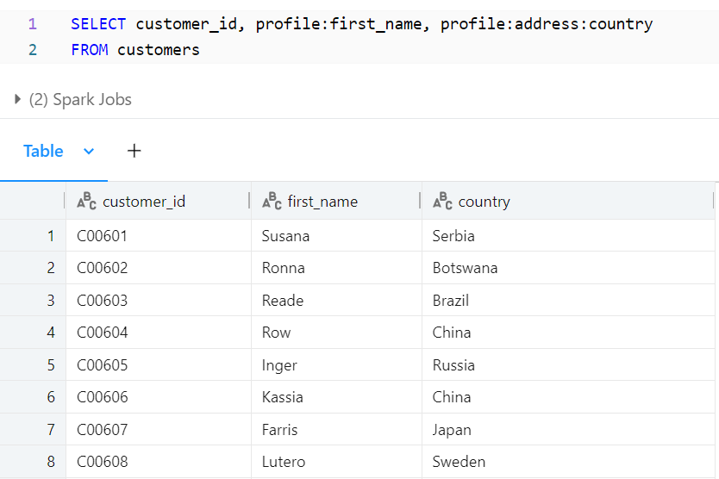

The colon allows us to access the nested parts of the JSON string. SparkSQL also have the ability to parse json objects into struct types, which has nested attributes. This can be done with the from JSON function.

So lets say that we now just want to focus on the profile column. Let us first query the column and get back one record.

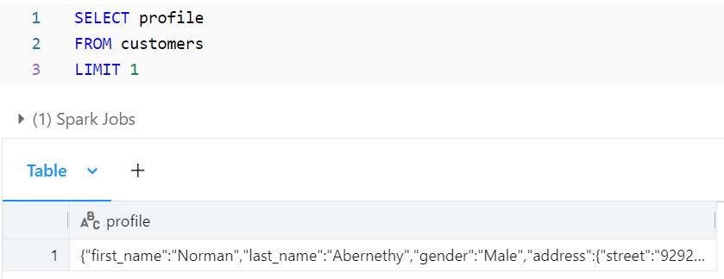

Lets create a temporary view named parsed_customers. We want to select the customer_id and then select another column named profile_struct. In the profile_struct, we can use the from_json command to define the column and the json structure to ensure that it is a struct type.

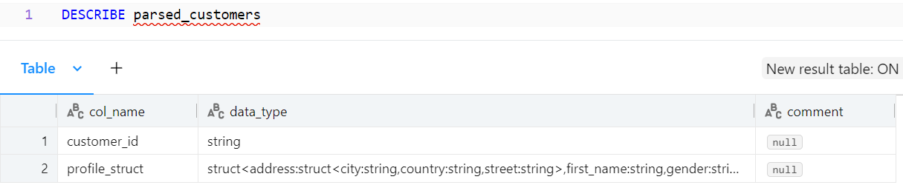

This new column has a struct data type and is no longer a string. In the customers table, the profile column was a string data type. This is why the temporary view was created, to make the json in each row into a struct type. With a struct type, we can interact by using the period, or dot syntax.

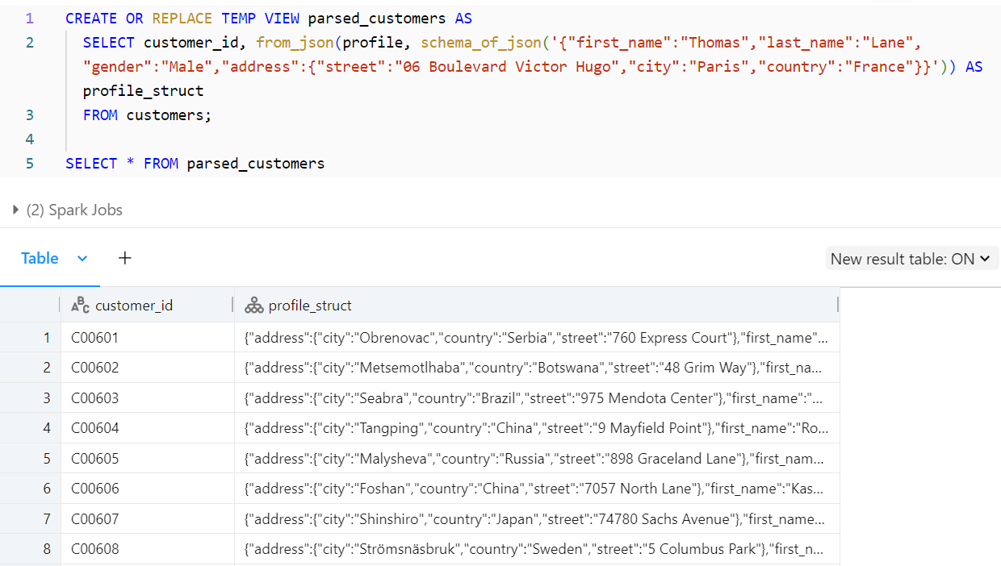

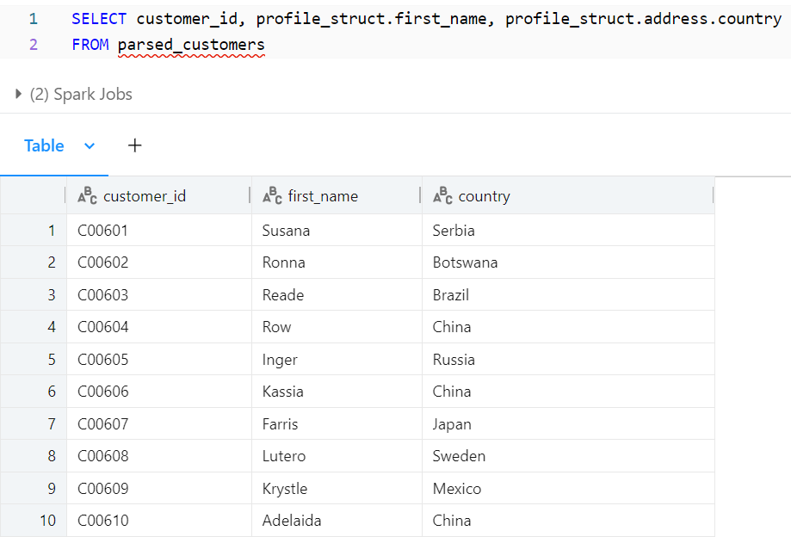

One the column has been created into a struct type, we can use the star operation to flatten columns. So we have now essentially taken a table which had a json string, created a temp view to change the json strings into struct types, and then we create another temporary view to flatten the previously created view so that the nested Json is no longer nested as much.

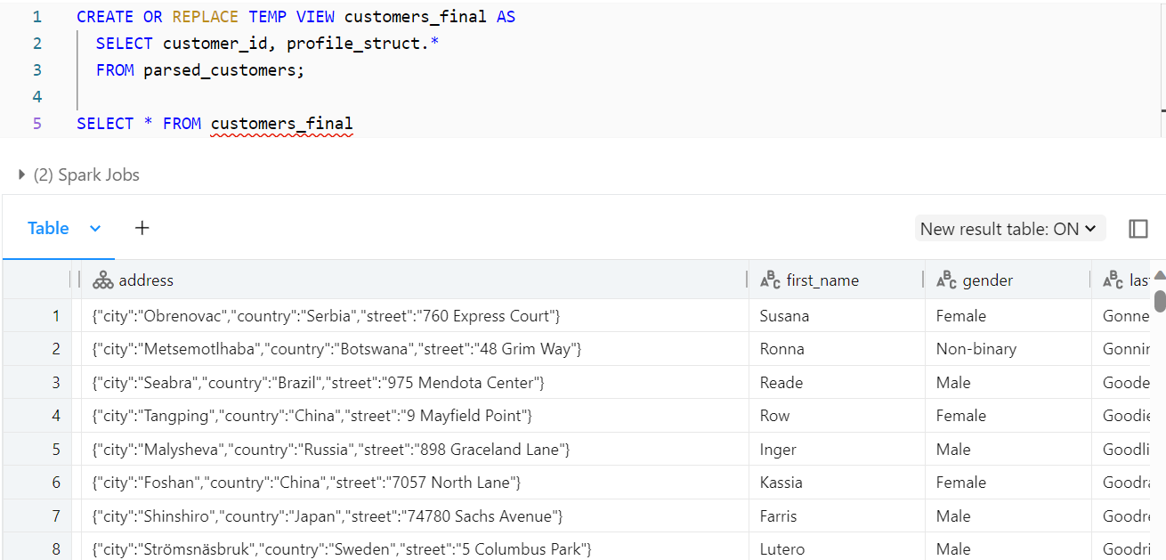

Lets now switch to the orders table to see another very interesting feature.

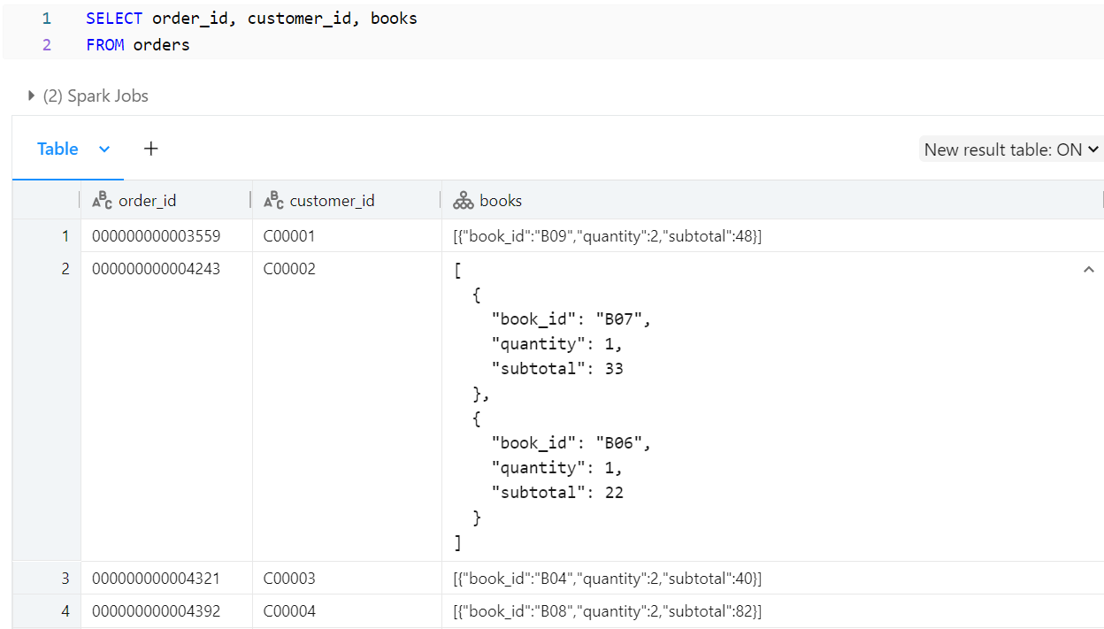

The book column is an array of a struct type. SparkSQL has a number of functions to deal with arrays. The most important one is the explode function, which allows you to put each element of an array into its own row. This can be seen below, where

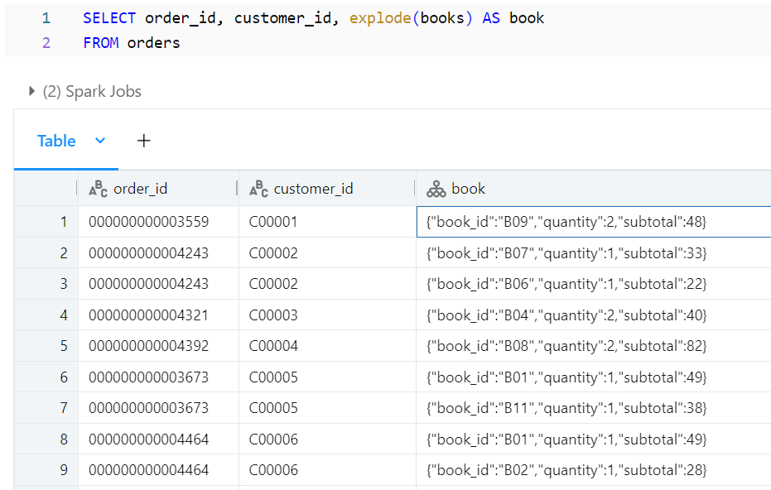

You can now see that the two elements for customer id C00002 have their own rows, as opposed to being combined into one row before within one array.

Another interesting function is the collect_set function, which allows us to collect unique values for fields, including fields within arrays.

You can flatten arrats as follows:

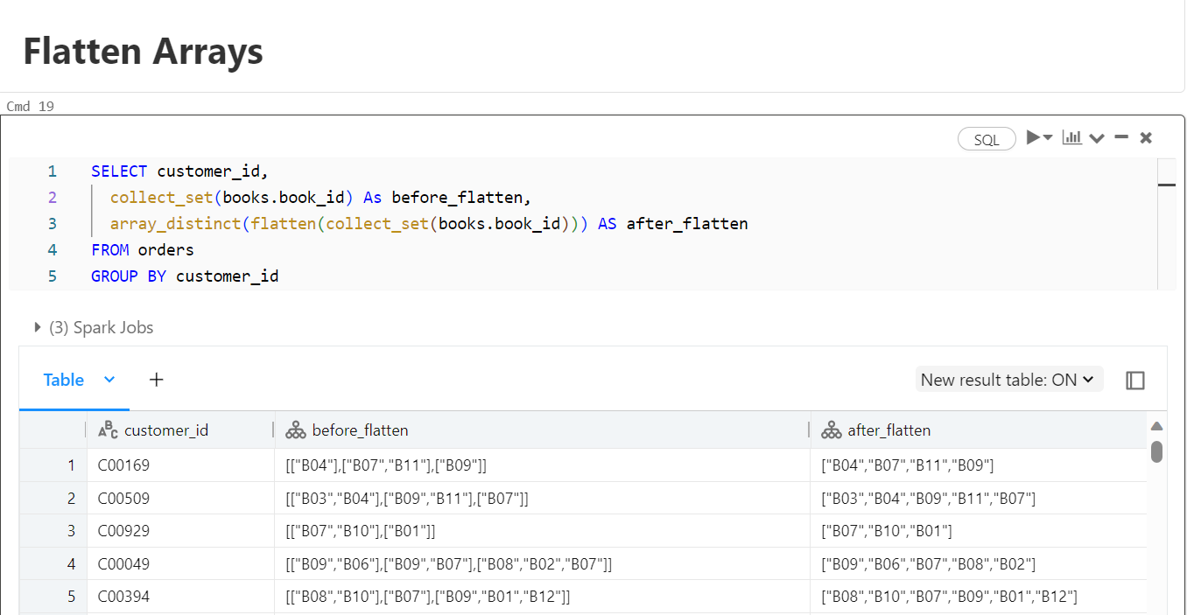

The code above is selecting data from the orders table and performing some aggregation operations using the collect_set and array_distinct functions. Here's a breakdown of the query:

SELECT customer_id, ...: This part of the query selects the customer_id column and computes two additional columns for each group of records with the same customer_id.

collect_set(books.book_id) As before_flatten: The collect_set function is used to create an array that collects all the distinct book_id values for each group of records with the same customer_id. The result is given an alias before_flatten.

array_distinct(flatten(collect_set(books.book_id))) AS after_flatten: This part of the query first applies the collect_set function as previously explained to collect all the distinct book_id values for each group. Then, it uses the flatten function to flatten the arrays of book_id values into a single array. Finally, it uses array_distinct to ensure that the array contains only distinct values. The result is given an alias after_flatten.

FROM orders: This part of the query specifies that the data is being selected from the orders table.

GROUP BY customer_id: The records in the orders table are grouped by the customer_id column. This means that the aggregation functions are applied separately for each unique customer_id.

In summary, this query groups orders by customer_id, collects the distinct book_id values for each group, and then flattens and deduplicates the arrays of book_id values. The result is a list of distinct book_id values for each customer, both before and after the flattening and deduplication.

SparkSQL supports the join operation.

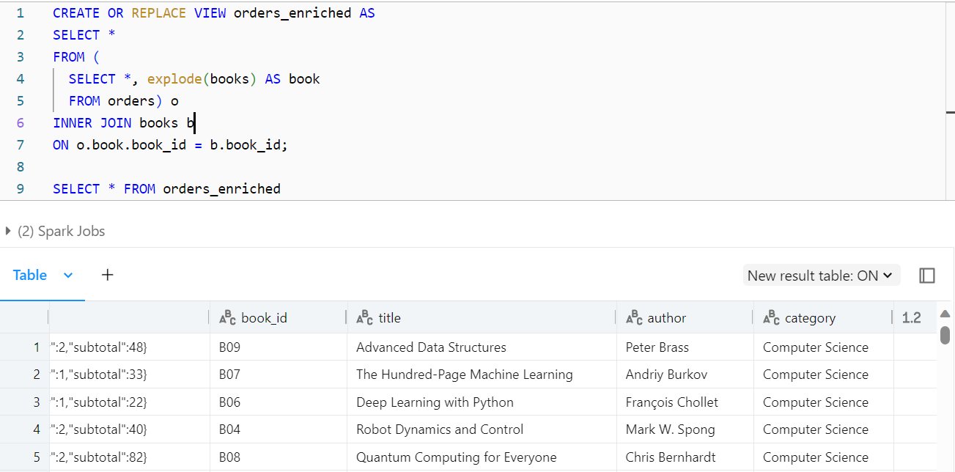

The SQL code above first creates a view named orders_enriched and then selects data from that view. Let's break down the code step by step:

CREATE OR REPLACE VIEW orders_enriched AS ...: This part of the code creates a view named orders_enriched. A view is a virtual table that contains the result of a SELECT statement and can be queried like a table.

SELECT * FROM ...: Inside the view definition, the code performs the following operations:

a. SELECT *, explode(books) AS book FROM orders: This line selects all columns from the orders table and applies the explode function to the books column. The explode function is used to transform an array or map column into multiple rows, effectively creating a new row for each element in the array or map. The result is an expanded set of rows, each with a single book from the original books array.

b. INNER JOIN books b ON o.book.book_id = b.book_id: After exploding the books array, the code performs an inner join with the books table using the book_id column to enrich the data. This joins the exploded book data from the orders with the book data from the books table based on the matching book_id.

SELECT * FROM orders_enriched: Finally, this part of the code selects all columns from the orders_enriched view. This will return the result of the previous join operation, where the order data has been enriched with the book data.

The orders_enriched view contains the combined information from the orders and books tables, where each row represents an order along with the details of the book(s) in that order.

You can query the orders_enriched view like a regular table to access the enriched data.

SparkSQL also supports the set operations. So we can do a union command or a intersect command which are both set operations, as you are dealing with sets.

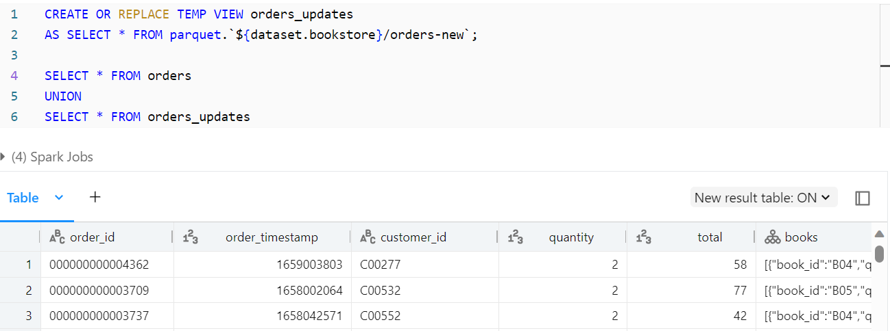

This is a UNION operation. It combines the rows from the original orders table and the orders_updates temporary view into a single result set. The UNION operator removes duplicates, so you'll get a distinct set of rows from both tables.

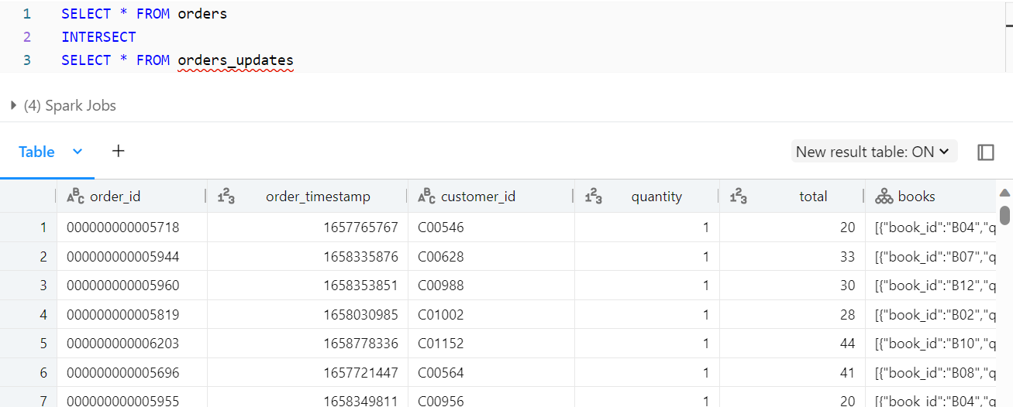

The INTERSECT operator combines the result sets from the two SELECT statements that come before and after it. It returns only the rows that are common to both sets. In other words, it returns records that exist in both the orders table and the orders_updates temporary view.

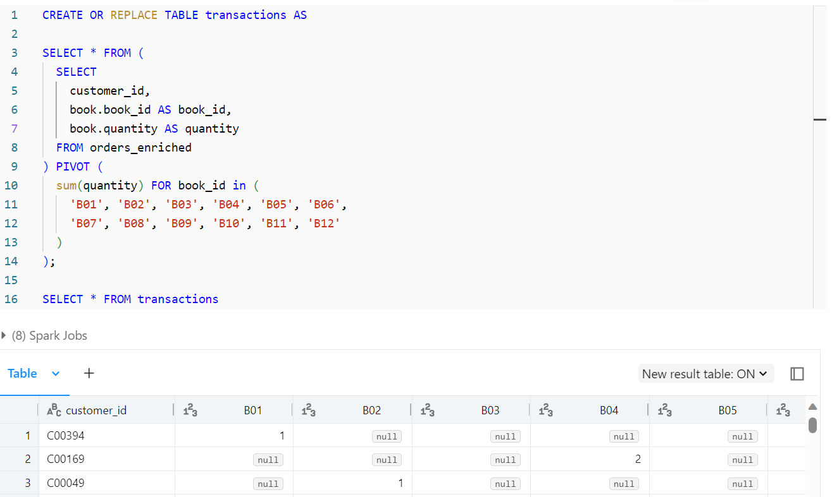

The code above first creates a new table named transactions using a PIVOT operation and then selects all data from that table. Let's break down the code step by step:

CREATE OR REPLACE TABLE transactions AS ...: This part of the code creates a new table named transactions. The structure and data in this table are generated by the following subquery and the subsequent PIVOT operation.

SELECT * FROM (SELECT ... FROM orders_enriched) PIVOT ...: In this section:

The subquery selects data from the orders_enriched view.

Within this subquery, you're extracting the customer_id, book_id, and quantity from the orders_enriched view, essentially creating a new structure.

PIVOT (sum(quantity) FOR book_id in (...) ): The PIVOT operation is used to transform the data. It groups and aggregates the data based on the book_id values provided in the IN clause. For each specified book_id, it calculates the sum of the quantity values for that book.

The result of the PIVOT operation is essentially a pivot table where each row represents a customer_id, and the columns represent different book IDs. The values in the pivot table are the sums of quantities for each book.

SELECT * FROM transactions: This part of the code selects and displays all the data from the newly created transactions table.

The transactions table will contain a summarized view of the data from the orders_enriched view, with customer IDs as rows and book IDs as columns, showing the total quantity of each book ordered by each customer.

**Higher Order Functions (UDF)**

Lets first take a look at the orders table once again.

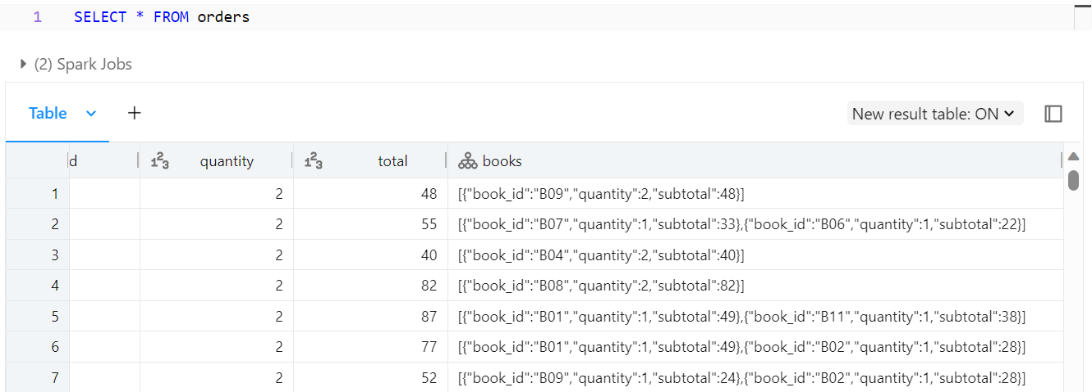

We can see that the books column has complex data types as the data type is struct type. To work directly with such struct types, we need to use higher order functions. Higher order functions allow you to work directly with hierarchical data such as arrays and objects. One of the most common higher order function is the filter function. In the example below, we are creating a new column named multiple_copies where we filter the books column to extract those books that has a quantity greater or equal to 2. This function iterates through the elements of the array books and applies the condition specified in the lambda function (in this case, i -> i.quantity >= 2). It returns an array that includes only the elements that satisfy the condition, meaning it includes only those books with a quantity of 2 or more.

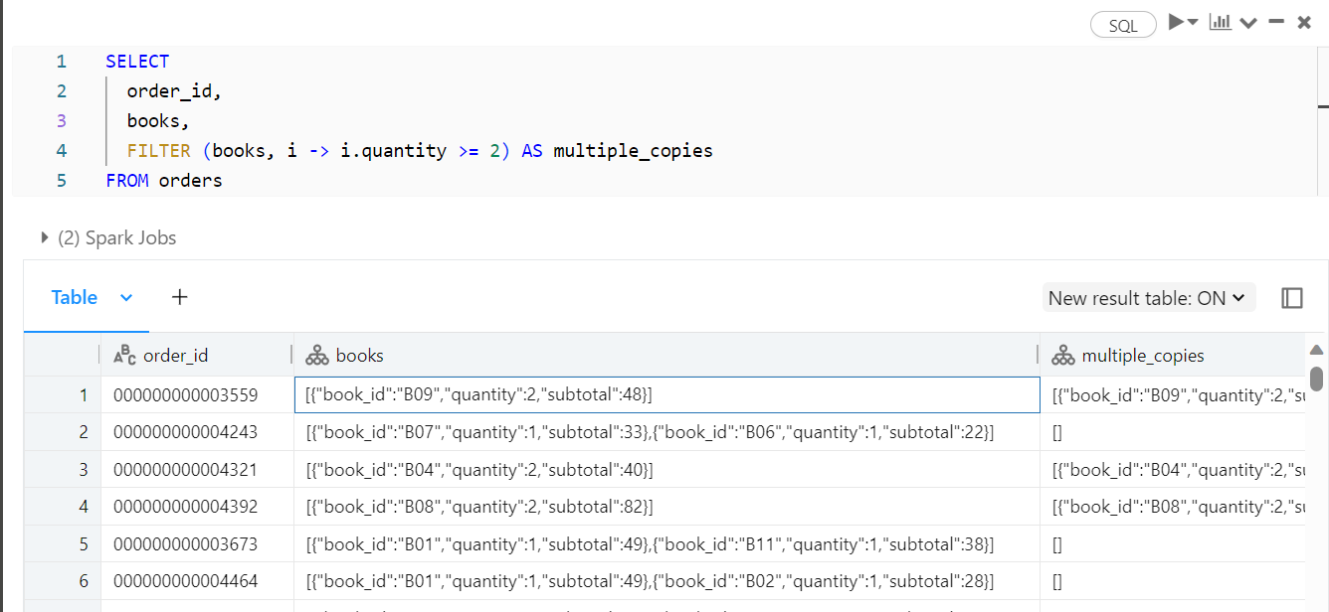

In summary, the query selects the order_id and books columns from the orders table. It then creates a new column called multiple_copies, which contains an array of books with a quantity of 2 or more based on the condition specified. This allows you to see, for each order, which books were ordered in quantities of 2 or more.

i ->: This part of the lambda function syntax defines the parameter(s) that the lambda function will accept. In this case, i is the parameter, and it represents an individual element of the array.

->: This arrow symbol separates the parameter i from the expression that defines the condition or operation to be applied to each element in the array.

i.quantity >= 2: Following the arrow ->, you specify the condition or operation that you want to apply to each element i in the array. Here, i.quantity >= 2 is the condition. It checks if the quantity attribute of the element i is greater than or equal to 2.

So, in the context of your query:

i represents each individual book object within the books array.

i.quantity >= 2 checks if the quantity attribute of a book is greater than or equal to 2.

The lambda function is applied to each element in the books array, and it filters out the elements (books) for which the condition i.quantity >= 2 is true. The result is a new array containing only the books with a quantity of 2 or more, which is then stored in the multiple_copies column.

So in other words I could also write the code like this below

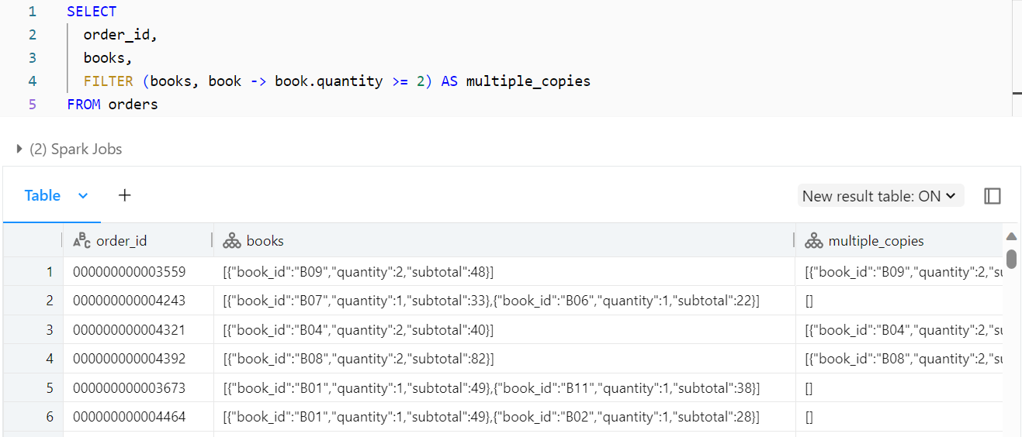

So filter the table books, and then filter through each book, and then the arrow condition is saying apply this condition on each book (element), which is book.quantity >=2. Then store the result as a new column named multiple_copies.

There are a lot of empty rows in the multiple_copies column, so lets add a where clause to only show the rows that have a multiple_copies value of above 0.

